PSHE/RSE | Autumn |  | Spring |  | Summer
EYFS Themes | Self Regulation;  My feelings  Building Relationships;  Special Relationships |  | Managing Self;  Taking on Challenges  Self Regulation; Listening and following instructions |  | Building Relationships;  My family and friends  Managing self;  My wellbeing
PSED  Personal, Social and Emotional Development | My Feelings  L1 Identifying my feelings  L2 Feelings jars  L3 Coping strategies  L4 Describing feelings  L5 Facial Expressions  L6 Creating a calm corner | Special Relationships  L1 My family  L2 Special people  L3 Sharing  L4 I am unique  L5 My interests  L6 Similarities and differences  (Including Anti-racism Resources) | Taking on Challenges  L1 Why do we have rules?  L2 Building towers  L3 Team den building  L4 Grounding  L5 Team races  L6 Circus skills | Self regulation  L1 Simon says  L2 Listening to a story  L3 Pass the whisper  L4 Obstacle races  L5 Blindfold walk  L6 Treasure hunt | My family and friends  L1 Festivals  L2 Sharing  L3 What makes a good friend?  L4 Being a good friend  L5 Teamwork  L6 Celebrating friendships | Managing self/My wellbeing  L1 What is exercise?  L2 Yoga and relaxation  L3 Looking after ourselves  L4 Being a safe pedestrian  L5 Eating healthily  L6 A rainbow of food
Themes  Unit Summary | My healthy self | Citizenship  (Not Y2/4) | Anti Racism | Staying safe (Not Y3/5) | Health protection/Growing up | Economic wellbeing  (Not Y1)
Year 1 | How can we look after our emotions?  L1 What emotions can we recognise?  L2 When and why do people show different emotions?  L3 How can emotions change?  L4 What helps us to feel calm or excited?  L5 What might make us feel worried, annoyed or upset?  L6 What can we do when our feelings get tricky? | How can I help others and the environment?  L1 What do babies and toddlers need?  L2 What do animals need?  L3 How can we look after our school environment?  L4 How can I share my ideas respectfully?  L5 Who helps look after our local environment?  L6 How do rules help everyone? | L1 What makes me special  L2 How I am the same and different to others?  L3 We are all unique  L4 Ways we are same and different  L5 People have different skin colours  L6 Hurtful behaviour and bullying | How can I stay safe?  L1 How can I stay safe at home?  L2 What is safe for our bodies?  L3 What rules can keep me safe?  L4 How can I stay safe near roads?  L5 How might my body feel when something is unsafe?  L6 Who can keep me safe? | How can I protect myself and others in daily life?  L1 How and why do we wash our hands?  L2 How can I protect myself in any weather?  L3 Who helps us stay healthy?  L4 What should I do if I feel unwell?  L5 How serious are different injuries?  L6 How can we get help for serious illnesses or injuries? | Connecting with others: How can I help myself and others feel safe?  L1 What makes me special?  L2 How do families show love and care for each other?  L3 What helps me feel safe and cared for?  L4 What is a friend?  L5 How can we have a kind and friendly class?  L6 How should people behave towards others?  CAN STILL DO ENTERPRISE ACTIVITY
Year 2 | How can we look after our bodies?  L1 How does moving my body make me feel?  L2 Why is sleep important?  L3 What foods can help me stay healthy?  L4 How can I make some healthy food and drink choices?  L5 What can I do to keep my teeth clean and healthy?  L6 How can I make healthy choices every day? | Connecting with others: How can I build safe, kind and caring relationships with others?  L1 How are we all different and the same?  L2 How are families different and the same?  L3 How can I show my feelings kindly and calmly?  L4 How can I let others know what is ok or not ok for me?  L5 Who can I talk to if something does not feel right?  L6 What should I do if someone is being unkind again and again? | L1 Hurtful behaviour is not acceptable  L2 How to report bullying  L3 The ways we are the same/different  L4 The ways we are the same/different  L5 Hurtful behaviour – how it makes others feel  L6 Hurtful behaviour and what to do about it | How can I make safe choices in different places?  L1 What makes my body special?  L2 How can I keep my body safe?  L3 How can I make safe choices at home?  L4 How can I stay safe in different places?  L5 What can I do if I cannot find my trusted adult?  L6 How can I stay safe around water? | How can we look after and respect our bodies as we grow?  L1 How do we grow and change?  L2 How will I change as I grow up?  L3 Do I make the rules about my own body?  L4 How can I talk about my body?  L5 How can we show respect for each other’s bodies?  L6 Who can I talk if I do not feel safe? | Milo’s Money  L1 Where does our money come from?  L2 What can we do with our money?  L3 What do we need money for?  L4 How can we help others?  L5 Respecting the things we have  Enterprise Activity?
Year 3 | How can I take care of my mind and body?  L1 How do emotions affect my body?  L2 How can I tell how someone else might be feeling?  L3 How are my mind and body connected?  L4 How does sleep help my mind and body?  L5 What can I do when I experience strong emotions?  L6 When should I ask an adult for emotional support? | What rights and responsibilities do we have?  L1 What are human rights?  L2 What rights should children have?  L3 How can we help the environment by reducing what we use?  L4 How can reusing items help the environment?  L5 Why is recycling important?  L6 How do local councils help look after their communities? | L1 Individuality and personal qualities  L2 Identity  L3 What makes our skin colour the colour it is  L4 What it means to be anti-racist  L5 Strategies to challenge racism  L6 Examples of where racism happened  L7 Personal identity | Connecting with others: What helps us feel safe and included?  L1 How can I respect myself?  L2 What are personal boundaries?  L3 What makes a family?  L4 How can I be a good friend?  L5 How can we repair a friendship after a falling-out?  L6 What are the different types of bullying? | How can we prevent illness and injury and respond if they happen?  L1 How can good hygiene help prevent illness?  L2 How can I protect myself from the sun?  L3 How does my body protect itself from illnesses?  L4 When should I tell an adult if I’m worried about my health?  L5 What first aid might help with common injuries?  L6 How can I get help in a medical emergency? | L1 Why do we work?  L2 How much do I have to spend?  L3 How do we spend our money?  L4 What does it mean to be charitable?  L5 Respecting the things we have - lending  Enterprise Activity
Year 4 | How can I make healthy choices?  L1 What is a balanced diet and why does having one matter?  L2 How can being active help my mind and body?  L3 How can I keep my energy up throughout the day?  L4 How can I get support for myself or others?  L5 How can I respond when things feel hard?  L6 Why is helping others good for me too? | Connecting with others: How can we respect each other?  L1 How can I show self -respect?  L2 How can I show respect to others?  L3 How can I build trusting friendships?  L4 How can we solve friendship challenges?  L5 How should I respond to bullying?  L6 What is a stereotype? | L1 The importance of self-respect  L2 Respecting everyone  L3 Diversity  L4 Strategies to respond to hurtful behaviour  L5 Anti-racist values charter  L6 Consolidate and reflect | How will my body and emotions change as I grow up?  L1 What are body boundaries?  L2 How will I grow and change during puberty?  L3 Which emotional changes could I experience when growing up?  L4 What is a period?  L5 How can we show kindness and understanding about body changes?  L6 Who can I talk to about growing up and changes? | What signs help me recognise what is safe or unsafe?  L1 How can I tell if a situation is unsafe?  L2 What do I do if a situation feels unsafe?  L3 How can I stay safe around traffic?  L4 Why can water be dangerous?  L5 What drugs are safe or unsafe?  L6 How can I prevent accidents? | L1 Work and pay  L2 If we can’t afford to buy things?  L3 Wants and needs  L4 Using our spending power to help others  L5 Keeping track of our money  Enterprise Activity?
Year 5 | How can I support my mind and body as I grow?  L1 What do food labels really tell us?  L2 How active am I and how can I move more?  L3 What are the different types of physical activity and how do they affect us?  L4 How can I recognise complex feelings?  L5 How can I respond to strong and complex feelings?  L6 How can we tell when someone might need support with their mental health? | How can we make a difference in our communities and beyond?  L1 How can we show care for others?  L2 How do people contribute to the community?  L3 How does the UK Government work?  L4 What is the role of a local councillor?  L5 What are pressure groups?  L6 How can people influence the decisions made by the government? | L1 Respecting similarities and differences  L2 Racism and what it means  L3 Stereotypes  L4 Strategies for challenging stereotypes  L5 What living in a community means  L6 Reflection | Connecting with others: Why are healthy relationships important?  L1 What makes me who I am?  L2 How do families show commitment to each other?  L3 How can families support and protect each other?  L4 What makes us make and maintain healthy friendships?  L5 How can we manage challenges in friendships?  L6 How can I be assertive and respectful? | How can I manage the changes to my body and emotions?  L1 How will my body grow during puberty?  L2 How can I keep myself clean and hygienic?  L3 How can we treat others with kindness during puberty?  L4 How can I manage my emotions and feelings during puberty?  L5 What is a period?  L6 How can I challenge behaviour which crosses personal boundaries? | L1 Why do we work?  L2 How much do I have to spend?  L3 Wants and needs  L4 Using our spending power to help others  L5 Why Save?  Enterprise Activity?
Year 6 | How do my choices today shape my future health?  L1 Why do healthy teeth matter for the future?  L2 How can I eat for a healthier future?  L3 What habits might support my future health?  L4 How can I recognise and regulate complex feelings?  L5 How does my mindset affect my personal growth?  L6 How can I support self-esteem for myself and others? | How can we protect everyone’s rights?  L1  L2  L3  L4  L5  L6  Awaiting update from Kapow | L1 Diversity  L2 Prejudice & discriminatory actions/behaviours  L3 Ways of responding to prejudice  L4 Prejudice and behaviours/actions which discriminate  L5 Responding to racism/prejudice if witnessed/experienced  L6 Summarise learning about diversity, prejudice, discrimination | How can I stay safe as a grow up?  L1 How can I stay safe on my own at home?  L2 How can I stay safe outside on my own?  L3 How can I travel safely on my own?  L4 How can I stay safe in, on and around water?  L5 How can I stay safe when I feel peer pressure?  L6 How can I stay safe around drugs? | How do people become parents and carers? (Parents have right to withdraw child from some lessons)  L1 What words can we use to describe our private body parts?  L2 How are babies made?  L3 How happens in pregnancy and how are babies born?  L4 How are families formed?  L5 How does life change after having a baby?  L6 What is consent? | L1 Work and pay  L2 If we can’t afford to buy things  L3 Making choices  L4 What are taxes and why do we have to pay them?  L5 What is borrowing?  Enterprise Activity?  Can do ‘Connecting with others: What does it mean to stand up for myself and others?’ after SATs?

Lifesavers and Milo’s Money Overview - Summer 2 Term
(Colour coded to match the online teacher resource books)
EYFS  Milo’s Money | The 5 big questions – | Year 1  (BQ or Milo?) | Year 2  Blend Milo/BQ | Year 3 | Year 4 | Year 5 | Year 6
Introduction to the story and Milo | Where does our money come from? | L1 Where do I get my money? | L1 Where do adults get their money? | L1 Why do we work? | L1 Work and pay | L1 Why do we work? | L1 Work and pay
Pocket 1  Spending | How does money make us feel? | L2 What can we do with money? | L2 What can we do with our money? | L2 How much do I have to spend? | L2 If we can’t afford to buy things | L2 How much do I have to spend? | L2 If we can’t afford to buy things
Pocket 2  Saving | What can we use our money for? | L3 Making choices | L3 What do we need money for? | L3 How do we spend our money? | L3 Wants and Needs | L3 Wants and Needs | L3 Making choices
Pocket 3  Wants and needs | How does our money help other people? | L4 Being generous | L4 How can we help others? | L4 What does it mean to be charitable? | L4 Using our spending power to help others | L4 Using our spending power to help others | L4 What are taxes and why do we have to pay them?
Pocket 4  Sharing | How can we look after our money? | L5 Saving/looking after our money | L5 Respecting the things we have | L5 Respecting the things we have - lending | L5 Keeping track of our money | L5 Why Save? | L5 What is borrowing?

Anti Racism Scheme Overview - Spring 1 PSHE
Reception
There is a folder in teams in curriculum 2024 – PSHE – New PSHE RSE curriculum folder has this curriculum overview and the anti racism planning.
Books | 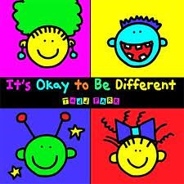 | 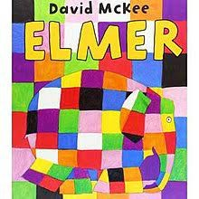 | 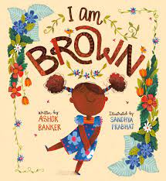
Books | It’s Ok to be Different  Todd Parr | Elmer  David Mckee | I am Brown  Ashok Banker and Sandhya Prabhat
Session objective and activity
Week 1 | I can talk about identify what makes me an individual
Week 1 | Read ‘It’s OK to be different’  Discuss the ways that you are different to your friend.  Draw yourself.
Week 2 | I can show my preferences
Week 2 | Children to say something that is ‘Ok’ – linked to learning from previous session e.g. ‘It’s Ok to like brussels sprouts’ or ‘It’s Ok to have a brown spot on my face’.  Play ‘Run around’ game – run to the picture that you prefer – children think of the things that they like and how they might be different to others.
Week 3 | I can think about the perspectives of others
Week 3 | Look at the book ‘Elmer’ – discuss the cover and read  Ask what the children think Elmer might be thinking/wondering at different points in the story.  Discuss how the elephants shaw that they love Elmer even though he is different.
Week 4 | I feel good about the ways we are the same and different
Week 4 | Recap the story of ‘Elmer’ and the key messages.  Talk about what is the same and what is different between you and a friend OR colour an elephant for an elephant parade. Make sure your elephant is different to the others.
Week 5 | I can talk about the ways we are the same and different
Week 5 | Read the book ‘I am Brown’ and discuss the key messages and answer linked questions.  Children to think of their own versions of ‘I am…’ linked to the book.
Week 6 | I can talk about my skin colour

Year 1
Books | 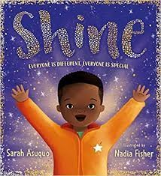 | 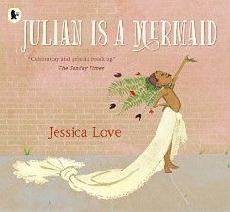 | 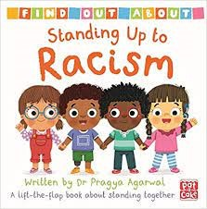
Books | Shine  Sarah Asuoquo | Julian is a Mermaid  Jessican Love | Standing up to Racism  Praggya Agarwal
Session objective
Week 1 | I can recognise what makes me special
Week 1 | Read ‘Shine’ and answer questions about the story  ‘What makes you shine?’ activity sheet
Week 2 | To know about how I am the same and different to others
Week 2 | Recap ‘Shine’ and remember the key messages. Answer questions about the story  Children to think about what makes them different to their friend and draw a picture of themselves and their friend.
Week 3 | To recognise ways in which we are all unique
Week 3 | Read ‘Julian is a mermaid’. Answer questions about the story.  Think about the word ‘unique’.  Children to think, write and draw the things that make them unique.
Week 4 | To recognise the ways we are the same as and different to other people
Week 4 | Recap ‘Julian is a mermaid’. Answer question ‘Why do you think we read this book?’ and ‘What is the special message in the story?’  Children to complete ‘All about me’ activity.
Week 5 | To know about how people have different skin colours
Week 5 | Look at the cover ‘Standing up to racism’ – discuss what it might be about.  Read the book and answer related questions. Focus on why we have different skin colours and the word ‘melanin’.  Children to consider what it is to be treated unfairly and how this makes people feel.  Children to draw a self-portrait, focusing on the skin colour as well as other features.
Week 6 | To know about how people may feel if they experience hurtful behaviour or bullying
Week 6 | Recap book ‘Standing up to racism’.  Recap questions and learning from last week.  Think about what you could do or say if you experience someone being treated unfairly because of their skin colour.

Year 2

Books | 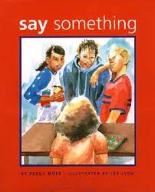 | 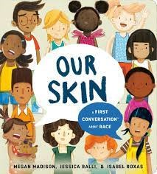 | 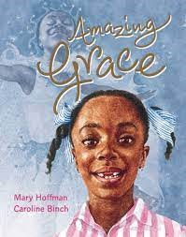
Books | Say Something  Peggy Moss | Our Skin  Megan Madison and Jessica Ralli | Amazing Grace  Mary Hoffman
Session objective and activity
Week 1 | To know that hurtful behaviour (including name calling, bullying and leaving other out) is not acceptable  To think about what others are feeling/thinking and understand that hurtful behaviours are wrong
Week 1 | Read ‘Say Something’  Discuss and reflect on what the different characters would be thinking
Week 2 | To know that hurtful behaviour is not acceptable; how to report bullying and the importance of telling a trusted adult
Week 2 | Consider strategies and actions when someone says or does something hurtful.  Think about how to be an ‘upstander’ not a ‘bystander’.
Week 3 | To know the ways in which we are the same and different to others
Week 3 | Read and discuss ‘Our Skin’  Think about and describe your own skin colour and that of others and why all skin colours are special. Learn about what makes skin colour different.
Week 4 | To know the ways in which we are the same and different to others
Week 4 | Design an ‘upstander’ superhero
Week 5 | To know what hurtful behaviour is, how it makes others feel and how to report it to a trusted adult
Week 5 | Read ‘Amazing Grace’ and discuss what happens in the story including the characters actions and feelings.
Week 6 | To know that hurtful behaviour is not acceptable and how to report it
Week 6 | Recap learning that has taken place and make links.  Work through scenario sheets thinking about the questions ‘What could you do or say?’

Year 3
Books | 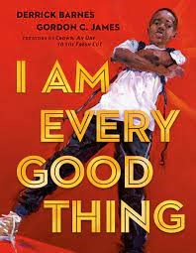 | 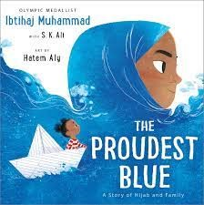 | 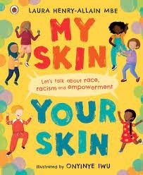
Books | I am Every Good Thing  Derek Barnes | The Proudest Blue  Ibtihaj Mohammed | My Skin, Your Skin  Laura Heny-Allain
Session objective and activity
Week 1 | To recognise individuality and personal qualities
Week 1 | Read ‘Every Good Thing’ – discuss the story and the author’s message/intentions.  Think about all the good things that you would describe about yourself.
Week 2 | To understand what is meant by identity
Week 2 | Discuss the story ‘The Proudest Blue’. Consider the religion of the main character and why religion can play an important part in some people’s identities.  Talk about differences between people that are visible and consider those which can’t be seen.  Make an identity jigsaw for yourself.
Week 3 | To understand what makes our skin the colour that it is
Week 3 | Look at scientific images of skin and discuss facts including how skin colour is genetic.  Learn about the words; race, racism and empowerment.  Make an ‘Anti-Racism’ poster including things that you have learnt.
Week 4 | To discover what it means to be anti-racist
Week 4 | Continue reading ‘My Skin, Your Skin’.  Focus on the line ‘we are not born racist’ – discuss what this means and why we think people become racist.  Consider what it means to be anti-racist and how we need to work together to dismantle racism.  Use skin-toned pieces of paper – find one to match own skin colour and to write ideas for making our school anti-racist.
Week 5 | To develop strategies to challenge racism
Week 5 | Recap what is race.  Consider what you would do if you experienced someone being racist.  Read poem ‘Be the change you want to see’ and consider what it is asking the reader to do.  Work with a partner to write a new poem about how to stand up to racism.
Week 6 | To recognise an example of where racism has happened.
Week 6 | Does racism happen today?  Look at the example of Marcus Rashford (taking the knee, the defacing of a mural and the racism of some football fans)
Week 7 | To know about personal identity and what contributes to who are
Week 7 | Compare similarities and differences with another person.  Create a leaflet about what makes you unique and special, your future ambitions and hopes and dreams.

Year 4
Books | 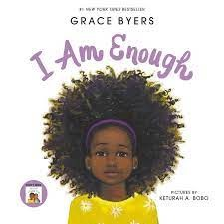 | 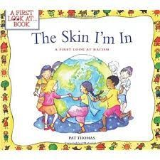 |  | 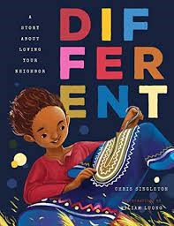
Books | I am Enough  Grace Byers | The Skin I’m in  Pat Thomas |  | Different  Chris Singleton
Books | 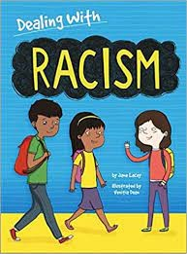 |  | 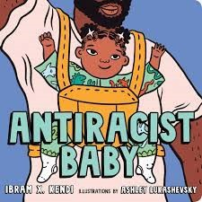
Books | Dealing with Racism  Jane Lacey |  | Anti-Racist Baby  Ibram X Kendi
Session objective and activity
Week 1 | To recognise the importance of self-respect and how this affects our thoughts and feelings about ourselves
Week 1 | Read ‘I am Enough’ and discuss themes and characters.  Discuss Maya Angelou quote ‘You alone are enough. You have nothing to prove to anybody.’ Link this to the story. Think of 6 reasons why ‘you are enough’ and share.
Week 2 | To recognise that everyone should expect to be treated with respect no matter the colour of their skin.
Week 2 | Discuss Nelson Mandela quote ‘No one is born hating another person because of the colour of his skin, or his background, or his religion. People must learn to hate, and if they can learn to hate, they can be taught to love, for love comes more naturally to the human heart than its opposite.’  Read ‘The Skin I’m in’ – discuss themes and feelings about racism and how you would respond if you witnessed this happening.
Week 3 | To know about diversity: what it means and the benefits of living in a diverse community.
Week 3 | ‘Why fit in when you were born to stand out?’ – discuss this quote.  Read ‘Different’ – discuss the story and its themes. Consider how someone would feel if they moved somewhere where they looked, sounded and dressed differently from everyone else.  Is it OK for someone to be treated unfairly because of the way the looked, sounded and dressed differently from others? How would you help someone if they moved to your school?  Learn what the word ‘diversity’ means and explain in your own words.
Week 4 | To know about strategies to respond to hurtful behaviour (experienced or witnessed)
Week 4 | Learn the definitions of the words; racism, prejudice, discrimination and consider examples of these.  Read ‘Dealing with Racism’ and discuss/answer questions.  Look at scenarios and consider what you think and would/could do in these situations.  Reflect on how you will spread the way racism is understood in school and how to help others understand that racism is not acceptable.
Week 5 | To create a charter showing anti-racist values
Week 5 | Recap previous learning and read ‘ Anti-racist Baby’. Brainstorm ideas about how to share the anti-racist message and create an agreed class charter.
Week 6 | To consolidate and reflect on learning
Week 6 | Discuss why football players take the knee.  Revisit and recall quotes and learning from the different books that have been read throughout the unit of learning.  Create a poster which shows learning and key messages.

Year 5
Books | 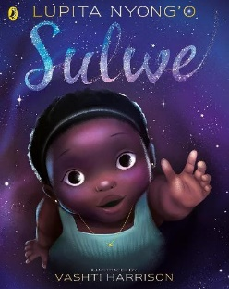 | 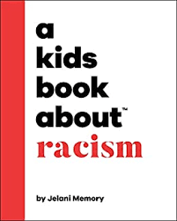 | 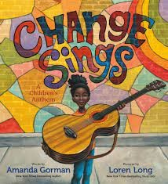 | 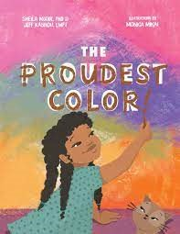
Books | Sulwe  Lupita Nyong’o | A Kids Book About Racism  Jelany Memory | Change Sings  Amanda Gorman | The Proudest Colour  Sheila Modir, Jeffrey Kashou, Modir
Session objective and activity
Week 1 | To know about respecting differences and similarities between people
Week 1 | Read ‘Sulwe’ – discuss and consider themes and messages.  Consider your own identity like Sulwe does. Children to reflect on what things have influenced their own identities, things that they have in common with others and the things that make them unique.
Week 2 | To know about racism and what it means
Week 2 | Discuss the quote ‘It is not our differences that divide us. It is our inability to recognise, accept and celebrate those differences.’ How does this quote relate to us?  Read ‘A kids book about racism’. Think about how people are different and how differences between people might divide them.  Plan a guide to teach younger children about racism; what it is, how it happens and how it makes people feel.
Week 3 | To know about stereotypes and how I can positively influence people’s behaviours and attitudes towards others.
Week 3 | Matching activity – which person does which job? Were your views impacted by stereotypes? Discuss what ‘stereotype’ means and how it links to our learning.  Read ‘The Proudest Colour’ – discuss themes and messages.  Watch BBC Bitesize clip – Not Racist vs anti-racist: what’s the difference?  Reflect on what it means to be anti-racist.
Week 4 | To know about strategies for challenging stereotypes
Week 4 | Read ‘The Proudest Colour’.  Why do we all have different skin colours? – Discuss and watch video clip explanation.  Reflect on what Zahra (character) learnt in the story and why this was important to her.  Explain that often we learn about the achievements of people in history and this is an opportunity to learn about people who make a difference to our world today e.g. Malala Yousafzai, Marcus Rashford The more we know about their achievements the more we can acknowledge and celebrate them.
Week 5 | To know about what living in a community means
Week 5 | Recap previous learning.  Discuss the US inauguration - (Joe Biden, Kamala Harris) and the significance of the role that Amanda Gorman played – watch clip ‘The Hills we Climb’.  Link Kamala Harris to ‘The Proudest Colour’ book.  Read ‘Change Sings’ and make links.  Consider what changes you would want to make in the world
Week 6 | To reflect on our learning
Week 6 | Revisit quotes and questions from previous learning and re-watch video clips  Read full version of ‘Change Sings’ – children/class to write their own version of this poem.

Year 6
Books | 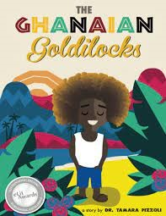 | 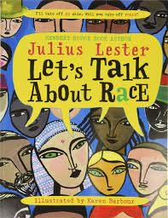 | 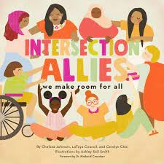
Books | The Ghanaian Goldilocks  Tamara Pizzoli and Phi Howell | Let’s Talk About Race  Julius Lester and Karen Barber | Intersection Allies – we make room for all  Chelsea Johnson, Latoya Council
Session objective and activity
Week 1 | To know about diversity and what it means
Week 1 | Look at the book cover – discuss where it is set. Read ‘Ghanaian Goldilocks’.  Answer questions and discuss how it is similar/different to other known stories.  Consider Kolifi’s hair and how this makes him stand out and unique. Relate to the term ‘diversity’.  Complete a culture wheel and reflect on all the things that make you unique. Compare with others.
Week 2 | To know about prejudice and how to recognise behaviours/actions which discriminate against others
Week 2 | Learn a little about the apartheid in South Africa. Look at ‘Whites Only’ sign images and discuss.  Discuss the concept that race is a social construct and consider the scientific reasons that humans are different.  Reflect on this learning and link to the culture wheels from the previous week.
Week 3 | To know about prejudice and actions which discriminate against others; ways of responding to it if witnessed or experienced.
Week 3 | Look at picture of twins with different skin colour and answer ‘why do we have different skin colours?’  Watch video clip about racism/Neal Maupay (footballer)  Discuss difference between being ‘non-racist’ and ‘anti-racist’ and how we can actively stand up to racism.  Explain the science of skin colour and answer questions around this.
Week 4 | To know about prejudice and how to recognise behaviours/actions which discriminate against others.
Week 4 | Revise what melanin is and how this affects skin colour and is genetic.  Discuss book Intersection Allies – what do you think it is about?  Make links with the book and the killing of George Floyd and the police response in the US.  Discuss protected characteristics and that it is illegal to discriminate because of these.  Children to choose protected characteristics that have significance for them and write about them making links to their previous learning.
Week 5 | To know about ways of responding to racism/prejudice if witnessed or experienced.
Week 5 | Discuss ‘empathy’ and why it is important.  Watch video ‘What is empathy?’ and discuss – link to examples of what racism looks/sounds like.  Look at data regarding racist incidents.  Consider what a ‘new normal’ (linked to quote by Barack Obama. Write own ideas for a set of rules for a ‘new normal’.
Week 6 | To summarise everything that has been learned about diversity, prejudice and discrimination.
Week 6 | Review learning from previous sessions and create selection of work that can be shared with others.  Create a set of rules/key messages regarding racism and how to be anti-racist.

