Curriculum+Geography Progression
Aims
For pupils, the study of geography offers a uniquely powerful lens through which to see the world, helping them to see connections between places, people, and environments at a range of scales that would otherwise be missed. Pupils are pushed beyond the confines of their everyday experience, to encounter places and landscapes that they would otherwise not meaningfully understand. This brings a sense of awe and wonder of the world, increases care and compassion for the planet and its inhabitants, and raises understanding of and tolerance for different ways of living. Geography also teaches pupils about their own local environment, compelling them to reconsider what they thought they knew in a wider context. The study of geography is also a matter of citizenship as it helps young people to encounter and engage with their world, find their place within it, and offers them a stronger voice to discuss the issues that matter.
Substantive and disciplinary content in geography
Every subject is unique and includes its own substantive content and disciplinary content. The Ark Curriculum Plus geography programme is designed to ensure that pupils not only have broad and strong substantive knowledge, but also understand the discipline of geography. Every primary school teacher needs to understand the distinction between these two things—between substantive content and disciplinary content. The two are taught together—the content of the ACP geography curriculum is structured so that pupils learn substantive and disciplinary content at the same time—pupils learn both geographical ‘facts’ and how to make sense of them simultaneously. When pupils learn geography, they tackle these two closely linked types of content, each dependent on the other. Any inadequacy in one will weaken the other, and each plays a vital part in securing scope, coherence, rigour, and sequencing.
Substantive knowledge
Think about the subject of geography as a discipline. As Christine Counsell writes, within every subject, there are established facts—the substantive knowledge, the substance, the stuff, the building blocks of factual content. Substantive knowledge is crucial in helping us to interpret everything surrounding us that we hear, see and read (Counsell, 2021: 154).
Geography is a cumulative and synoptic discipline. Pupils’ knowledge of what we often call substantive concepts such as ‘climate zone’, ‘migration’, and ‘continent’ come up time and time again in the geography curriculum. And we know if pupils are able to build up knowledge of these concepts—building richer and richer schemata of these concepts and terms over time that can help them access increasingly complex material throughout the curriculum, which helps them to learn, understand, and remember more—they make more progress.
In the progression map substantive geographical knowledge is divided into three overarching strands, which are referenced in the National Curriculum KS1 and KS2 programme of study. The three substantive strands are:
- Locational knowledge For example: location of globally significant places; geographical positioning that provides context for understanding.
- Environmental, physical, and human geography For example: migration, climate zones, biomes, distribution of natural resources.
- Geographical skills and fieldwork (what you might also think of as procedural knowledge) For example: using maps and globes; collecting first-hand evidence.
Below you can find a table listing where you can find the main substantive concepts for each year group. Please note that although these list the main substantive concepts, each unit may touch on all three at varying levels of depth. To look into the substantive concept of a unit in more detail use the Unit planning guidance for each unit.
 | Year 1, Unit 1 | Year 1, Unit 2 | Year 1, Unit 3 | Year 2, Unit 1 | Year 2, Unit 2 | Year 3, Unit 1 | Year 3, Unit 2 | Year 3, Unit 3 | Year 4, Unit 1 | Year 4, Unit 2 | Year 5, Unit 1 | Year 5, Unit 2 | Year 6, Unit 1 | Year 6, Unit 2 | Year 6, Unit 3
Locational knowledge | X | X | X | X | X | X | X | X | X | X
Environmental, physical, and human geography |  | X | X | X | X |  | X | X | X | X | X | X |  | X | X
Geographical skills and fieldwork | X | X |  | X |  | X |  |  |  |  |  |  | X

Disciplinary knowledge
Although geography teachers, education researchers, and curriculum designers may use different terms, all of them recognise that learning geography involves the development of both substantive knowledge (the ‘stuff’ of geography) and familiarity with the ‘second-order’ (or procedural disciplinary concepts). These shape the way in which the ‘stuff’ or ‘substance’ is understood, organised, and debated, as well as the ways in which it is actually generated.
We want pupils to develop as scholars within the discipline of geography, therefore pupils need to know how we arrived at established facts. How did we get there? How is it justified? How is it revised? What’s the degree of certainty attached? They need to know the grammar of geography.
The simplest way to think about the difference is that substantive knowledge is knowing ‘what’ and disciplinary knowledge is knowing ‘how’.
As we’re teaching we need to interweave the what and the how for our children. Such disciplinary understanding is not only important in its own right, it also interacts powerfully with pupils’ building of rich, broad, secure substantive knowledge. As we know from cognitive psychology, ‘memory is the residue of thought’. Well-crafted disciplinary teaching contributes to making substantive knowledge secure, through encouraging pupils to think deeply about the substantive content of the curriculum. The substantive knowledge enables pupils to gain the internal reference points that allow them to recognise the patterns, notice the contrasts, ask the questions, and discuss the options that the disciplinary content will demand. The two go hand in hand and are dependent on one another.
Thinking geographically is vital. Simply 'knowing' the capital of Uzbekistan or the location of Timbuktu is not, in itself, geographical thinking. The best we could say is that it enables geographical thinking. We need facts in order to think, but we also need concepts to enable us to group bits of information or facts together. Simply absorbing lists of geography's vocabulary does not amount to much more than a dramatic feat of memory: impressive, but not in itself a sign of the intellectual development that we could regard as geographical thinking. For this, we are looking for a form of conceptual knowledge development which links facts together through geographic thought.
The grammar of geography—its big ideas—have been expressed in various ways, from Early Years to Post-16.

The disciplinary concepts we focus on in KS1 and KS2 are:
DC1: The physical world​: the land, water, air, and ecological system; landscapes; and the processes that bring them about and change them.
DC2: Human environments​: societies, communities, and the human processes involved in understanding work, home, consumption, and leisure—and how places are made.
DC3: Interdependence​: crucially, linking the physical world and human environments and understanding the concept of sustainable development.
DC4: Place and space​: recognising similarities and differences across the world and developing knowledge and understanding of location, interconnectedness, and spatial patterns.
DC5: Scale​: the ‘zoom lens’ through which the subject matter is ‘seen’, and the significance of local, regional, national, international, and global perspectives.
DC6: Young people’s lives: using their own images, experiences, meanings, and questions; ‘reaching out’ to children and young people as active agents in their learning.
Another distinction which helps us to understand why we teach disciplinary content is to distinguish substantive contextual knowledge from disciplinary conceptual knowledge.
The substantive knowledge or vocabulary may be regarded as the context of geographical enquiry. This concerns the specific place and locational setting of the conceptual content under investigation.
But learning only the context, as an end in itself, makes relatively little contribution to thinking geographically. It can also be repetitive and intellectually dull—in which learning geography is more a 'burden on the memory rather than a light in the mind'. We should instead be mindful that even seemingly clear cut geographical facts can be challenged. By incorporating disciplinary or conceptual knowledge, the curriculum becomes one of 'engagement' rather than one of 'compliance’
EYFS provides pupils with a crucial developmental stage in their educational journey that allows them to explore and experience the world around them. Through first hand experiences and fieldwork, pupils explore and begin to understand the world and their place within it. Pupils begin to acquire important geographical vocabulary in EYFS that provides the foundations for geographical learning in KS1 and KS2. As pupils move beyond KS1, they begin to deepen their knowledge and geographical skills that enables them to develop substantive and disciplinary knowledge.
Enquiry questions
The enquiry question is the question that pupils will explore and answer at the end of each unit to assess what they have learned. The enquiry question provides a focus for each unit with lessons sequenced to provide pupils with the knowledge and skills to plan and create successful responses.
The pupil workbook and teaching guidance has been deliberately designed to allow teachers full reign over how they would like pupils to present their work. The assessment of the responses themselves, will come from internal decisions and discussions from each individual school.
More information and guidance on how to implement the enquiry question can be found in the unit’s Enquiry question support document.

National Curriculum Unit Links
Early Years Foundation Stage
The Key Stage 1 and Key Stage 2 curriculum builds on the National Curriculum framework for Early Years Foundation Stage, especially the area of learning and development ‘Understanding the World’. The framework gives three Early Learning Goals for this section. The goal below provides pupils with a strong foundation on which to build on their Geography knowledge and skills:
Understanding the World: People, Culture, and Communities
Children at the expected level of development will:
- Describe their immediate environment using knowledge from observation, discussion, stories, non-fiction texts, and maps.
- Know some similarities and differences between different religious and cultural communities in this country, drawing on their experiences and what has been read in class.
- Explain some similarities and differences between life in this country and life in other countries, drawing on knowledge from stories, non-fiction texts, and—when appropriate—maps.

The Key Stage 1 and 2 National Curriculum framework divides the learning pupils should receive into four categories; Locational knowledge, Place knowledge, Human and physical geography, and Geographical skills and fieldwork. Whilst the Ark Curriculum Plus geography units cover all of these requirements, some units fall into more than one category:
Key Stage 1
Key Stage 1 National Curriculum links
Year 1, Unit 1: Our local area | Year 1, Unit 2: The United Kingdom | Year 1, Unit 3: Beside the sea | Year 2, Unit 1: Planet Earth | Year 2, Unit 2: Life in Kenya
Place knowledge | Locational knowledge  Human and physical geography  Geographical skills and fieldwork | Place knowledge  Human and physical geography | Locational knowledge  Place knowledge  Human and physical geography  Geographical skills and fieldwork | Place knowledge  Human and physical geography

Key Stage 2
Lower Key Stage 2 National Curriculum links
Year 3, Unit 1: UK settlement and land use | Year 3, Unit 2: Climate and climate zones | Year 3, Unit 3: Europe | Year 4, Unit 1: Amazon: Rivers and rainforests | Year 4, Unit 2: The USA
Locational knowledge  Geographical skills and fieldwork  Human and physical geography  Place knowledge | Locational knowledge  Human and physical geography | Locational knowledge  Human and physical geography  Place knowledge | Locational knowledge  Human and physical geography  Place knowledge | Locational knowledge  Human and physical geography  Place knowledge

Upper Key Stage 2 National Curriculum links
Year 5, Unit 1: Asia: Mountains, volcanoes, and earthquakes | Year 5, Unit 2: Biomes | Year 6, Unit 1: Mapping the world | Year 6, Unit 2: Global challenges: Climate change | Year 6, Unit 3: Global challenges: Trade
Human and physical geography | Human and physical geography | Geographical skills and fieldwork | Human and physical geography | Human and physical geography

Geography sequence rationale
The Ark Curriculum Plus geography curriculum provides you with a knowledge-rich, comprehensive curriculum that has been strategically sequenced to ensure a broad and effective learning experience for all pupils whilst meeting the National Curriculum requirements. Each unit of work is underpinned by a clear rationale and conceptual rigour. Where connections are meaningful, links between the subjects have been embedded to ensure pupils gain a rich understanding from both a historical and geographical perspective.
Our curiosity for the world around us begins at an early age. Geography allows us to understand and explore the ‘what’, the ‘where’, and the ‘how’ of our world: giving us the knowledge we need to understand where, how, and why events occur; their impacts on the environment; and how they have then influenced people’s lives in the past, the present, and the potential future. Through studying geography, pupils make sense of the world and learn how events from both their own localities and the wider world can impact them directly and indirectly. They can understand, describe, and appreciate the world whilst also being able to discuss and debate issues on a local, national, and global scale.
In Key Stage 1, pupils begin their journey in geography with a study of the familiar—the local area. They then move outwards to study the United Kingdom and the British seaside, and outwards again to gain an overview of Earth and its continents and oceans. Pupils then study a contrasting location within Kenya, Africa.
Through Key Stage 2, pupils develop their understanding of locations, places, processes, and people. In Lower Key Stage 2, they use their knowledge of the UK to understand settlements and land use before exploring Europe and North and South America. The exploration of these continents includes identifying the location and characteristics of a range of the most significant human and physical features, as well as the opportunity to explore three places in more depth and compare them to their own locality. Pupils also learn about climate, climate zones, rivers, and rainforests. In Upper Key Stage 2, pupils explore Asia before focussing once again on the wider world in the biomes unit. They explore the human and physical characteristics of Asia and learn about mountains and natural disasters, such as volcanoes and earthquakes. A case study of a natural disaster allows pupils to see the impact on both a place and the people within it.
In Year 6, when looking at the world, pupils consider the global challenges faced in the movement of people, growing populations, the distribution of natural resources, fair trade, and the impact of climate change. They will also discover what they can learn from different maps of the world and draw their own maps based on fieldwork within their own locality.
You can find the prior and future learning in the Unit planning guidance for every unit.
 |  | Unit 1 | Unit 2 | Unit 3
Year 1 | 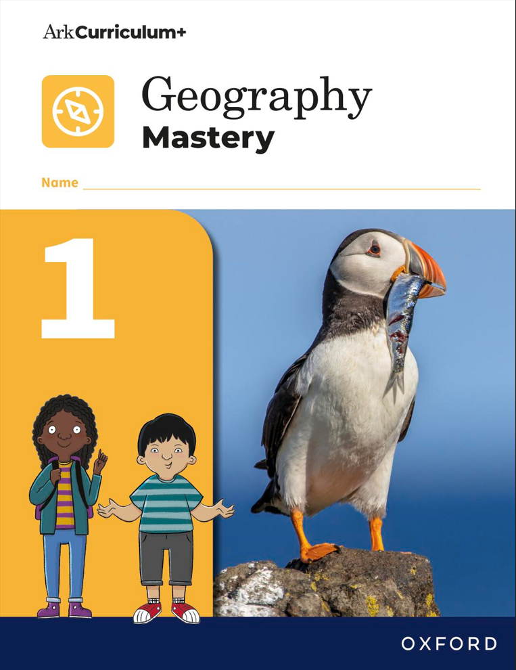 | Our local area  Pupils begin their journey with a study of the familiar— their local area. | The United Kingdom  Pupils then move outwards to study the United Kingdom, its four countries, and their capital cities. | Beside the sea  Originally a history unit, this unit has been redeveloped to ensure pupils were receiving a balance of both subjects. This unit explores the United Kingdom’s coastlines.
Year 2 | 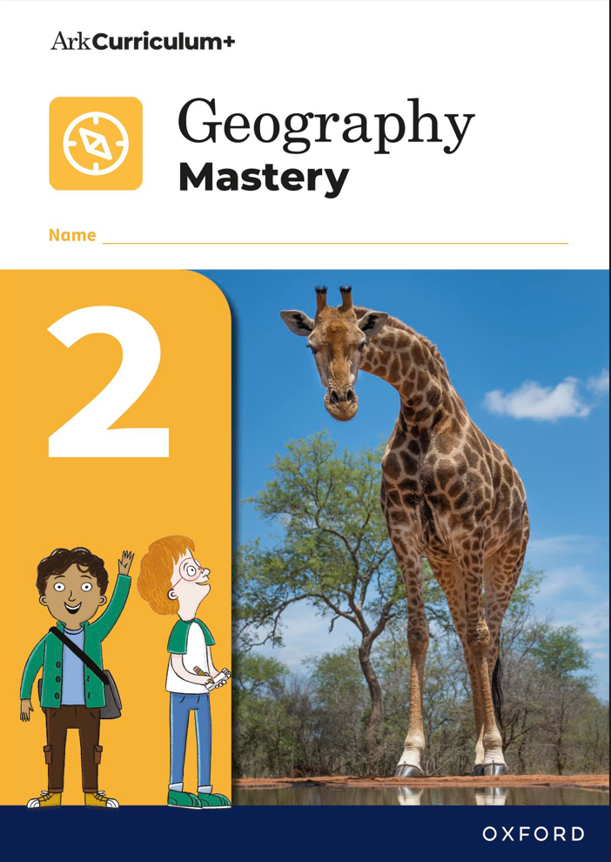 | Planet Earth  Having studied local geography and the UK in Year 1, pupils then ‘zoom out’ further to study the world’s seven continents and five oceans. | Life in Kenya  This unit builds on knowledge from the previous unit and meets the National Curriculum requirement for pupils to study similarities and differences between the UK and a non-European country.

Year 3 | 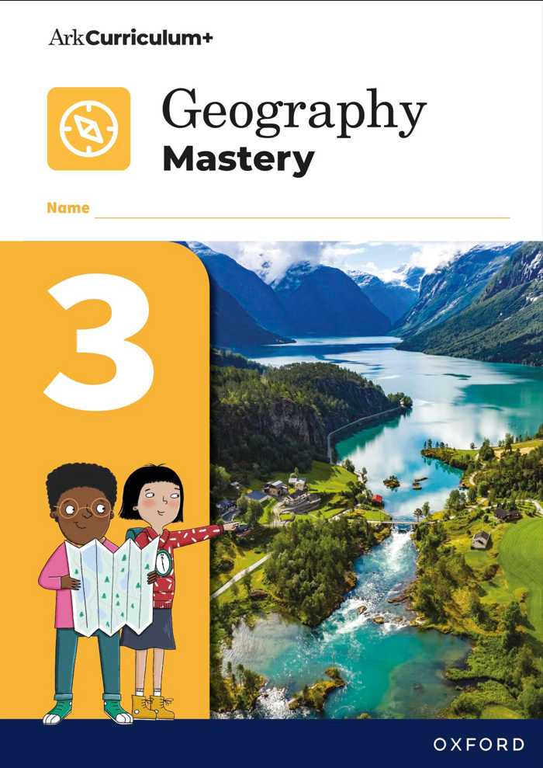 | Settlement and land use  Pupils study this unit as part of the National Curriculum requirement but to also make connections with the History unit, ‘Stone, Bronze and Iron Age’ to make sense of settlements and land use in the past before looking at it today. This is the first opportunity pupils have to study the water cycle. | Climate and climate zones  Pupils build on their knowledge from Year 2, ‘Planet Earth’ to study the climates and climate zones around the world. | Europe  After studying the United Kingdom and Planet Earth in KS1, pupils ‘zoom back in’ on their own continent to study it’s human and physical geography.
Year 4 | 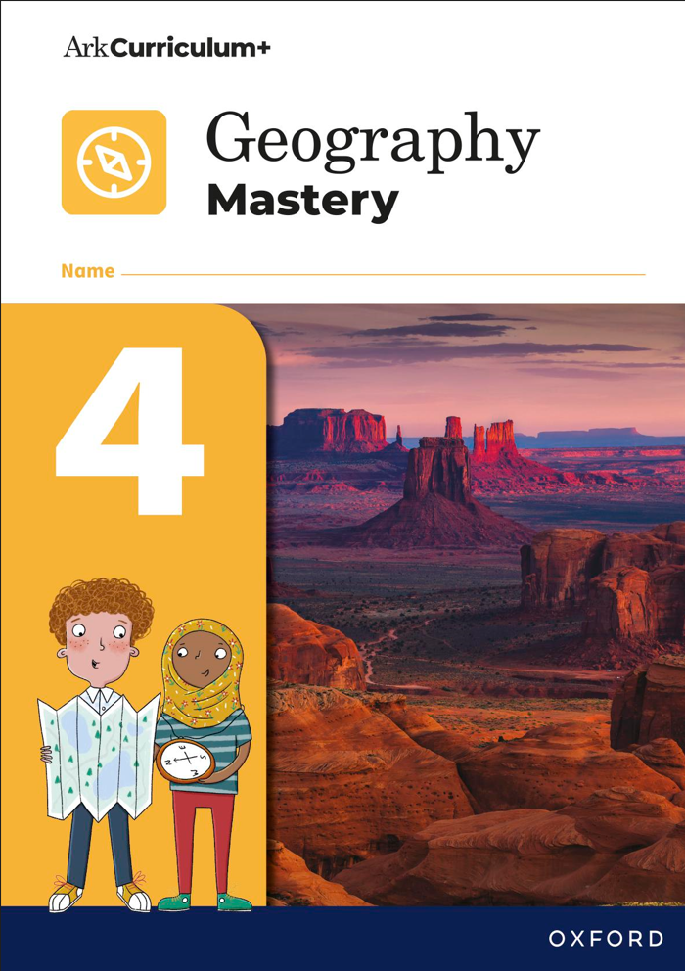 | Amazon: Rivers and rainforests  This unit meets the National Curriculum requirement of studying the continent South America then exploring the Amazon, developing pupils’ wider understanding of Planet Earth and its human and physical geography. Pupils also build on their knowledge of the water cycle from Year 3. | The USA  This unit is another example of the National Curriculum being met through the exploration of North America then the closer, in-depth study of the USA. This unit continues to support and grow pupils knowledge of our planet and the human and physical geography within it.
Year 5 | 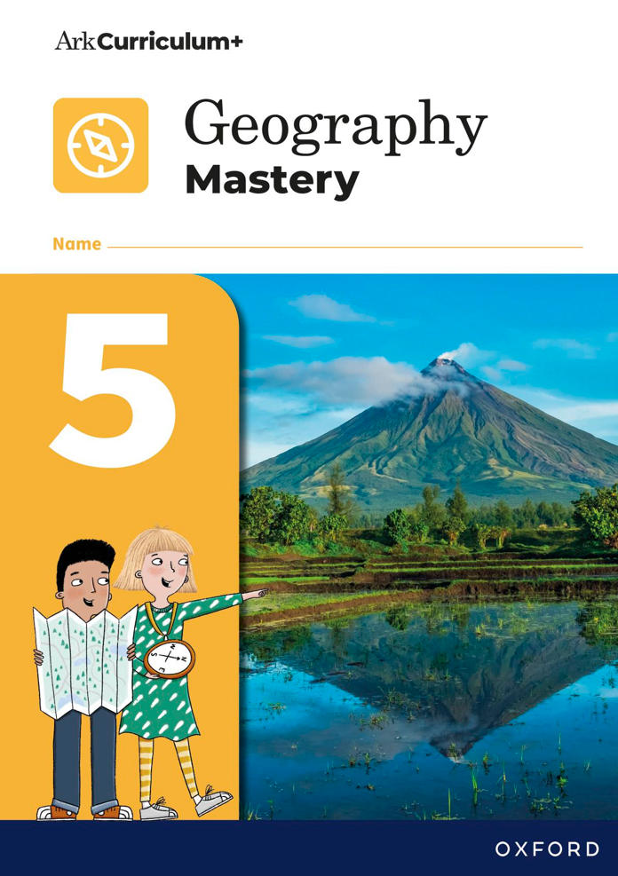 | Asia: Mountains, volcanoes, and earthquakes  Pupils continue exploring Planet Earth and its human and physical geography with this unit. | Biomes  Previously this unit was part of the climate and climate zones unit but has been separated to give pupils a more in-depth understanding whilst limiting opportunities for misconceptions between climate zones and biomes.
Year 6 | 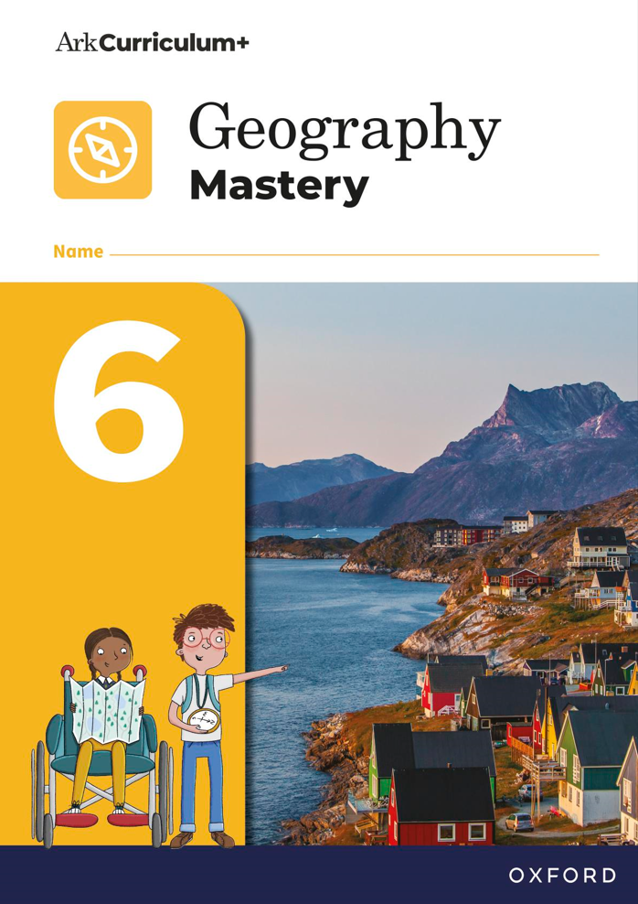 | Mapping the world  Whilst pupils will have been developing their fieldwork skills and knowledge over KS1 and KS2, this unit allows pupils to engage in fieldwork by using all that knowledge in a more complex way and create their own maps from their local area. | Global challenges: Climate change  Pupils will have a strong understanding of the human and physical geography of the world at this stage. Therefore, this unit draws all this knowledge together so pupils can study global issues and challenges we face today. | Global challenges: Trade  Originally part of Unit 2, this unit has been separated to allow pupils to focus in-depth at two major global issues rather than a wider range in insufficient complexity.

Unit resources
Planning  resources | Progression  Document  (1 per subject)  Where all the disciplinary, substantive, and key learning concepts can be found from Years 1–6 and the progression of these concepts. | Unit planning  guidance  (1 per unit)  Teacher guidance on how to teach each step of the lesson and where to find the unit’s prior and future learning, the substantive and disciplinary concepts within that unit, and the key terms and knowledge. | Subject  knowledge guide  (1 per unit)  A teacher-facing resource to inform and guide the teacher on the basic subject knowledge they need to know to successfully and confidently teach that unit. | Enquiry  support document  (1 per unit)  A teacher-facing resource to support with the implementation of the end of unit assessment—the answering of that unit’s enquiry question.
Teaching  resources | PowerPoint  teaching slides  (1 set per lesson)  Slides to support and guide the teacher and pupils through each stage of the lesson. | Discovery box  (1 per unit)  Activity cards for pupils that could be sent home prior to a unit to encourage engagement with an upcoming topic. | Posters  (1 set per unit)  A4 downloadable PDFs that include the key information on that unit that can be used in a class display.
Pupil resources | Workbook  (1 per year)  A pupil resource where pupils complete the majority of their activities. | Additional lesson  resources  (number varies per unit)  Extra documents to support pupil activities. Such as, sorting cards. | Knowledge  organiser  (1 per unit)  A pupil resource which includes all the key learning of that unit. This could be sent home with pupils or attached to the workbook. | Knowledge quiz booklet  (1 per year of KS1 Geography)  Every unit’s knowledge quiz and score table for KS1. | Knowledge record  (1 per unit of KS2 Geography)  A pupil resource where pupils keep a record of their key learning that lesson

Year 1, Unit 1: Our local area
Enquiry question: What is our local area like? |  | Main disciplinary focus:  DC4: Place and space
Disciplinary concepts: DC4 |  | Substantive concepts: Locational knowledge; Geographical skills and fieldwork
Lesson sequence | Disciplinary concepts | Key terms | Key takeaway
- Where do we go to school and what is it like there? | DC4: Place and space | map—item that shows us what places look like from above. | - Pupils know what a map is.  - Pupils know where they go to school.  - Pupils can draw and describe their school grounds.
- What is it like to live in our local area? | DC4: Place and space | local area—the area around your home. | - Pupils know what a local area is.  - Pupils know the name of their local area.  - Pupils can describe things they can see, smell, and hear in their local area.
- What is special about our local area? | DC4: Place and space | local landmark—something like a building, park, river, or place which makes our local area special. | - Pupils know what a local landmark is.  - Pupils can name and describe some of the buildings, places, events, and people from their local area.  - Pupils can use a range of adjectives to describe their favourite local landmark.
- Where do people live and work in our local area? | DC4: Place and space | home—the place where someone lives. | - Pupils know what a house/home is.  - Pupil can identify different types of houses/ homes.  - Pupils know what a job/place of work is.  - Pupils know some of the jobs/places of work found in the locality.
- Can we map our local area? | DC4: Place and space | symbol—small images on maps that show landmarks. | - Pupils know what a map is.  - Pupils know the difference between near and far.  - Pupils know which places are near to school and which are far.  - Pupils can mark places near and far on a map.

- What would we change about our local area? | DC4: Place and space | improvements—things that would make something better. | - Pupils understand what it means to like something.  - Pupils understand what it means to dislike something.  - Pupils can say what they like and dislike about their local area.  - Pupils can suggest changes to the local area.  - Pupils write about their local area in the future.

Year 1, Unit 2: The United Kingdom
Enquiry question: What are the countries that make up the United Kingdom like? |  | Main disciplinary focus:  DC4: Place and space
Disciplinary concepts: DC4 |  | Substantive concepts: Locational knowledge; Environmental, physical, and human geography; Geographical skills and fieldwork
Lesson sequence | Disciplinary concepts | Key terms | Key takeaway
- What is the United Kingdom? | DC4: Place and space | United Kingdom—a union made up of four countries. Charles III is the king. | - Pupils understand what ‘union’ means.  - Pupils can name and locate the four countries that make up the UK.
- What is it like to live in Scotland? | DC4: Place and space | capital city—a large city where the country’s Parliament meets. | - Pupils know the capital of Scotland is called Edinburgh, and can locate it on a map.  - Pupils can identify the border between Scotland and England.  - Pupils are aware of some of Scotland’s famous landmarks and traditions (music and food).
- What is special about Wales? | DC4: Place and space | national landmark—an object or feature that is famous and easily recognised. | - Pupils know the capital of Wales and can locate it on a map.  - Pupils are aware of some of Wales’s attractions and landmarks, including Snowdonia.  - Pupils understand Wales is famous for its mountainous geography.  - Pupils know of Snowdon, where it is located, and can describe the view from the top.
- Why do people visit Northern Ireland? | DC4: Place and space | tourist—someone who spends time away from home for leisure, holiday, and fun. | - Pupils understand that Ireland is two countries, and that only Northern Ireland is part of the UK.  - Pupils know the name of the capital city of Northern Ireland and where it is located.  - Pupils are familiar with Irish customs and traditions.  - Pupils know what the Giant’s Causeway is and where it is located.  - Pupils know the difference between a natural and a human-made landmark.
- What is England famous for? | DC4: Place and space | parliament—a group of people who run a country | - Pupils know that England is the biggest country in the UK, and can locate its capital.  - Pupils can compare and contrast the city and countryside.  - Pupils are familiar with some of England’s famous landmarks.
- What is the Union Jack and what does it represent? | DC4: Place and space | flag—a piece of cloth hung on a flagpole, which represents something like a country. | - Pupils know the flags of the four countries in the UK.  - Pupils recognise the Union Jack flag and understand what the Union Jack flag represents.

Year 1, Unit 3: Beside the sea
Enquiry question: What human and physical features can you find at the seaside? |  | Main disciplinary focus:  DC2: Human environments
Disciplinary concepts: DC1, DC2 |  | Substantive concepts: Locational knowledge; Environmental, physical, and human geography
Lesson sequence | Disciplinary concepts | Key terms | Key takeaway
- What is the seaside and where is it? | DC1: The physical world  DC2: Human environments | coast—the land next to the sea. | - Pupils understand what the terms ‘seaside’ and ‘coastline’ mean.  - Pupils can locate and name seaside resorts in each country of the UK.  - Pupils know that the seaside is located along the coastline.  - Pupils can name their local seaside.
- What physical features are found at the seaside? | DC1: The physical world | physical feature—a thing that is natural and not human-made, such as a coastline, beach, hill, or cliff. | - Pupils understand what the term ‘physical feature’ means.  - Pupils can describe some of the physical features found at the seaside.
- What human features are found at the seaside? | DC2: Human environments | human feature—a thing that is human-made, such as a pier, lighthouse, or promenade. | - Pupils understand what the term ‘human feature’ means.  - Pupils can describe some of the human features found at the seaside.
- What do people do at the seaside? | DC2: Human environments | fairground—an outside area with lots of fun rides, shows, stalls, and other entertainment. | - Pupils can describe some of the activities that people do at the seaside.  - Pupils understand the difference between land activities and water activities.
- Can we plan a trip to the seaside? | DC2: Human environments | compass—object that shows which direction things are in. | - Pupils understand how to use a compass, and revisit the compass directions north, south, east, and west.  - Pupils can use compass directions to plot a route around a map.
- How can we stay safe at the seaside? | DC2: Human environments | lifeguard—a person who makes sure everyone is safe as they swim in a pool or in the sea. | - Pupils are able to spot hazards at the seaside.  - Pupils understand the rules for how to stay safe at the seaside.

Year 2, Unit 1: Planet Earth
Enquiry question: Can you describe the seven continents and five oceans that make up planet Earth? |  | Main disciplinary focus:  DC1: The physical world
Disciplinary concepts: DC1, DC2, DC4 |  | Substantive concepts: Locational knowledge; Environmental, physical, and human geography; Geographical skills and fieldwork
Lesson sequence | Disciplinary concepts | Key terms | Key takeaway
- What are the seven continents that make up planet Earth? | DC4: Place and space | continent—a very large area of land that commonly contains different countries. | - Pupils know what a globe is and what it shows.  - Pupils understand that the Earth is round and so a globe shows information better than a flat map.  - Pupils know what a continent is.  - Pupils can name the seven continents in the world, recognise their shapes, and where they are in relation to one another.
- What are the five oceans that make up planet Earth? | DC4: Place and space | ocean—a very large area of salty water. | - Pupils know what an ocean is.  - Pupils can name and locate the five oceans that make up planet Earth.  - Pupils can tell the difference between an ocean and a sea.  - Pupils know some of the wildlife that lives in each ocean.
- What is the continent of Europe like? | DC1: The physical world​  DC2: Human environments | border—a real or imaginary line that divides two countries. | - Pupils can locate Europe on a map.  - Pupils can name some of Europe’s countries and capital cities.  - Pupils know what Europe’s climate is like.  - Pupils can distinguish between human and physical features in Europe.
- What is the continent of North America like? | DC1: The physical world​  DC2: Human environments | tropical climate—high temperatures and high levels of rainfall. | - Pupils can locate North America on a map.  - Pupils can name some of North America’s countries and capital cities.  - Pupils know what North America’s climate is like.  - Pupils can name some of North America’s landmarks.
- What is the continent of South America like? | DC1: The physical world​  DC2: Human environments | territory—an area of land that belongs to another country. | - Pupils can locate South America on a map.  - Pupils can name some of South America’s countries and capital cities.  - Pupils understand the difference between a country and a territory.  - Pupils know what South America’s climate is like.  - Pupils can name some of South America’s landmarks.
- What is the continent of Oceania like? | DC1: The physical world​  DC2: Human environments | ecosystem—an area where plants and animals live and co-exist together. | - Pupils can locate Oceania on a map.  - Pupils can name some of Oceania’s countries and capital cities.  - Pupils know what Oceania’s climate is like.  - Pupils can name some of Oceania’s landmarks and native animals.  - Pupils can research and write a fact file for a native Oceanic animal.
- What is the continent of Africa like? | DC1: The physical world​  DC2: Human environments | migration—the movement of people or animals from one place to another. | - Pupils can locate Africa on a map.  - Pupils can name some of Africa’s countries and capital cities.  - Pupils know what Africa’s climate is like.  - Pupils can name some of Africa’s landmarks and native animals.
- What is the continent of Asia like? | DC1: The physical world​  DC2: Human environments | skyscraper—a very tall, tower building. | - Pupils can locate Asia on a map.  - Pupils can name some of Asia’s countries and capital cities.  - Pupils know what Asia’s climate is like.  - Pupils can name some of Asia’s landmarks and native animals.

- What is the continent of Antarctica like? | DC1: The physical world​  DC2: Human environments | glacier—a slow-moving mass of ice and snow, like a frozen river. | - Pupils can locate Antarctica on a map.  - Pupils understand why Antarctica does not have any countries or cities.  - Pupils know what Antarctica’s climate is like and how the extreme conditions make it impossible for humans to live there.  - Pupils can name some of Antarctica’s animals and say what they eat.
- Why are some parts of Earth hot and some parts cold? | DC1: The physical world | hemisphere—half of Earth—the top half is the Northern Hemisphere, and the bottom half is the Southern Hemisphere. | - Pupils can recognise the Northern and Southern Hemispheres and the Equator.  - Pupils understand places are warm or cold because of their location.  - Pupils know there are seven different climate zones and each continent falls into different zones.

Year 2, Unit 2: Life in Kenya
Enquiry question: How is living in Kenya similar and different to living in the UK? |  | Main disciplinary focus:  DC4: Place and space
Disciplinary concepts: DC1, DC4 |  | Substantive concepts: Locational knowledge; Environmental, physical, and human geography
Lesson sequence | Disciplinary concepts | Key terms | Key takeaway
- Where in the world is Kenya? | DC4: Place and space | continent—a very large area of land that commonly contains different countries. | - Pupils recall the names of the seven continents and where they are in relation to one another.  - Pupils understand the difference between a country and a continent (and that Kenya is a country within the continent of Africa).  - Pupils can locate Kenya on a map and locate the countries and ocean that it borders.  - Pupils can suggest ways to travel to Kenya from the UK.
- What is the climate like in Kenya? | DC1: The physical world | climate—the typical weather for a specific area over 30 years. | - Pupils know what the term climate means.  - Pupils understand how a country’s location affects its climate.  - Pupils can locate countries on the Equator.  - Pupils can compare the climate of Kenya with the climate of the UK, listing similarities and differences.
- What is the landscape of Kenya like? | DC1: The physical world | savannah—an area of tropical grassland, dotted with trees. | - Pupils explore the physical and human features of Kenya.  - Pupils can identify physical features of Kenya on the map.  - Pupils can explain what savannahs, valleys, deserts, and volcanos are.  - Pupils can distinguish between features that can be found in both countries and features that are just in Kenya.

- What is it like to live in rural Kenya? | DC4: Place and space | nomads—people who travel from place to place to find food and land for their animals; they do not have a permanent home. | - Pupils understand what the term rural means.  - Pupils can analyse a typical day in the life of a rural Kenyan child and compare it to their own, observing similarities and differences.  - Pupils learn about the Maasai and understand how their Nomadic lifestyle differs from the lives of other Kenyans living in rural areas.
- What is it like to live in urban Kenya? | DC4: Place and space | outskirts—the area around the edge of a city, furthest away from the city centre. | - Pupils understand what the term urban means and how it is the opposite to rural.  - Pupils compare the life of an urban child in Kenya to their own.
- What are the similarities and differences between Kenya and the UK? | DC4: Place and space | compare—to look at the similarities and differences between two or more things. | - Pupils can identify similarities and differences between living in Kenya and the UK.  - Pupils can sort features of the different countries into categories.

Year 3, Unit 1: Settlements and land use
Enquiry question: What is the land like in the United Kingdom and how do we use it? |  | Main disciplinary focus:  DC1: The physical world  DC2: Human environments
Disciplinary concepts: DC1, DC2, DC3, DC4, DC5, DC6 |  | Substantive concepts: Locational knowledge; Geographical skills
Lesson sequence | Disciplinary concepts | Key terms | Key takeaway
- Where are mountains and hills in the UK? | DC1: The physical world  DC4: Place and space | mountain—a mountain is an area of land that rises above the land around it. | There are hills and mountains in each country in the UK. Some parts of the UK are more mountainous than others.
- Which seas and oceans surround the UK? | DC1: The physical world  DC4: Place and space | coast—a coast is where the land meets the sea. | The UK is an island, surrounded by seas. Seas and oceans represent a body of water. Where the land meets the sea, it is called a coast.
- Where are rivers located in the UK? | DC1: The physical world  DC4: Place and space | river—a naturally flowing body of water. | Rivers change along the course. Distinct features can be found along the course of a river and are shaped by different processes.
- Where have people chosen to settle in the UK? | DC1: The physical world  DC2: Human environments  DC4: Place and space | settlement—a place where people have chosen to live. | Settlements of different sizes can be found across the UK. Some settlement are located in rural areas whilst others are located in urban areas.
- What are the countries of the UK? | DC1: The physical world  DC2: Human environments  DC4: Place and space | county—an area of a country that has its own council. | There are lots of different counties or regions in England, Scotland, Wales, and Northern Ireland. Each county has different sized settlements. A council is responsible for looking after the local services for the people who live there.
- How is land used in the UK? | DC1: The physical world  DC2: Human environments  DC4: Place and space | land use—how humans use the land in a certain place. | The land in the UK is used for farming, building, leisure, and conservation. The countryside is used mostly for farming and conservation. Built up land is used mostly for buildings and leisure.

Year 3, Unit 2: Climate and climate zones
Enquiry question: How are climate zones different around the world? |  | Main disciplinary focus:  DC1: The physical world  DC4: Place and space
Disciplinary concepts: DC1, DC2, DC3, DC4, DC5 |  | Substantive concepts:  Locational knowledge; Environmental, human, and physical geography
Lesson sequence | Disciplinary concepts | Key terms | Key takeaway
- What is the weather like in your local area? | DC5: Scale | weather—weather is the day-to-day conditions of the atmosphere, e.g. sunny, rainy, windy. | Weather is the day-to-day condition of the atmosphere; climate is the average weather of a place over time. Weather conditions can be measured and recorded using specialist equipment such as a rain gauge or thermometer.
- How is the climate different around the world? | DC1: The physical world  DC4: Place and space | climate zone—a climate zone is a large area with a certain type of climate. | Climates are different around the world. They are influenced by proximity to the Equator. Places get colder as you move away from the Equator.
- What are polar and subpolar climate zones like, compared to arid climate zones? | DC1: The physical world  DC4: Place and space | polar climate zone—a polar climate zone has cold winters and summers, and little rainfall. | Polar climate zones are the coldest areas on Earth. These are found furthest away from the Equator.
- What are temperate and Mediterranean climate zones like? | DC1: The physical world  DC4: Place and space | temperate climate zone—a temperate climate zone has four seasons, changing temperatures, and it can rain at any time. | Temperate zones have four different seasons and are located north or south of the subpolar zones. Mediterranean climate zones are located closer to the Equator than the temperate zones. Mediterranean zones have two seasons: dry, very warm summers and cool, wet winters.
- What are tropical and equatorial climate zones like? | DC1: The physical world  DC4: Place and space | tropical climate zone—a tropical climate zone has a rainy summer season and a very hot and very dry winter season. | Tropical and Equatorial climate zones are located in different places on Earth. Tropical climate zones have two very different seasons, while Equatorial climate zones are not and humid all year round.
- What is the weather and climate like in the UK? | DC1: The physical world  DC4: Place and space | data—data is information collected from observing, questioning, or measuring. | Weather varies across the UK as well as the world. Weather data can be collected and recorded. This data can be plotted on different types of charts and graphs to compare the weather in different places.

Year 3, Unit 3: Europe
Enquiry question: Which countries are in Europe and what are they like? |  | Main disciplinary focus:  DC3: Interdependence  DC4: Place and space
Disciplinary concepts: DC1, DC2, DC3, DC4, DC5 |  | Substantive concepts:  Locational knowledge; Environmental, human, and physical geography
Lesson sequence | Disciplinary concepts | Key terms | Key takeaway
- Which countries are in Europe? | DC4: Place and space | Europe—Europe is one of the seven world continents. | A continent is a large area of land that includes more than one country. Europe is located in the Northern Hemisphere and includes over 40 different countries.
- What are some of the key physical and human features of Europe? | DC4: Place and space | human features—human features are linked to human activities.  physical features—are linked to the natural world. | Geography explores the physical and human world. There are many physical features across Europe, these include mountains, rivers, forests, and coastlines. Human features including buildings and landmarks, such as castles, bridges, and monuments.
- What is it like in the countries of Northern and Eastern Europe? | DC4: Place and space | capital city—a capital city is a city in a country where the government is located. | Each country has a capital city. All countries are different but have some similarities. Sweden is a country in Northern Europe. Poland is one of the countries in Eastern Europe.
- What is it like in the countries of Western and Southern Europe? | DC4: Place and space | population—population is the number of people living in a place. | Belgium is a country in Western Europe. Spain in one of the countries in Southern Europe.
- Where is Italy and what are its physical features? | DC4: Place and space | physical features—a physical features is one that occurs naturally. | Italy is a Mediterranean country in Southern Europe. It is bordered by four other countries and by the Mediterranean Sea. The climate in the North of Italy is different to the South of Italy.
- What is it like to live in Rome? | DC4: Place and space | landmark—a landmark is something that is easy to see that helps you remember the location of a place. | Rome is the capital city of Italy. It was founded over 2000 years ago. Rome has a Mediterranean climate and has landmarks such as St Peter’s square and the Colosseum.

Year 4, Unit 1: Amazon: Rivers and rainforests
Enquiry question: What is the Amazon, why is it significant and should it be protected? |  | Main disciplinary focus:  DC3: Interdependence  DC4: Place and space
Disciplinary concepts: DC1, DC2, DC3, DC4, DC5 |  | Substantive concepts:  Locational knowledge; Environmental, human, and physical geography
Lesson sequence | Disciplinary concepts | Key terms | Key takeaway
- What are the key physical features of South America? | DC1: The physical world | physical feature—a physical features is something that is created in nature, such as climate zones, biomes, oceans, mountains, and rivers. | South America is a continent located in the Southern Hemisphere. There are many different climate zones across the continent with different physical features.
- What are the key human features of South America? | DC2: Human environments | country—a country is an area of land which is ruled by the same government. | South America is a diverse continent which is made up of 12 independent countries and 1 territory. There are various religions, languages, and currencies across South America. Different industries export different products to different countries around the world.
- What are tropical rainforests and where are they found? | DC1: The physical world  DC4: Place and space | tropics—the tropics are the region of the Earth near to the Equator and between the Tropic of Cancer in the Northern Hemisphere and the Tropic of Capricorn in the Southern Hemisphere. | Tropical rainforests are located along the Equator and have hot temperatures and high amounts of rainfall all year round. The Amazon Rainforest is the largest tropical rainforest in the world and contains a diverse range of trees, plants, and animals.
- What is it like inside a tropical rainforest? | DC1: The physical world | biodiversity—the variety of wildlife and plans in a particular habitat, such as the rainforest. | Tropical Rainforests have four different layers; emergent, canopy, understory, and forest floor layers. Each layer has distinct characteristics and have access to different amounts of rainfall and sunlight.

- Which animals live in a tropical rainforest? | DC1: The physical world | biodiversity—the variety of wildlife and plans in a particular habitat, such as the rainforest. | Tropical rainforests are home to many animals. These animals have adapted to live in different layers of the rainforest, as such, their characteristics are also different. Some animals move between different rainforest layers.
- Do people live in the Amazon Rainforest? | DC2: Human environments | settlement—a place where people choose to live. | The Amazon rainforest is home to many different indigenous people. These indigenous tribes live a traditional way of life. Some remain isolated and uncontacted. The Yanomami tribe is the largest Amazon tribe. There are similarities and differences between different tribes.
- What is happening to the Amazon Rainforest? | DC3: Interdependence | deforestation—the clearing of a wide area of forest by cutting down or burning trees. | The Amazon Rainforest is the largest remaining tropical forest. Large areas of land are being cleared for different uses. Many species of plants and animals as well as indigenous people are losing their homes. We can do more to protect the rainforest.
- What are the features of a river and where are major rivers found? | DC1: The physical world | river course—the journey of a river between source and mouth. | A river is a body of water that flows across the land. Rivers have a source, course, and a mouth. Rivers can be different lengths and carry different volumes of water. The water cycle is an important part of making sure there is water in our rivers.
- How has the Amazon River shaped the land? | DC1: The physical world | meander—a curve in a river’s course. | Rivers do not travel in straight lines. They meander across the land. Rivers cause erosion of the land and deposit rock and soil along the course of the river. Erosion and deposition create the meanders of a river and can eventually form ox bow lakes.
- How are rivers used? | DC3: Interdependence | natural resource—something that is created by nature but then used by humans for their benefit, such as burning fossil fuels for heating homes and driving cars. | Rivers are a natural habitat for plants and animals. Humans use rivers in different ways. Their impact on this use can be positive or negative. The use of a river can have later consequences, which may not be immediately obvious.

Year 4, Unit 2: The USA
Enquiry question: What is it like in the USA? |  | Main disciplinary focus:  DC1: Physical world  DC2: Human environments  DC3: Interdependence
Disciplinary concepts: DC3, DC4, DC5 |  | Substantive concepts:  Locational knowledge; Environmental, human, and physical geography
Lesson sequence | Disciplinary concepts | Key terms | Key takeaway
- Where in the world is the USA? | DC4: Place and space | country—a country is an area of land that is controlled by one government. | The USA is a diverse country in the continent of North America. The USA has 50 states and four main climate zones.
- What are the states of the USA and how do their populations vary? | DC4: Place and space | state—is an area within the USA which has its own government. | The USA is a diverse country, made up of different states with different population sizes in each.
- What is the physical landscape like across the USA? | DC4: Place and space | topography—is the study of the physical features of the land. | The USA is a large country with varied physical characteristics, such as mountains, rivers, lakes, and deserts.
- What are some of the most significant human-made landmarks in the USA? | DC2: Human environments | landmark—an important or significant place that is easily seen or recognised. | The USA has a number of significant landmarks that have been built throughout history.
- What is California like and who lives there? | DC3: Interdependence | population—The number of people living in a place. | California is the most populated state and is located on the West Coast of the USA.
- What is it like in New York State and in New York City? | DC3: Interdependence | skyline—an outline of land and buildings against the sky. | New York state is located on the East Coast. The state capital is Albany. In New York City, space is limited so people have built skyscrapers.

Year 5, Unit 1: Asia: Mountains, volcanoes, and earthquakes
Enquiry question: What are natural disasters and how do they impact the lives of people living in Asia? |  | Main disciplinary focus:  DC1: Physical world  DC3: Interdependence
Disciplinary concepts: DC1, DC3 |  | Substantive concepts:  Environmental, physical, and human geography
Lesson sequence | Disciplinary concepts | Key terms | Key takeaway
- What are the key physical features of Asia? | DC1: Physical world | topography—is the study of the physical features of the land. | Asia is a diverse continent, and the largest. It is located in the Northern Hemisphere.
- What are the key human features of Asia? | DC2: Human environments | life expectancy—the number of years that a person is expected to live. | Different people in different countries have different life expectancies. These statistics are dependent on many factors.
- Where are some of the most significant borders in Asia? | DC4: Place and space | border—something that separates geographical areas. | Borders can be natural or human made and separate different countries. Borders can be classified as hard or soft.
- What are tectonic plates? | DC1: Physical world | tectonic plates—pieces of the rocky outer layer of Earth known as the crust. | The Earth is comprised of different layers. Tectonic plates move in different directions and at different speeds.
- How are mountains formed? | DC1: Physical world | landform—a natural feature of Earth’s surface. | Mountains are most often formed by the movement of the tectonic plates. 20 percent of the Earth’s surface is covered by mountains.
- How are volcanoes formed? | DC1: Physical world | volcanic eruption—lava and gas are released from a volcano— sometimes explosively. | Volcanoes most often form along tectonic boundaries and allow magma, ash, and gases to escape from inside the Earth.
- What happens when a volcano erupts? | DC1: Physical world | volcanic eruption—lava and gas are released from a volcano— sometimes explosively. | Volcanic eruptions can be catastrophic but they also bring benefits to the surrounding area.
- What is an earthquake? | DC1: Physical world | fault lines—these are located in many parts of the world and are closely related to the structure of Earth. | Earthquakes area caused due to the movement of tectonic plates. Seismic waves travel out from the focus. The intensity of an earthquakes can be recorded.

- What happens when an earthquake strikes? | DC3: Interdependence | aftershock—a smaller earthquake that happens in the same area after the main earthquake. | People can prepare for earthquakes. However, people’s ability to prepare and deal with earthquakes varies depending on where the earthquakes occur and their intensity.
- What are the secondary consequences of a volcanic eruption or an earthquake? | DC3: Interdependence | natural disaster—a natural event such as a flood, earthquake, or hurricane that causes great damage or loss of life. | Tsunamis can be caused by underwater earthquakes or volcanoes and can have a significant impact on people and the environment.

Year 5, Unit 2: Biomes
Enquiry question: What are the different biomes of the world? |  | Main disciplinary focus:  DC1: Physical world  DC3: Interdependence​
Disciplinary concepts: DC1, DC3 |  | Substantive concepts:  Environmental, physical, and human geography
Lesson sequence | Disciplinary concepts | Key terms | Key takeaway
- Does everywhere in the world have the same climate? | DC1: Physical world | climate zones—large areas around the world that share a similar climate. | Climate varies around the world and is influenced by proximity to the Equator, the tropics, or the poles.
- What are the different biomes of the world? | DC1: Physical world | ecosystem—a community of animals, plants, microorganisms, non-living things, and their shared environment. | Biomes are large-scale ecosystems defined by factors such as climate, soil, and vegetation. Biomes can be found across different continents at different scales.
- How have the flora and fauna of different biomes adapted to life there (1)? | DC1: Physical world | adaptation—living things are adapted to their habitats. This means that they have special features that help them survive. | Flora and fauna adapt to survive in different biomes. The geographical distribution of tundra and boreal forest biomes are influenced by distance from the Equator.
- How have the flora and fauna of different biomes adapted to life there (2)? | DC1: Physical world | adaptation—living things are adapted to their habitats. This means that they have special features that help them survive. | Flora and fauna adapt to survive in different biomes. The geographical distribution of tropical rainforest and savannah biomes are influenced by proximity to the Equator.
- What challenges do humans face living in each biome? | DC3: Interdependence | resource—a physical material that humans need and value such as land, air, and water. | Some resources are essential, others desirable. Different biomes present a range of challenges and opportunities for the people who live there.
- Case study: What impact have humans had on the deciduous forests of the UK? | DC3: Interdependence | deforestation—the purposeful clearing of forested land. | The scale of deciduous forests covering the UK has changed over time. This brings with it challenges and opportunities.

Year 6, Unit 1: Mapping the world
Enquiry question: How can maps and fieldwork help us to understand a place? Is there anything they cannot tell us? |  | Main disciplinary focus:  DC6: Young people’s lives
Disciplinary concepts: DC4, DC6 |  | Substantive concepts:  Geographical skills and fieldwork
Lesson sequence | Disciplinary concepts | Key terms | Key takeaway
- What can maps tell us about the world? | DC4: Place and space | cartographer—someone who makes maps. | Maps are designed for different uses and show places at different scales.
- How can you locate places on a map? | DC4: Place and space | location—the place where a particular point or object exists. | Lines of latitude and longitude are used to locate places around the world. These lines are measured in degrees, minutes, and seconds.
- How do you read an Ordnance Survey (OS) map? | DC4: Place and space | grid reference—a location on a map, which is found using numbered lines called northings and eastings. | Four and six figure grid references allow you to locate with accuracy specific features on Ordnance Survey maps in Great Britain.
- Can you plan fieldwork? | DC6: Young people’s lives | fieldwork—the process of observing and collecting data about people, cultures, and natural environments. | Outdoor geographical investigations of physical and human environments involve fieldwork. Geographical enquiry underpins fieldwork processes and skills.
- Can you carry out fieldwork? | DC6: Young people’s lives | fieldwork—the process of observing and collecting data about people, cultures, and natural environments. | Fieldwork involves the processes of observing and collecting information or data to better understand geographical knowledge and ideas.
- Can you present your findings? | DC6: Young people’s lives | fieldwork—the process of observing and collecting data about people, cultures, and natural environments. | Fieldwork findings can be presented in different ways for different purposes.

Year 6, Unit 2: Global challenges: Climate change
Enquiry question: What is climate change? |  | Main disciplinary focus:  DC3: Interdependence
Disciplinary concepts: DC1, DC2, DC3, DC4, DC5, DC6 |  | Substantive concepts:  Environmental, physical, and human geography
Lesson sequence | Disciplinary concepts | Key terms | Key takeaway
- How does the climate of a place influence how its land is used? | DC1: Physical world | land use—the function of land— what it is used for. | The climate influences how land is used in different parts of the world. Changes to climate affect how land is used.
- What is climate change? | DC1: Physical world | global warming—the rise in the average temperature of Earth’s air and oceans. | Climate change is happening and affects people and places around the world differently.
- What causes global warming? | DC1: Physical world | greenhouse gases—cause climate change and include gases such as carbon dioxide and methane. | The activities of people are contributing to the rise in greenhouse gases that contribute to global warming.
- What are the effects of climate change? | DC3 Interdependence | sea levels—the measure of the average height of a sea’s surface. | Global warming will affect people around the world. Negative consequences of global warming include sea level rises, polar ice sheets melting.
- How does climate change affect land use? | DC3 Interdependence | agriculture—the practice of farming, including cultivation of the soil for the growing of crops and the rearing of animals to provide food, wool, and other products. | Climate change will impact on agriculture around the world. This will have consequences for people and environments.
- How can we make a difference? | DC6: Young people’s lives | carbon footprint—the amount of carbon dioxide released into the atmosphere because of your own energy needs. | As responsible global citizens we can all limit the impact we have on the environment. Environmentalists actively campaign to raise awareness of this and international agreements are reached to limited people’s impact on the planet.

Year 6, Unit 3: Global challenges: Trade
Enquiry question: What are natural resources and why do we use them? |  | Main disciplinary focus:  DC3: Interdependence
Disciplinary concepts: DC1, DC2, DC3, DC4, DC5, DC6 |  | Substantive concepts:  Environmental, physical, and human geography
Lesson sequence | Disciplinary concepts | Key terms | Key takeaway
- What are natural resources? | DC3: Interdependence | overconsumption—we consume more than we need, and it creates a demand that the planet cannot cope with. | Natural resource use has changed over time. With rising demand for some resources overconsumption means that we are no longer using some resources sustainably.
- How are natural resources distributed? | DC3: Interdependence | distribution—the way in which things are shared or spread out over an area. | Resource distribution is unequal. The unequal distribution provides opportunities and challenges for different people around the world.
- How does the UK trade with the rest of the world? | DC3: Interdependence | trade—the way people buy and sell goods and services. | The UK trades with people in different countries around the world. Goods are imported and exported for sale, making money for the economy of different countries.
- Is trade around the world fair? | DC3: Interdependence | GDP: Gross Domestic product—the total value of goods and services provided in a country during one year. | Countries consume different materials at different rates. More wealthy countries often consume more than less wealthy countries. Trade is not always fair, but it can be made fairer for workers who export raw materials.
- Sustainability: how does the challenge affect the globe? | DC3: Interdependence | Renewable energy—resources that are infinite and can be replenished. | Renewable and non-renewable resources are used at different rates around the world. Some resources need to be used in a more sustainable way to ensure they last for longer.
- How can we achieve sustainability? | DC6: Young people’s lives | sustainability—a resource can be maintained at a certain level for as long as is needed. | Organisations at different scales aim to become more sustainable. There are different ways to do this.

