**Communication and Language**

To ask questions, share knowledge and engage in discussions about what they know or have learnt about traditional tales

Story share- traditional tales. The Little Red Hen, the Elves and the Shoe Maker, the Three Little Pigs, Jack and the Beanstalk, The Gingerbread Man, The Easter story. Discuss and compare characters and retell narratives in the correct order.

Daily opportunities for children to share news from home.

Language development- introduction to new vocabulary linked to topic.

**Personal, Social and Emotional Development**

Kapow lessons on health and well beingMaking healthy choices, keeping active, healthy diet.

Keeping calm and dealing with a difficult situation. Being a good friend.

Developing independence with self-care e.g. putting own coats on and zipping these up.

Class rules and expectations- continue to remind and reinforce these with class.

Take 5 each day- amazing breathing practice.

**Physical Development**

PE – athletics, dance

Throwing and catching, full body movements

Parachute games in hall.

Gym track at break and outdoor quad area, climbing frame, bike riding. OPAL at lunchtimes.

Funky fingers and dough disco.

Fine motor control activities continued.

Pencil grip work. Letter formation continued using Letter join to support with handwriting sessions

Sewing activities linked to sewing shoes for Elves and the Shoemaker

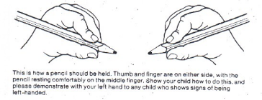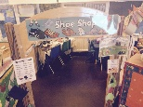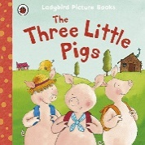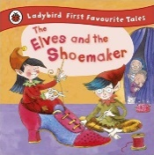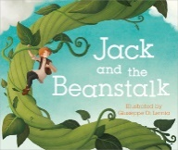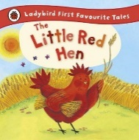

**Expressive Arts and Design**

Role play area- castle from the story Jack and the beanstalk, role playing making bread for the little red hen, shoe shop for The elves and the shoe maker. Outside role play building houses out of different materials.

DT -Food – cooking and decorating biscuits. Design a house for the three little pigs. What material would you use, how could you adapt your design? Can the house be blown over with a hairdryer.Can you design and make a boat to help the gingerbread man get across the river?

Art-Painting props for role play, painting pigs, little red hen, beanstalks, castles. Using different media to create- collage, painting, ink, Easter craft.

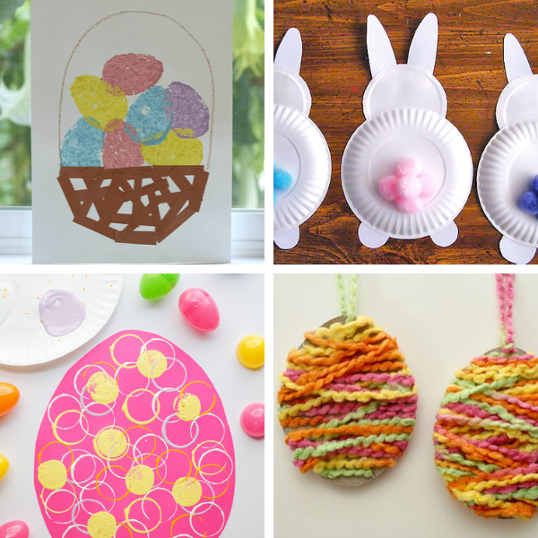 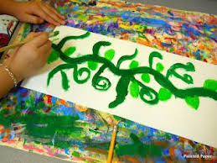

**Can you tell me a traditional tale?**

**Literacy**

Phonics –This half term we will recap phase 3 sounds. We will continue to look at blending and segmenting 4 letter words and 2 syllable words as well as words ending in ‘ing’.

We will use the phase 3 diagraphs and trigraphs in our writing and to help us with our reading.

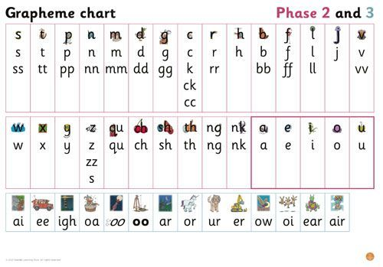

We will revise all phase 2 and 3 tricky words.

Writing- instructional texts, how to plant a bean, how to build a house for the three little pigs, wanted posters. Labelling- castles, shoe designs. Writing simple narrative- retell story of 3 little pigs, Easter story. Poety- write a poem about Spring.

Reading- books coming home daily for practice at home. 3 reading practice sessions per week in class to go alongside reading practice at home.

**Mathematics**

Height- taller shorter. Building and comparing towers.

Understanding 10- number bonds to 10 work, ten frames, dot cards.

Reinforce number formation through a variety of activities- Jack and the beanstalk writing numbers on leaves, lolly sticks to build a house of sticks.

Counting in 2’s- elves and the shoemakers counting socks pairs of shoes.

Shape- 2D and 3D shape- building castles with 2D and 3D shapes and labelling these castles with correct shape names.

Begin to know months of the year.

Recognise coins to 10p giving change in shoe shop.

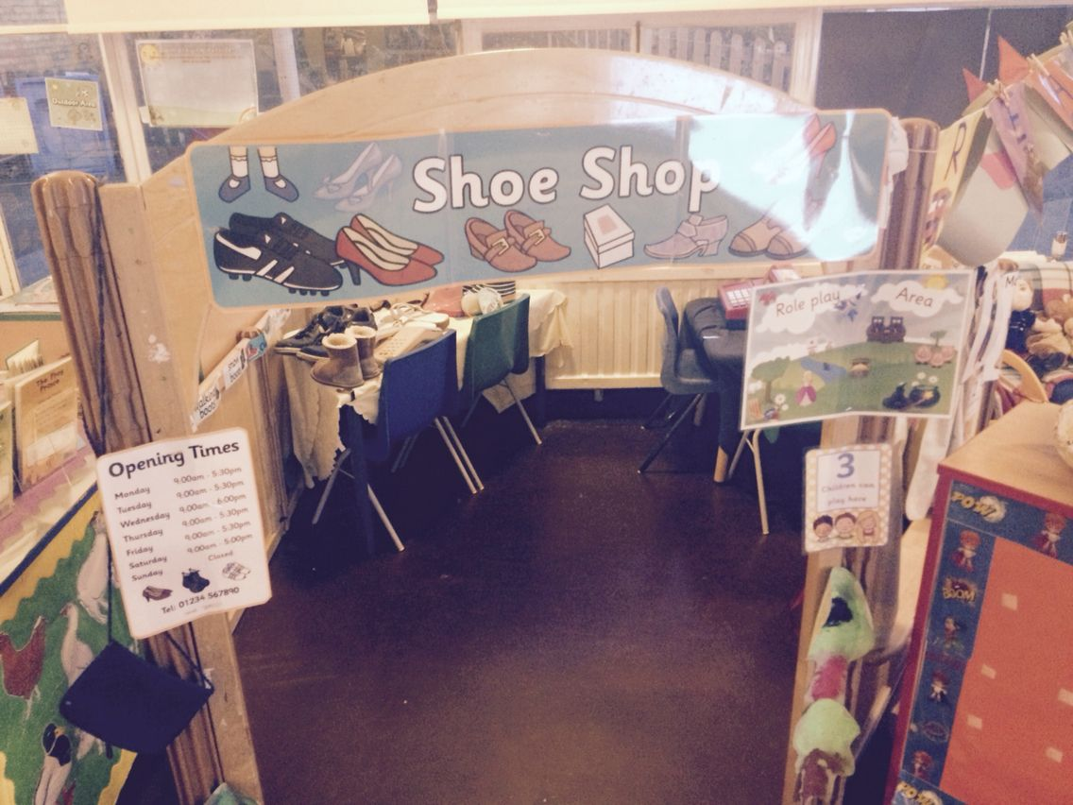 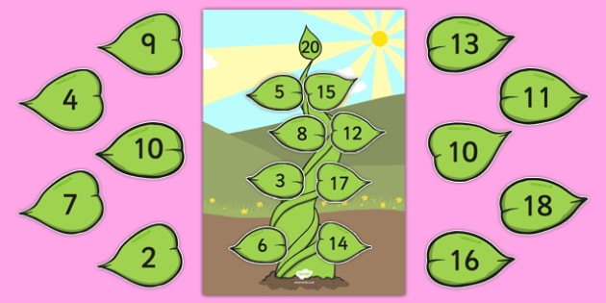

**Understanding the World**

Science- floating and sinking, investigating items that float and sink to help the gingerbread man cross the river- investigating waterproof materials to design a waterproof outfit for him. Changes of matter making bread. Disolving experiment with biscuits.

Geogaphy- look at Greens windmill in Nottingham, where is this loctaed on map of Nottingham how far is it from the school?

History- look at History of Greens windmill.

RE- Bible stories -The story of Noah, Joseph, The good Samaritan, The Easter Story.

Look at Easter celebrations

ICT -Create shoe drawings on 2 simple software. 