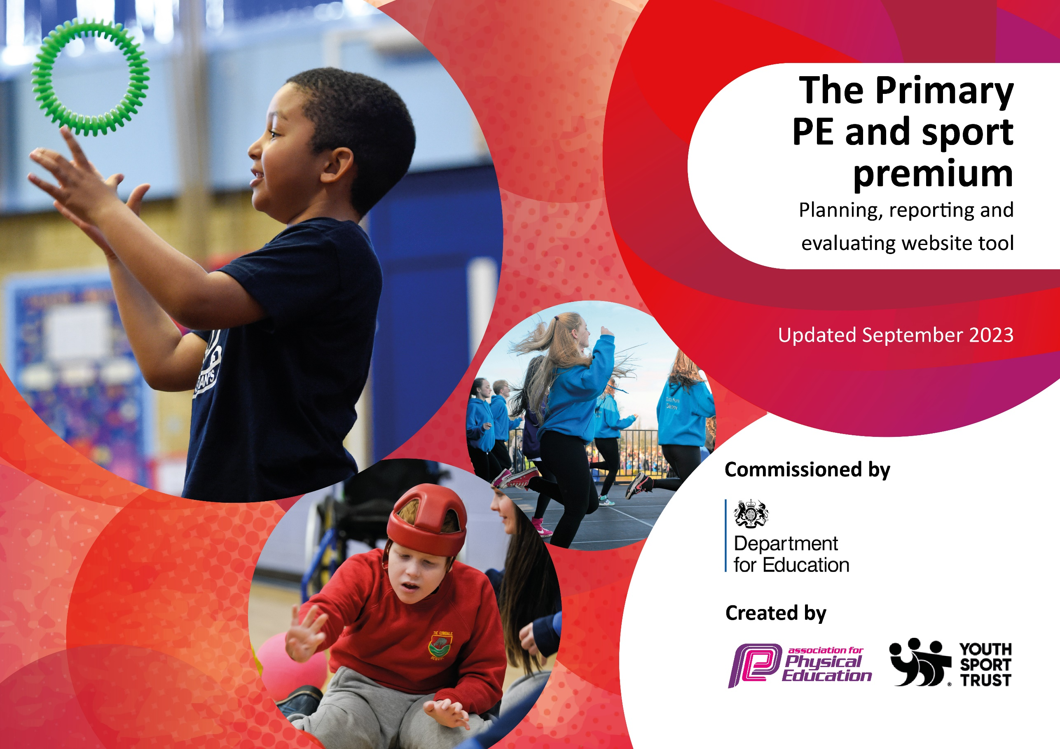

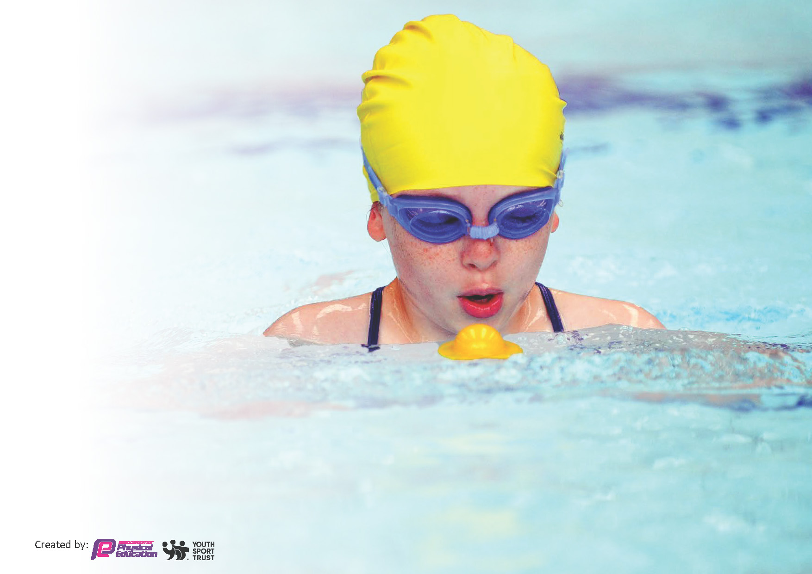
This template can be used for multiple purposes:
by:
- It enables schools to effectively plan their use of the Primary PE and sport premium
- It helps schools to meet the requirements (as set out in guidance) to publish information on their Primary PE and sport premium
- It will be an effective document to support Ofsted inspections enabling schools to evidence progress in Physical Education (PE) and evidence swimming attainment, which forms part of the PE National Curriculum. We would recommend schools consider
the Intent, Implementation and Impact of any spend, as examined within the Education Inspection Framework.

It is important that your grant is used effectively and based on school need.

Schools must use the funding to make additional and sustainable
improvements to the quality of the PE, School Sport and Physical Activity (PESSPA)
they offer. This means that you should use the Primary PE and sport premium to:

- Build capacity and capability within the school to ensure that improvements made now will benefit pupils joining the school in future years
- Develop or add to the PESSPA activities that your school already offers.

The Primary PE and sport premium should not be used to fund capital spend projects; the school’s core budget should fund these. Further detail on capital expenditure can be found in the updated Primary PE and sport premium guidance.

The Primary PE and sport premium guidance, outlines 5 key priorities that funding should be used towards. It is not

necessary that spending has to meet all the key priorities, you should select the priorities that you aim to use any funding towards.

Although completing this template is not a requirement for schools, schools are required to publish details of how they spend this funding. Schools must also outline what the impact this funding has had on pupils’ PE and sport participation and attainment and how any spending will be sustainable in the future. All funding must be spent by 31st July 2024.

The Department for Education has worked closely with the Association for Physical Education (afPE) and the Youth Sport Trust (YST) to develop this template and encourages schools to use it. This template is an effective way of meeting the reporting requirements of the Primary PE and sport premium.
Review of last year’s spend and key achievements (2023/2024)

We recommend you start by reflecting on the impact of current provision and reviewing your previous spend.

Activity/Action | Impact | Comments
Evidence of this can be found on the sports premium documentation 2023/24 form

Key priorities and Planning
This planning template will allow schools to accurately plan their spending.

Action – what are you planning to do | Who does this action impact? | Key indicator to meet | Impacts and how sustainability will be achieved? | Cost linked to the action
Employ specialist sports providers to give children access to sports the wouldn’t have experienced before  Yoga  Basketball  Bikeability  Provide daily swimming lessons for 5 year groups through the use of a pop-up swimming pool on school grounds. Also run specific groups for SEND children  Refresh/ purchase of equipment for OPAL pay at lunchtime to facilitate activity  CPD and upskilling opportunities for staff | Teaching staff, specialist sports coaches, pupils.  Targeted support for pupils requiring additional swimming instruction to meet the National Curriculum requirement of swimming 25m confidently.  SEND children  Play time (midday supervisors) pupils- experiencing the play  Staff and their teaching of Pe, therefore pupils and the lessons they experience | Key indicator 2:  Key indicator 4:  Key indicator 2:  Key indicator 4:  Key indicator 1:  Key indicator 4:  Key indicator 1:  Key indicator 5 | More pupils meeting their daily physical activity goal, more pupils encouraged to take part in PE and Sport Activities. More children likely to continue with these sports outside of school time.  Increased percentage of pupils meeting the National Curriculum swimming requirements by Year 6.  Improved pupil confidence in water safety and swimming skills.  Enhanced engagement and enthusiasm for swimming among pupils.  Reduction in the number of pupils requiring external swimming lessons to achieve the 25m target.  Children have access to far greater range of play equipment that encourages them to be physically active in many different ways. OPAL play continues to evolve over time to improve and provide the best experiences  Staff improve their confidence and proficiency of delivering PE lessons, leading to better outcomes for pupils | £1000 costs for additional coaches to support lunchtime sessions. (forest yoga)  £490 basketball coach  £400 bikeability  (Total cost £7500)  £5500 of sports funding to be spent on top up swimming sessions  Up to £1000  £10000

Keep PE profile high within school. Newsletters each half term feature a club or sport covered. Competition results shared in assemblies  Target less active children/ those who woud benefit from additional sporting activities to attend targeted intervenions, extra-curricular clubs or extra -curricular fixtures | Pupils, parents, wider community  Pupils who are less active/ lacking in confidence are exposed to more physical activity | Key indicator 3  Key indicator 2  Key indicator 4 | The importance of PE is shared with the community and children are encouraged to participate in PE activities  Pupils who are less active improve their experiences of sport and increase time spent physically active. Positive experiences should lead to increased engagement now and in the future. | None  £500 for sports coach plus specialist equipment (e.g. a boccia set)

Key achievements 2024-2025
This template will be completed at the end of the academic year and will showcase the key achievements schools have made with their Primary PE and sport premium spending.

Activity/Action | Impact | Comments

Swimming Data
Meeting National Curriculum requirements for swimming and water safety.
Priority should always be given to ensuring that pupils can perform safe self-rescue even if they do not fully meet the first two requirements of the National Curriculum programme of study

Question | Stats: | Further context  Relative to local challenges
What percentage of your current Year 6 cohort can swim competently, confidently and proficiently over a distance of at least 25 metres? | % | Use this text box to give further context behind the percentage.  e.g., 30% - we are struggling to get pool space due to our local pool closing so we have had to use a much smaller local school pool. We have had to limit the number of pupils attending swimming lessons during one term which means some pupils have attended fewer swimming lessons than others.
What percentage of your current Year 6 cohort can use a range of strokes effectively [for example, front crawl, backstroke, and breaststroke]? | % | Use this text box to give further context behind the percentage.  e.g., Even though your pupils may swim in another year please report on their attainment on leaving primary school at the end of the summer term 2024

What percentage of your current Year 6 cohort are able to perform safe self-rescue in different water-based situations? | % | Use this text box to give further context behind the percentage.
If your schools swimming data is below national expectation, you can choose to use the Primary PE and sport premium to provide additional top-up sessions for those pupils that did not meet National Curriculum  requirements after the completion of core lessons. Have you done this? | Yes/No
Have you provided CPD to improve the knowledge and confidence of staff to be able to teach swimming and water safety? | Yes/No

Signed off by:

Head Teacher: | Lindsey Jamson Headteacher
Subject Leader or the individual responsible for the Primary PE and sport premium: | Lindsey Jamson Headteacher
Governor: | Catherine Harrold
Date: | September 2024

