Spring 2 2024  Can you tell me a traditional tale? | Week 1  24.02.25 | Week 2  3.3.25  World book day 6th | Week 3  10.3.25  Parents Evenings?  Science week | Week 4  17.3.25 | Week 5  24.3.25  23rd World Maths Day Mother’s Day 30th | Week 6  31.3.25  Easter events  Bonnet Parade
Weekly Theme | The Gingerbread Man | The Elves and the Shoemaker | The Little Red Hen | Jack and the Beanstalk | The three little pigs | The three Billy Goats Gruff
Key Texts | 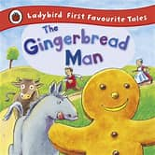 | 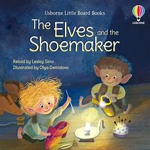 | 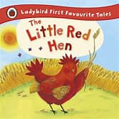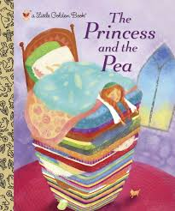 | 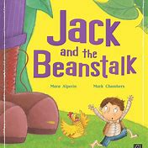 | 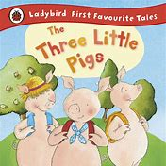 | 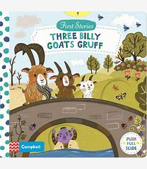
Rhyme of the week | Humpty Dumpty | Pat a cake | Baa, Baa, Black Sheep | Hot cross buns | This little piggy went to market | London bridge is falling down
PSED  Kapow Self Regulation – Listening and following instructions  Lessons 1-6  Take 5 Daily practices | L1 Simon Says  The importance of listening carefully | L2 Listening to a story | L3 Pass the Whisper  The importance of listening carefully, telling the truth and thinking of others’ feelings | L4 Obstacle Races  Following instructions or actions | L5 Blindfold walk  Follow and give simple instructions | L6 Treasure Hunt Listen to and respond to instructions
RE  A special Person: Jesus’ Miracles | What is a miracle?  What happened to the man who was blind? | What kind of miracles did Jesus perform? | Why do Christians celebrate  Easter?  What happened to  Jesus on Palm Sunday | What happened to  Jesus on Good Friday  and Easter Sunday?  Why do we celebrate  it? | What is the  story about Jesus at  Easter? | How do Christians Celebrate Easter?
PE  2 x week | TB Sports Coach - Athletics GSFP  Class Teacher - Dance Unit 2 GSFP
PD | Fine Motor  Daily – Name writing, letter formation/handwriting activities, pencil grip, craft and scissors skills activities  Writing simple words or phrases each morning as part of registration routine.  Weekly dough disco and funky fingers activities
Gross Motor
Action rhymes songs/dance – wake and shake/wii dance etc
C&L | Enjoy sharing non-fiction texts with teacher- recipes making bread and gingerbread.  Understand how to listen carefully and why listening is important | Listen with attention and respond to stories such as Fairytale twist; princess smartypants, the great fairytale disaster.  Use talk to organise thinking. | Discuss and compare characters.  Remembers key points from a story told without props or pictures.  Can chn say something about the character they are dressed as? | Engage in storytimes.  Listen to and talk about stories to build familiarity and understanding.  Articulate their ideas and thoughts in well-formed sentences. | Other repeated refrain stories - The enormous turnip –  What’s the story quiz? Can chn explain what is on the card and how it links to a story? | Hot Task Link -  Retell a narrative.  Retell a known story using s map (story pegs)  Retell the story, once they have developed a deep familiarity with the text, some as exact repetition and some in their own words.
Literacy  See Spring 2 Little Wandle Planning.  Jack and the Beanstalk Role play outside, the elves and the shoemaker inside | Little Wandle phonics review Phase 3: ai ee igh oa oo ar or ur oo ow oi ear  The Gingerbread Man  Wanted posters for the gingerbread man  Write a List of ingredients to make a gingerbread man | Little Wandle phonics review Phase 3: er air words with double letters longer words  The Elves and the shoemaker  Design and describe a shoe  Write who they think has been making the shoes  Science week investigation write ups | Little Wandle phonics words with two or more digraphs  Speech bubbles to show what characters say in story.  The little Red Hen’s  Instructions/Recipe for making bread  . | Little wandle phonics longer words words ending in –ing compound words  Mother’s day messages  Jack and the Beanstalk  Instructional text – How to plant a bean  Bean Diary  Design seed packets for magic beans | Little wandle phonics longer words words with s in the middle /z/ s words ending –s words with –es at end /z/  Introduce Easter Story work  Design and write about a new house for the three little pigs | Little Wandle phonics assessment week.  Finish Easter stories  Finish the Elves and the Shoemaker innovated story
Talk For Writing  The Elves and the Shoemaker Model Text |  | Immersion -Hook  Find shoes left in classroom for teacher.  Non fiction- descriptive writing design and label shoes. | Imitation  Learn story and create s map to help with the retell of the story | Innovation  Change character from elves to a character of choice. Change shoes to an object of choice. | Invention  Write own version of the Elves and the shoemaker story.
NCETM  Mastering Number | Counting, ordinality and cardinality | Comparison | Composition | Composition | Composition
White Rose Maths | Time  Talk about time  Order and sequence time  Building 9 and 10  Find 9 and 10  Compare numbers to 10  Represent 9 and 10 | Building 9 and 10  Conceptual subitising to 10  1 more  1 less  Composition ot 10  Bonds to 10 (2 parts)  Make arrangements of 10 | Building 9 and 10  Bonds to 10 (3 parts)  Doubles to 10 (find a double)  Doubles to 10 (find a double)  Explore odd and even | Explore 3D shapes  Recognise and name 3D shapes  Find 2D shapes within 3D shapes  Use 3D shapes for tasks  3D shapes in the environment | Explore 3D shapes  Identify more complex shapes  Copy and continue patterns  Patterns in the environment | Review and Recap  Assessment week – Find areas to focus on to meet ELGS and recap
Ongoing: Daily calendar, Visual timetable, Weather chart, Number rhymes and independent learning.
Key Vocab: same, different, match, pairs, big, small, sort, compare, group, big, little, long, short, tall, thick, thin, more, fewer, equal, odd, even, balance, heavy, light, pair, double, halve, longer, shorter, taller, today, tomorrow, yesterday, minute
UW  Past and Present  People, culture and communities  The Natural World  (History/Geography /Science) | The disappearing gingerbread man – dissolving activity  Floating and sinking – design then make him a boat – which materials would be best? | Materials – investigate the properties of materials…which make the best shoes? | Read the princess and the pea…which materials are best for a comfy bed?  Investigate the properties of different materials for shoes  Seasonal change spring Can name the four seasons and identify and describe features of Spring. | Local history -Greens windmill Sneinton. Plan a trip to the windmill.  Takes an interest in and comments on images of familiar situations from the past- greens windmill local history study.  Develop an understanding of growth and decay and changes over time. - plant study linked to Jack and the beanstalk.  Growth and change – seeds | How do windmills work? Visit to Greens Mill  Science Cooking changes in materials bread making heating | Easter celebrations  Easter activity day KS1?  If not, do as a class.
UW Vocab | Dough, knead, plant, harvest | Germinate, roots, stem, | Rigid, hard, soft, uncomfortable | Waterproof, float, sink | sails, miller, grindstone
ICT  E safety  Privacy and Security  Computing  Beebots | ??
DT Food – Cooking (Changes in materials) |  | Design  Different types of biscuits and styles of design  Lesson plan: MTP Biscuits - Brenden is Teaching  Biscuits explained | Design  Design own types of biscuit– ingredients and design for gingerbread characters | Make  Make dough and bake gingerbread biscuits Decorate gingerbread biscuits – weighing, counting out ingredients etc | Make  Make dough and bake gingerbread biscuits Decorate gingerbread biscuits – weighing, counting out ingredients etc  Design red nose biscuits for 21st March?? | Evaluate  What went well? What could we improve next time?
EAD Music Sing Up Units | Up and down | Up and down | Up and down | Five fine bumblebees | Five fine bumblebees | Five fine bumblebees
EAD | Plasticine boats, how many marbles can they hold?  Design boats  Split pin gingerbread men | Create shoes from designs  Sew cardboard shoes  2d shape elves  Role play shoe shop | Little red hen paper plates  Little red hen character masks/headbands  Act out the story  Draw/paint a picture of a windmill  Little red hen song http://www.mrsjonesroom.com/songs/littleredhen.html | Mothers day cards  Role play castle  Create harp, eggs, hen, coins, swords, shields, crowns, plates, goblets and jewellery  Magic bean packets  Paint magic bean stalks  . | Toilet roll pig finger puppet for puppet show.  Pictures of houses  Use different media to create representations of pigs | Easter Story Books  Easter cards  Easter pattern printing  Easter egg hunt  Spring flower craft
EAD Being Imaginative  Role Play – The Giant’s Castle | Role play area – Giants castle  Small world – free choice – dolls house, garage, pirate ship, sea creatures, wild animals, dinosaurs, farm yard, train set, fairy tale castle etc

Sponsored read during easter holiday – send forms out 5th week.

