Curriculum Plus history progression
Contents
Aims 2
Substantive and disciplinary content in history 2
Substantive knowledge 2
Disciplinary knowledge 4
Enquiry questions 5
How Ark Curriculum Plus links to the National Curriculum requirements 6
History sequence rationale 8
Local history requirements 10
Unit resources 11
Unit overview 12
Year 1, Unit 1: Toys Over Time 13
Year 1, Unit 2: Transport and Travel 14
Year 2, Unit 1: The Great Fire of London 16
Year 2, Unit 2: Kings and Queens 18
Year 2, Unit 3: People Who Made a Difference 20
Year 3, Unit 1: Stone, Bronze, and Iron Ages 22
Year 3, Unit 2: Ancient Egypt 24
Year 4, Unit 1: The Romans 26
Year 4, Unit 2: Roman Britain 28
Year 4, Unit 3: Maya Civilisation 30
Year 5, Unit 1: Anglo-Saxons and Scots 32
Year 5, Unit 2: Vikings 34
Year 5, Unit 3: Baghdad and the Middle East 36
Year 6, Unit 1: Ancient Greece 38
Year 6, Unit 2: Conflict and Resolution 40

Aims
The history curriculum is carefully mapped out so that all pupils leave primary school equipped with an understanding of the past that paves the way for their future. Throughout their journey in history, pupils will acquire a breadth of knowledge: of places and people, and significant events through time. Pupils will be given the opportunity to develop their ability to ask perceptive questions, think critically, analyse evidence, examine arguments, develop judgement, and understand
differing perspectives.
There are four core pillars underpinning the discipline of history:
1. Historical enquiry exposes pupils to key questions and gives them the opportunity to ask their own questions.
2. Historical enquiry relies on pupils acquiring sufficient substantive knowledge.
3. Alongside this knowledge, pupils are given the opportunity to develop disciplinary knowledge: cause, consequence, change and continuity, similarity and difference, historical significance, sources and evidence, and historical interpretation. Historical concepts provide the structure that shapes the practice of history. These will be revisited multiple times throughout the year and progress across year groups.
4. Finally, pupils learn to communicate historical findings in a sequenced, coherent manner both in verbal and written form.
Identifying and combining these core pillars work towards the overall goal of history education—gaining clear historical perspective. With clear historical perspective pupils will be empowered to be active global citizens: understanding the connections between local, regional, national, and international history; between cultural, economic, military, political, religious, and social history, and between short- and long-term timescales.
Substantive and disciplinary content in history
Every subject is unique and includes its own substantive content (SC) and disciplinary content (DC). The simplest way to think about the difference between the content is: the substantive knowledge is the ‘what’ and the disciplinary knowledge is the ‘how’. The Ark Curriculum Plus history curriculum ensures that pupils not only have broad and strong substantive knowledge—a coherent picture of the past—but also have understanding of the discipline of history. The content of the Ark Curriculum Plus history curriculum is structured so that pupils learn substantive content (the ‘what’) and disciplinary content (the ‘how’) at the same time; pupils learn both historical ‘facts’ and how to make sense of them simultaneously.
Substantive knowledge
Substantive knowledge not only transforms what pupils see in the world and how they see it but also enables pupils to build a ‘big picture’ of the past within which they can embed new historical knowledge. It is the substantive knowledge of the past which also plays a role in helping people interpret the world today. Pupils’ knowledge of what we often call substantive terms such as ‘empire’, ‘peace’, and ‘monarchy’ come up time and time again in the curriculum. If pupils are able to build up richer and richer schemata of these concepts and terms over time, this can help them access increasingly complex material throughout the curriculum. This helps pupils to learn, understand, and remember more—meaning they make more progress.
There are 19 substantive concepts that we want our pupils to gain understanding of by the end of Key Stage 2. They learn these substantive concepts through repeated encounters, with meaningful examples that develop in depth and complexity as the years progress.
We have provided a table below which shows where you can find the progression of the main substantive concepts across the year groups. The main substantive concepts highlighted for each unit show the overarching main focus of that lesson but within each lesson there are many examples of multiple substantive concepts touched and built upon. To look at each substantive concept in more detail, please use the Unit Planning Guide for each unit.
Substantive concept | Year 1 Unit 1 | Year 1 Unit 2 | Year 2 Unit 1 | Year 2 Unit 2 | Year 2 Unit 3 | Year 3 Unit 1 | Year 3 Unit 2 | Year 4 Unit 1 | Year 4 Unit 2 | Year 4 Unit 3 | Year 5 Unit 1 | Year 5 Unit 2 | Year 5 Unit 3 | Year 6 Unit 1 | Year 6 Unit 2
chronology | X | X |  |  |  | X | X
civilisation |  |  |  |  |  |  | X |  | X | X |  |  |  | X
communication |  |  | X |  |  |  |  |  | X | X
conflict |  |  |  | X | X |  |  | X |  |  |  | X |  |  | X
defence |  |  |  |  |  |  |  |  |  |  | X |  | X
democracy |  |  |  |  |  |  |  |  |  |  |  |  |  | X
empire |  |  |  |  |  |  |  | X |  | X |  |  |  | X | X
government |  |  | X | X | X |  | X |  |  |  |  |  |  | X | X
invasion |  |  |  | X |  |  |  | X |  |  |  | X |  | X
migration |  |  |  |  |  |  |  |  |  |  | X
monarchy |  |  | X | X |  |  |  |  |  |  | X | X | X
peace |  |  |  |  |  |  |  |  |  |  |  |  |  |  | X
power |  |  |  | X | X |  | X | X |  |  | X |  |  | X
religion |  |  |  |  |  | X | X |  | X | X | X
settlement |  |  | X |  |  | X | X | X | X | X | X
society | X | X | X |  | X | X | X | X | X | X | X | X | X | X | X
technology | X | X | X |  |  |  | X |  | X | X |  | X |  |  | X
trade |  |  |  |  |  | X |  |  | X | X |  | X | X
warfare |  |  |  |  |  |  |  |  |  |  |  | X | X |  | X

Below is an example of the progression of the substantive concept ‘invasion’ developed throughout the curriculum. You can see that although Year 5, Unit 1 does not have ‘invasion’ marked as a main substantive concept for that unit; the concept of invasion is still taught and builds upon pupils’ knowledge of invasion from prior units. This is true for all the units where all the substantive concepts are taught in varying degrees of complexity alongside the main substantive concepts for that lesson and unit.

Invasion
Year group | Unit | Substantive knowledge
Year 2 | Unit 2: Kings and Queens​ | Pupils are first introduced to the substantive concept ‘invasion’ in Lesson 2. Pupils study the monarch William the Conqueror and his invasion of England in the Battle of Hastings in 1066 by investigating the Bayeux Tapestry.
Year 4 | Unit 1: The Romans​ | Pupils return to the substantive concept in Year 4 when they continue the Key Stage 2 chronological study of British history and learn about invasion through the unit ‘The Romans’. Here pupils study how and why there were multiple attempts, with successes and failures, to invade Britain. ​
Year 5 | Unit 1: Anglo-Saxons and Scots​ | Pupils’ understanding of invasion is visited again and built on in Year 5 where pupils learn about the various invasions of England once the Romans left during the time of the Anglo-Saxons.
Year 5 | Unit 2: The Vikings​ | In this unit, pupils centre the learning of the whole unit around the question ‘Were the Vikings just invaders?’, drawing on their prior knowledge of invasion and their new learning through this unit by studying Viking invasions, raids, and settlements in England. ​
Year 5 | Unit 3: Baghdad and the Middle East ​ | In this unit pupils use their prior knowledge of invasion in British history to support their new learning in the world history unit to understand how Islam’s Golden Age came to an end, in part by learning about the  Mongol invasions.
Year 6 | Unit 1: Ancient Greece​ | Continuing with another world history unit, pupils continue to build on their knowledge of invasion in Year 6 by studying the invasions and conquests of Alexander the Great in the Mediterranean, Egypt, the Middle East, and other parts of Asia.
Year 6 | Unit 2: Conflict and Resolution​ | Lastly, pupils use their prior knowledge of the substantive concept to support their understanding of invasion within modern history through the threat of invasion and actual invasion in both the First World War and the Second World War. ​

Disciplinary knowledge
We want pupils to develop as scholars within the discipline of history—so pupils need to know how we arrived at established facts. Pupils need to understand something of the contested nature of history. Such disciplinary understanding is not only important in its own right, it also interacts powerfully with pupils’ building of rich, broad, secure substantive knowledge. Therefore, through encouraging pupils to think deeply about the substantive content of the curriculum, well-crafted disciplinary teaching contributes to making substantive knowledge secure. The substantive knowledge enables pupils to gain the internal reference points that allow them to recognise the patterns, notice the contrasts, ask the questions, and discuss the options that the disciplinary content will demand. As with the substantive concepts, each unit and lesson have a main disciplinary concept focus, but overall all the disciplinary concepts are taught throughout the units and years with varying degrees of complexity.
The disciplinary concepts we focus on in Key Stage 1 and Key Stage 2 are:
DC1 Cause and consequence
DC2 Continuity and change
DC3 Similarity and difference
DC4 Significance
DC5 Evidence
DC6 Interpretation
Substantive and disciplinary content go hand in hand and are dependent on one another. Any inadequacy in one will weaken the other, and each plays a vital part in securing scope, coherence, rigour, and sequencing.
Enquiry questions
Each unit is approached through an overall enquiry question which allows the substantive and disciplinary concepts to be explored. The enquiry question provides a focus for each unit with lessons sequenced to provide pupils with the knowledge and skills to plan and create successful responses in answering the enquiry question at the end of each unit.
The pupil workbook and teaching guidance has been deliberately designed to allow teachers full reign over how they would like pupils to present their work in answering the enquiry question. The assessment of the responses themselves will come from internal decisions and discussions from each individual school.
More information and guidance on how to implement the enquiry question can be found in the unit’s enquiry question support document.

How Curriculum links to the National Curriculum requirements
The Key Stage 1 and Key Stage 2 curriculum builds on the National Curriculum framework for Early Years Foundation Stage, especially the learning and development area of ‘Understanding the World’. The framework gives three early learning goals for this section. The goal below provides pupils with a strong foundation on which to build their history knowledge and skills.
Understanding the world: Past and present
Children at the expected level of development will:
- talk about the lives of the people around them and their roles in society
- know some similarities and differences between things in the past and now, drawing on their experiences and what has been read in class
- understand the past through settings, characters, and events encountered in books read in class and storytelling.

Within both Key Stage 1 and 2, the units cover the National Curriculum statutory requirements for history by:
- following a carefully constructed and intentional curriculum design architecture to develop a chronological understanding of British, local, and world history
- presenting teachers and pupils with a variety of lesson tasks that require pupils to analyse connections, contrasts, and trends over time
- presenting and highlighting historical language through the key vocabulary and key terms
- addressing and devising questions on change, cause, similarity and difference, and significance through the mapped out disciplinary concepts
- constructing responses on historical information through lesson tasks and pupils’ enquiry question responses
- analysing a range of sources within lesson tasks and understanding how these have constructed our knowledge of the past.

Ark Curriculum Plus resources offer pupils a knowledge-rich sequence of learning that goes beyond the National Curriculum’s requirements and suggestions. The Ark Curriculum Plus history curriculum encourages depth and breadth with its units, challenging pupils to become historians of the world.
Key Stage 1 National Curriculum links
Changes within living memory | Events beyond living memory that are significant nationally or globally | The lives of significant individuals in the past who have contributed to national and international achievements | Significant historical events, people, and places in their own locality
Year 1, Unit 1: Toys Over Time  Year 1, Unit 2: Transport and Travel* | Year 2, Unit 1: The Great Fire of London  Year 2, Unit 2: Kings and Queens | Year 2, Unit 3: People Who Made a Difference | Year 1, Unit 2: Transport and Travel*

*covers two National Curriculum requirements

Key Stage 2 National Curriculum links
Changes in Britain from the Stone Age to the Iron Age | The Roman Empire and its impact on Britain |  | Britain’s settlement by  Anglo-Saxons and Scots |  | The Viking and Anglo-Saxon struggle for the Kingdom of England to the time of Edward the Confessor |  | A local history study
Year 3, Unit 1: Stone, Bronze, and Iron Ages | Year 4, Unit 1: The Romans  Year 4, Unit 2: Roman Britain* |  | Year 5, Unit 1: Anglo-Saxons and Scots |  | Year 5, Unit 2: Vikings |  | Year 4, Unit 2: Roman Britain*  Year 6, Unit 2: Conflict and Resolution*
Key Stage 2 National Curriculum links
A study of an aspect or theme in British history that extends pupils’ chronological knowledge beyond 1066 |  | The achievements of the earliest civilisations |  | Ancient Greece |  | A non-European society that provides contrasts with British history
Year 6, Unit 2: Conflict and Resolution* |  | Year 3, Unit 2: Ancient Egypt |  | Year 6, Unit 1: Ancient Greece |  | Year 4, Unit 3: Maya Civilisation  Year 5, Unit 3: Baghdad and the Middle East

*covers two National Curriculum requirements

History sequence rationale
The Ark Curriculum Plus history curriculum provides you with a knowledge-rich, comprehensive curriculum that has been strategically sequenced to ensure a broad
and effective learning experience for all pupils while fully aligning with the National Curriculum. Each unit of work is underpinned by a clear rationale and conceptual rigour. Where connections are meaningful, links between the subjects have been embedded to ensure pupils gain a rich understanding from both a historical and geographical perspective.
In Key Stage 1, pupils develop their understanding of the past—beginning with familiar objects and places within living memory before moving beyond living memory. Pupils study toys and transport in Year 1. They then further develop their understanding of the past by studying the lives of significant individuals both nationally and internationally as well as studying a significant event beyond living memory. Pupils study the Great Fire of London, kings and queens, and significant individuals who have made a difference in Year 2.
In Key Stage 2, the curriculum divides into two main strands: a study of Britain’s past and a series of studies focusing on civilisations and people around the world. When studying British history, units are taught chronologically from the Stone Age in Year 3 to the Roman invasions and an in-depth study into Roman Britain in Year 4, to the Anglo-Saxons, Scots, and Vikings, and ending with the Battle of Hastings in Year 5.
After this chronological study of British history, in Year 6 pupils move to studying an isolated unit in modern history, chosen because of its significance: Conflict and Resolution—the First World War and the Second World War.
Units about world civilisations have been linked to the geographical studies of continents focused on in each year group. These civilisations often overlap with one another, and comparisons will be made between the civilisations in Africa, the Middle East, Europe, and South America, but also with the different periods of British history occurring at the time. Pupils gain an overview of the locations of the earliest civilisations before studying the Ancient Egyptians, the Maya, Baghdad in its
Golden Age, and Ancient Greece.
You can find the main links to prior and future learning in the unit planning guide for every unit.

 |  | Unit 1 | Unit 2 | Unit 3
Year 1 | 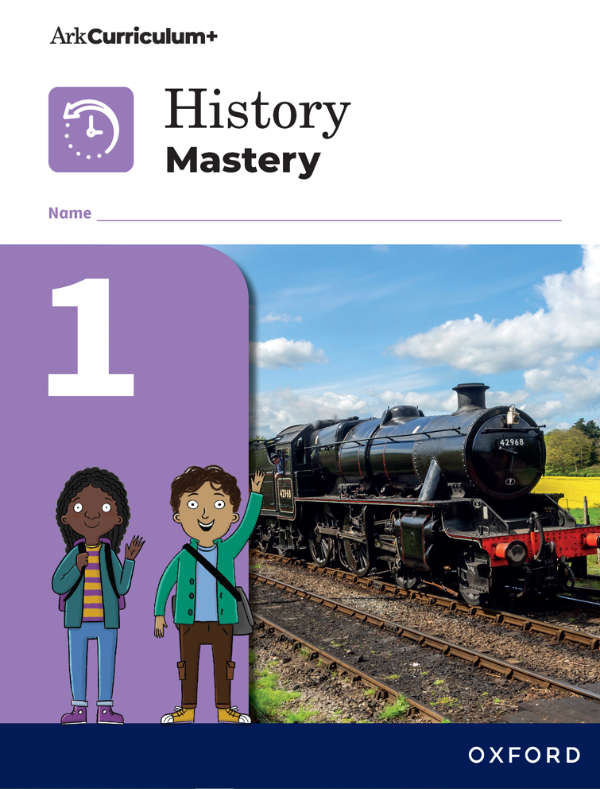 | Toys Over Time:  Pupils are introduced to history as a topic for the  first time and investigate changes in toys within  living memory. | Transport and Travel:  Pupils investigate the changes of transport over time and investigate transport in their local area.
Year 2 | 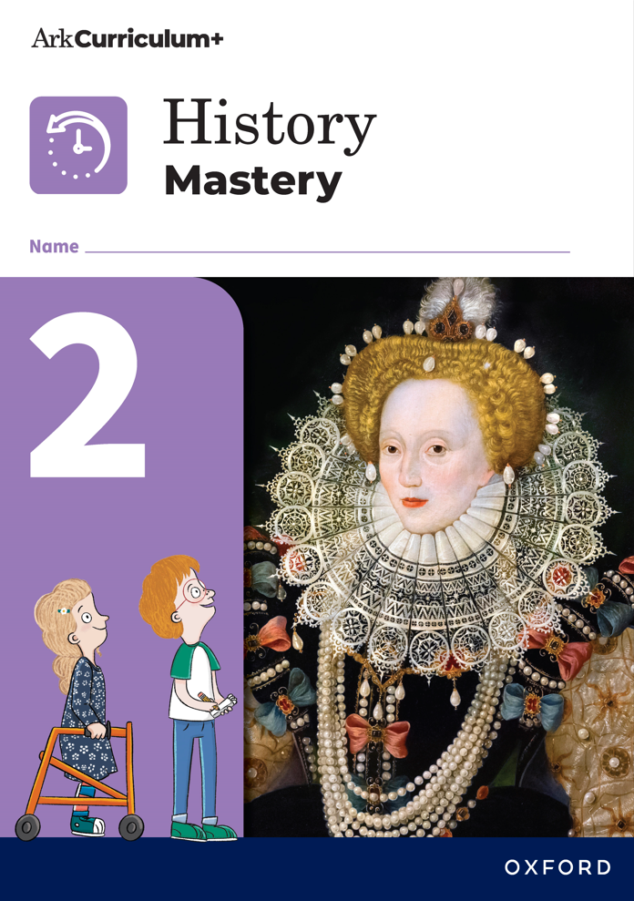 | The Great Fire of London:  This is the first unit where pupils study history outside of living memory. | Kings and Queens:  Pupils are introduced to the concept of a monarch  in Unit 1 and investigate a range of monarchs  outside living memory in this unit alongside the  current royal family. | People Who Made a Difference:  Pupils investigate the lives of significant people both nationally and internationally.
Year 3 | 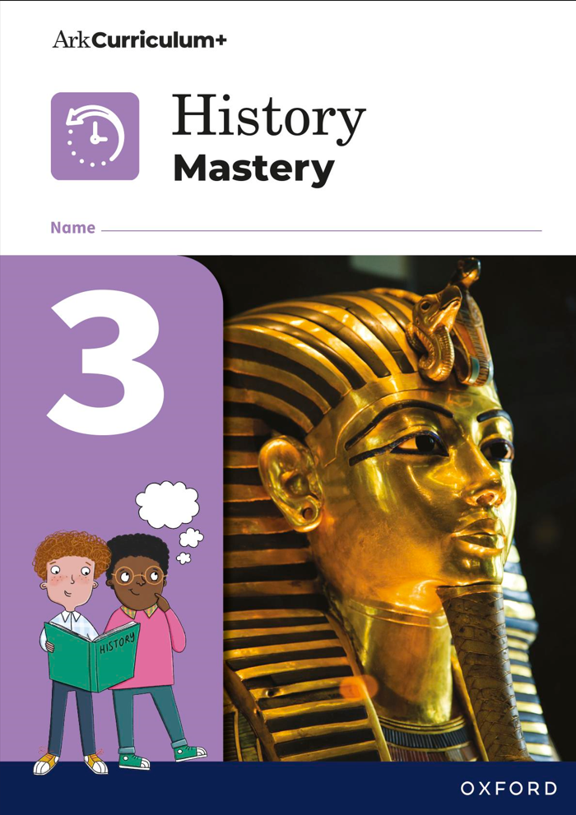 | Stone, Bronze, and Iron Ages:  In Key Stage 2, history splits into two strands. Here, pupils first learn about British history by looking at the three prehistoric periods. | Ancient Egypt:  The second strand of history focuses on civilisations and people around the world. In this unit pupils learn about a civilisation that existed during the same time period as later prehistoric British civilisations. The amazing artefacts and remains of Ancient Egypt support learning and engagement with pupils of this age group.
Year 4 | 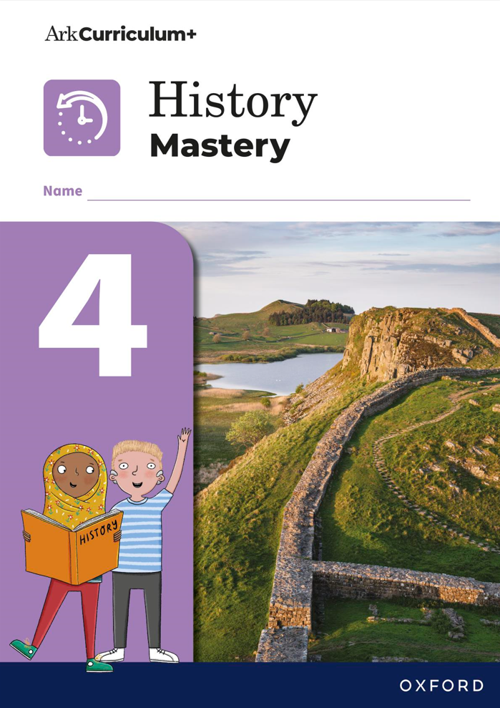 | The Romans:  The Roman conquest of Britian marks the end of the Iron Age, so pupils are first introduced to the  Romans and the Roman invasion of Britain here. | Roman Britain:  After being introduced to the Romans and their invasion of Britain in the previous unit, pupils then learn about life in Britain under Roman rule. | Maya Civilisation:  Pupils learn about their second civilisation from  outside of British history, which during the time of Ancient Egypt so pupils can make chronological connections.
Year 5 | 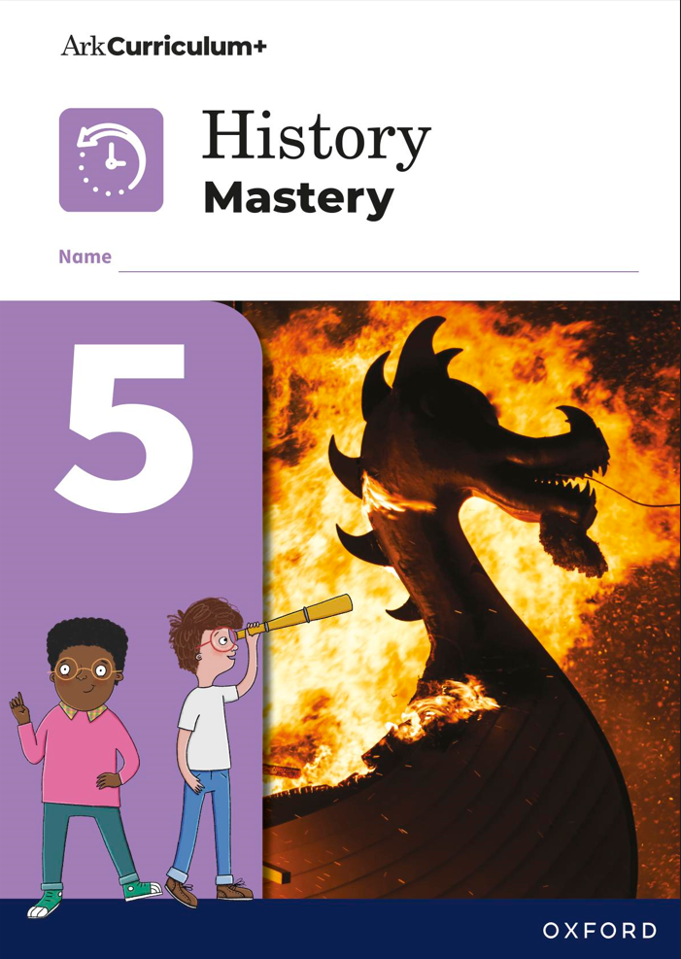 | Anglo-Saxons and Scots:  This time period follows Roman Britain and deals  with the early Anglo-Saxon period up to the time of  King Alfred. | Vikings:  This time period overlaps with the Anglo-Saxon period when Vikings first began to invade, raid, and settle in Britain. It includes the unification of England and ends with the start of the Norman period in 1066. | Baghdad and the Middle East:  This is the third world civilisation unit studied in history. This period overlaps with the same time period as the Ancient Maya, allowing pupils to make chronological links.
Year 6 | 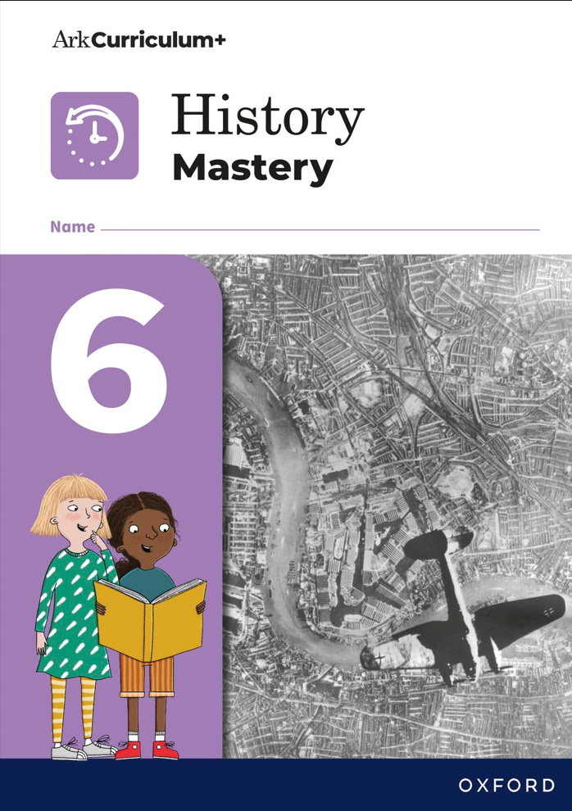 | Ancient Greece:  This is the final world civilisation unit pupils explore in Key Stage 2 which took place at the same time as Ancient Egypt, Ancient Maya, and Bronze and Iron Age Britain, allowing pupils to make chronological links. Placing this unit in Year 6 allows topics like democracy to be explored in depth. | Conflict and Resolution:  This introduces pupils to modern history and  teaches pupils about the First World War and the Second World War.

Local history requirements
The National Curriculum gives requirements for Key Stage 1 and 2 for pupils to undertake a local history study.
In the Key Stage 1 framework the National Curriculum states:
- ‘Pupils should be taught about: significant historical events, people, and places in their own locality’
In Key Stage 2, the three examples that the National Curriculum give for where this may take place are:
- ‘a depth study linked to one of the British areas of study listed
- a study over time tracing how several aspects of national history are reflected in the locality (this can go beyond 1066)
- a study of an aspect of history or a site dating from a period beyond 1066 that is significant in the locality.’
Throughout the Key Stage 1 and 2 British history units, opportunities for local history are highlighted within the unit planning guidance and sometimes the subject knowledge guide. You may well think of more opportunities pertinent to your local area. All PowerPoint teaching slides and additional resources are fully editable so they could be adapted to add local content. Lessons could be amended to focus on the local area.
However, within Key Stage 1, the main opportunity for a local history study is in ‘Travel and Transportation’ (Year 1, Unit 2). In Key Stage 2 there are two main opportunities for a more detailed local history study: ‘Roman Britain’ (Year 4, Unit 2) and ‘Conflict and Resolution’ (Year 6, Unit 2).
In the unit ‘Roman Britain’, teachers are given the opportunity to organise a local trip to a Roman archaeological site; this could be building remains, Roman roads, or locally discovered artefacts in a museum. Teachers are guided to design their own task for pupils to complete based on this local study with a completed example and template of what this could look like. This activity would link to bullet point one of the National Curriculum guidance.
‘Conflict and Resolution’ studies the impact of the First World War and the Second World War on British civilians. In Lesson 4, pupils learn about the role of women in the First World War and can investigate a woman during this time from their local area. In Lesson 5, pupils look at the aftermath of war and are given an opportunity to look at the impact of the First World War on local people, including visiting local war memorials if possible. In Lesson 8, pupils will have the opportunity to study the impact of the Blitz on their local area/their closest city. Teachers are encouraged to adapt the lesson to allow for pupils to take a trip to their local area affected by the Blitz and use a map to visit the various impact sites or to look at the experiences of evacuees who came to the local area. These activities would link to bullet point three of the National Curriculum guidance.
We encourage teachers and schools to complete these areas of the curriculum or to adapt to suit their own locality, to align with the National Curriculum requirements.
Unit resources
The following resources are provided across the primary history course:
Planning  resources | Progression document  (1 per subject)  Where all the disciplinary, substantive, and key learning concepts can be found from  Year 1–6 and the progression of these concepts. | Unit planning guidance  (1 per unit)  Teacher guidance on how to teach each step of the lesson and where to find the unit’s prior and future learning, the substantive and disciplinary concepts within that unit, and the key terms  and knowledge. | Subject knowledge guide  (1 per unit)  A teacher facing resource to inform and guide the teacher on the basic subject knowledge they need to know to successfully and confidently teach that unit. | Enquiry support document  (1 per unit)  A teacher facing resource to support with the implementation of the end of unit assessment―the answering of that unit’s enquiry question.
Teaching  resources | PowerPoint teaching slides  (1 set per lesson)  Slides to support and guide the teacher and pupils through each stage of the lesson. | Discovery box  (1 per unit)  Activity cards for pupils that could be sent home prior to a unit to encourage engagement with an upcoming topic. | Posters  (1 set per unit)  A4 downloadable PDFs that include the key information on that unit that can be used in a class display.
Pupil  resources | Workbook  (1 per year)  A pupil resource where pupils complete the majority of  their activities. | Additional lesson resources  (number varies per unit)  Extra documents to support pupil activities, such as sorting cards. | Knowledge organiser  (1 per unit)  A pupil resource which includes all the key learning of that unit. This could be sent home with pupils or attached to the workbook. | Knowledge quiz booklet  (1 per year of KS1 history)  Every unit’s knowledge quiz and score table for Key Stage 1. | Knowledge record  (1 per unit of KS2 history)  A pupil resource where pupils keep a record of their key learning that lesson.

Unit overview
What follows are tables that summarise the enquiry question, lesson questions, disciplinary and substantive concepts, key terms, and key takeaways for each unit. Far more detail on each unit is available in the relevant unit planning guidance.
Year 1, Unit 1: Toys Over Time
Enquiry question: How are toys today similar and different from toys in the past? |  | Main disciplinary focus: DC3: Similarity and difference  To identify ways in which toys remain similar over the past c. 70 years and ways in which toys have changed
Disciplinary concepts: DC2, DC3 |  | Substantive concepts: Chronology, society, technology
Lesson sequence | Disciplinary concepts | Key terms  (general definition) | Key takeaway  (key term in context)
1. What different types of toys are there? | DC3: To categorise different types of toys | If things are similar they are quite alike. (SC: Society) | Toys can be grouped based on similarities and differences.
2. Can I describe my favourite toy? | DC3: To describe toys using key characteristics | When we describe something we say what it is like. (SC: Society) | Toys look and feel different. They can be described using adjectives.
3. Which toys did our grown-ups play with? | DC2: To distinguish between toys from the past and present | The past is something that has already happened. (SC: Chronology) | Some toys from the past are very similar to toys we play with today.
4. How do we know that some toys are from the past? | DC2: To identify the similarities and differences between old and new toys | Modern means new, or from the present day. (SC: Chronology) | There are similarities and differences between toys from the past and modern toys from today.
5. Why are toys today different from toys in the past? | DC2: To explore how toys have improved over time | A material is what something is made from. (SC: Technology) | Toys have become stronger and safer. The materials used have improved over time.
6. Can we put toys in order? | DC2: To place toys in time order from oldest to newest | A timeline shows the order that things happened. (SC: Society) | Toys can be ordered on a timeline from oldest to newest.
National Curriculum links: Changes within living memory
This unit covers the National Curriculum by:
- focusing on multiple disciplinary concepts, especially similarity and difference
- providing chronological facts and key knowledge of British history
- presenting and highlighting historical language through the key vocabulary and key terms
- providing knowledge for pupils to construct responses on historical information through lesson tasks and pupils’ enquiry question responses
- offering a range of sources within lesson tasks for analysis and understanding how these have constructed our knowledge of the past.
This unit covers the National Curriculum requirement that pupils should be taught about changes within living memory. Where appropriate, these should be used to reveal aspects of change in national life.
Year 1, Unit 2: Transport and Travel
Enquiry question: How has transport changed over time? |  | Main disciplinary focus: DC2: Continuity and change  To understand that new technology has resulted in a change in transport over time
Disciplinary concepts: DC2, DC3, DC4 |  | Substantive concepts: Chronology, technology, society
Lesson sequence | Disciplinary concepts | Key terms  (general definition) | Key takeaway  (key term in context)
1. How do we travel around today? | DC3: To identify the different modes of transport we use today | Transport means to take people or goods from one place to another. (SC: Technology) | There are many different modes of transport that we use today.
2. What transport did people use in the past? | DC3: To understand how people used to travel in the past | The past means something that has already happened. (SC: Chronology, society) | Journeys made in the past were different from today.
3. How have boats changed over time? | DC2: To understand how boats have changed over time | An engine is the part of a vehicle that produces power to make it move. (SC: Technology) | Over time, engines have made boat journeys faster and safer.
4. How were the first trains different from trains today? | DC2: To compare trains in the past to modern day trains | Diesel is an oil that powers engines. (SC: Chronology, technology) | The first trains were powered by steam. Now trains are powered by electricity or diesel.
5. How did trains change people's lives? | DC4: To understand the impact trains had on people’s lives | A station is a building where trains or buses stop. (SC: Society) | The invention of the train had a big impact on people’s lives.
6. How has road transport changed? | DC2: To understand how cars and buses have changed over time | A passenger is a person who is travelling in a car, bus, train, plane, or ship. (SC: Technology, society) | Over time, cars and buses have changed to make road travel cheaper and faster.
7. How have bicycles changed since they were first invented? | DC2: To understand how bicycles have changed over time | If you are safe, you are not likely to get hurt. (SC: Technology) | Over time, bicycles have become much safer, more comfortable, and easier to use.
8. How has air travel changed over time? | DC2: To understand how air travel has changed over time | A flight is a journey by air. (SC: Chronology, technology) | Journey by flight has changed over time.
9. Why can we only find some types of transport in certain areas? | DC2: To understand how travel has changed in my local area | Traffic is all the vehicles travelling on the roads. (SC: Chronology, society) | Some types of transport are only used in certain areas. Transport has changed in our local area.
10. How have humans travelled in space? | DC4: To understand the significance of space travel | A spacecraft is a vehicle that travels in space. (SC: Technology) | The invention of spacecraft was  significant in the history of transport.
National Curriculum links: Changes within living memory
This unit covers the National Curriculum by:
- focusing on multiple disciplinary concepts, especially continuity and change
- providing chronological facts and key knowledge of British history
- presenting and highlighting historical language through the key vocabulary and key terms
- providing knowledge for pupils to construct responses on historical information through lesson tasks and pupils’ enquiry question responses
- offering a range of sources within lesson tasks for analysis and understanding how these have constructed our knowledge of the past.
This unit covers the National Curriculum requirement that pupils should be taught about changes within living memory. Where appropriate, these should be used to reveal aspects of change in national life, significant historical events, people, and places in their own locality.

Year 2, Unit 1: The Great Fire of London
Enquiry question: How did the Great Fire affect the people of London? |  | Main disciplinary focus: DC1: Cause and consequence  To identify the causes of the Great Fire of London and the impact that the fire had on the people living there
Disciplinary concepts: DC1, DC2, DC5 |  | Substantive concepts: Communication, government, monarchy, settlement, society, technology
Lesson sequence | Disciplinary concepts | Key terms  (general definition) | Key takeaway  (key term in context)
1. What was London like in 1666? | DC2: To compare London in 1666 to now | When we compare different things, we look at them to see in what ways they are similar or different. (SC: Monarchy, technology, communication) | There are similarities and differences between life in 1666 and life now.
2. What were the main events of the Great Fire of London? | DC2: To describe the key events of the Great Fire of London | An event is an important thing that happened. (SC: Technology, communication) | The fire spread quickly and it was difficult to put it out.
3. How do we know so much about the Great Fire of London? | DC5: To use primary sources to identify details of the Great Fire of London | A source is something that tells us about history. (SC: Society) | The diaries of Pepys and Evelyn tell us a lot about what happened in the Great Fire of London.
4. Why did the fire spread so quickly? | DC1: To identify the reasons why the fire spread so quickly | A cause is a reason why something happened. (SC: Technology) | There are many reasons why the fire spread so rapidly.
5. What damage did the fire cause? | DC1: To understand the types of damage the fire caused | To damage something means to break or ruin it. (SC: Settlement) | Much of London was destroyed  by the fire. This left lots of people homeless.
6. How did London change after the fire? | DC2: To understand how London changed when it was rebuilt after the fire | To rebuild is to build something again. (SC: Settlement, government) | London was rebuilt with improvements.
National Curriculum links: Events beyond living memory that are significant nationally or globally
This unit covers the National Curriculum by:
- focusing on multiple disciplinary concepts, especially cause and consequence
- providing chronological facts and key knowledge of British history
- presenting and highlighting historical language through the key vocabulary and key terms
- providing knowledge for pupils to construct responses on historical information through lesson tasks and pupils’ enquiry question responses
- offering a range of sources within lesson tasks for analysis and understanding how these have constructed our knowledge of the past.
This unit covers the National Curriculum requirement that pupils should be taught about events beyond living memory that are significant nationally or globally (for example, the Great Fire of London, the first aeroplane flight, or events commemorated through festivals or anniversaries).
Year 2, Unit 2: Kings and Queens
Enquiry question: Who was the most powerful British monarch? |  | Main disciplinary focus: DC2: Continuity and change  To consider the changing power of the monarchy through analysing some key monarchs
Disciplinary concepts: DC1, DC2, DC5 |  | Substantive concepts: Conflict, government, invasion, monarchy, power
Lesson sequence | Disciplinary concepts | Key terms  (general definition) | Key takeaway  (key term in context)
1. What is a monarch? | DC2: To understand what a monarch is and identify some monarchs from the past | Hereditary monarchy means that the role of king or queen is passed down in a family. (SC: Monarchy, power) | The power held by the monarchy in the UK has changed over time.
2. Why is King William I known as ‘William the Conqueror’? | DC5: To analyse the actions of William the Conqueror through the Bayeux Tapestry | To conquer means to take control of a country or city and its people by force. (SC: Invasion, conflict) | William I won the Battle of Hastings in 1066 and conquered England.
3. Why is King John I known as ‘Bad King John’? | DC1: To consider how Magna Carta stopped King John I abusing his power | Magna Carta was a list of promises that said a monarch should rule fairly and follow the law. (SC: Monarchy, government) | King John signed Magna Carta and no monarch has had as much power since.
4. Who was Queen Elizabeth I? | DC5: To examine two portraits of Elizabeth I and how they depict her changing power | Power is the ability to control people or things. (SC: Conflict) | Queen Elizabeth I was a powerful monarch.
5. Who was Charles I and what was the English Civil War? | DC1: To understand that there were battles for power that led to fairer government | Parliament is the group of people who are elected to make and change the laws of a country. (SC: Conflict, monarchy, government) | There were many different battles for power that led to fairer, parliamentary rule.
6. What does the monarchy do today? | DC5: To identify the role of the Prime Minister and the monarchy today and how these differ from the past | A constitutional monarchy means the king or queen shares power with a government. (SC: Power) | The British monarchy today is constitutional.
National Curriculum links: Events beyond living memory that are significant nationally or globally
This unit covers the National Curriculum by:
- focusing on multiple disciplinary concepts, especially continuity and change
- providing chronological facts and key knowledge of British history
- presenting and highlighting historical language through the key vocabulary and key terms
- providing knowledge for pupils to construct responses on historical information through lesson tasks and pupils’ enquiry question responses
- offering a range of sources within lesson tasks for analysis and understanding how these have constructed our knowledge of the past.
This unit covers the National Curriculum requirement that pupils should be taught about the lives of significant individuals in the past who have contributed to national and international achievements. Some should be used to compare aspects of life in different periods (for example, Elizabeth I and Queen Victoria, Christopher Columbus and Neil Armstrong, William Caxton and Tim Berners-Lee, Pieter Bruegel the Elder and LS Lowry, Rosa Parks and Emily Davison, Mary Seacole and/or Florence Nightingale and Edith Cavell).

Year 2, Unit 3: People Who Made a Difference
Enquiry question: How did these significant people make a difference? |  | Main disciplinary focus: DC4: Significance  To consider what makes people significant and how significant people can bring about change
Disciplinary concepts: DC4 |  | Substantive concepts: Conflict, government, power, society
Lesson sequence | Disciplinary concepts | Key terms  (general definition) | Key takeaway  (key term in context)
1. What makes someone significant? | DC4: To understand the criteria that are used to measure how significant someone is | Significant means someone or something important. (SC: Power) | Historians use criteria to talk about how significant people are.
2. What are human rights? | DC4: To understand what human rights are and why they are important | Human rights are rights that belong to everyone. (SC: Government) | The Universal Declaration of Human Rights (UDHR) was written to make sure that everyone is treated fairly.
3. Why is Nelson Mandela remembered? | DC4: To identify reasons why Nelson Mandela was a good leader | Racism is believing that one race of people is better and treating the other groups unfairly. (SC: Society, conflict) | Apartheid was a form of racism that kept Black people and white people in South Africa separated. Nelson Mandela fought for equality and justice for Black people.
4. How did Rosa Parks and Martin Luther King stand up for Black people’s rights? | DC4: To identify ways in which Rosa Parks and Martin Luther King protested to end segregation | Civil rights are the rights to freedom and equality. (SC: Society, government, conflict) | Rosa Parks and Martin Luther King Jr. were involved in the Civil Rights Movement in the USA, protesting against inequality.
5. How does Malala Yousafzai fight for girls’ rights? | DC4: To explain why Malala Yousafzai is significant | Equality means everyone is treated the same. (SC: Society, government) | Malala Yousafzai started a charity to help girls achieve equality in education.
6. How did these people make a difference? | DC4: To identify similarities and differences in the methods of protest used by individuals studied in this unit | Protest is something you say or do to show that you disagree with something. (SC: Society, government) | Rashford, Mandela, Parks, Luther King, and Yousafzai used different methods of protest to make a difference.
National Curriculum links: The lives of significant individuals in the past who have contributed to national and international achievements
This unit covers the National Curriculum by:
- focusing on multiple disciplinary concepts, especially significance
- providing chronological facts and key knowledge of British history
- presenting and highlighting historical language through the key vocabulary and key terms
- providing knowledge for pupils to construct responses on historical information through lesson tasks and pupils’ enquiry question responses
- offering a range of sources within lesson tasks for analysis and understanding how these have constructed our knowledge of the past.
This unit covers the National Curriculum requirement that pupils should be taught about the lives of significant individuals in the past who have contributed to national and international achievements. Some should be used to compare aspects of life in different periods (for example, Elizabeth I and Queen Victoria, Christopher Columbus and Neil Armstrong, William Caxton and Tim Berners-Lee, Pieter Bruegel the Elder and LS Lowry, Rosa Parks and Emily Davison, Mary Seacole and/or Florence Nightingale and Edith Cavell).

Year 3, Unit 1: Stone, Bronze, and Iron Ages
Enquiry question: How did life change for people living in the Stone, Bronze, and Iron Ages? |  | Main disciplinary focus: DC2: Continuity and change  To evaluate how agriculture, tools, trade, and communities changed life throughout the Stone, Bronze, and Iron Ages
Disciplinary concepts: DC2, DC5, DC6 |  | Substantive concepts: Chronology, religion, settlement, society, trade
Lesson sequence | Disciplinary concepts | Key terms  (general definition) | Key takeaway  (key term in context)
1. How do artefacts inform us about prehistory in Britain? | DC5: To understand how historians have used artefacts to find out about early Stone Age Britain | Prehistory is the period of history before written records. (SC: Chronology) | In Britain, prehistory included the Stone, Bronze, and Iron Ages.
2. How did life change during the Stone Age in Britian? | DC2 and DC5: To understand what an archaeological site and its artefacts tell us about the changes during the Stone Age | Agriculture means farming, which includes growing crops and rearing animals to provide food, clothing, and other products. (SC: Settlement) | In the Neolithic period, people started to tame animals and plough fields (agriculture). As a result, people began to form permanent settlements.
3. What was life like in Bronze Age Britain? | DC2: To identify the changes in the Bronze Age and their impact compared to the Stone Age | Trade is when people buy and sell things. (SC: Trade) | People could make new goods from bronze and other metals, and used these to trade. As a result, some people became wealthy for the first time.
4. What was life like in Iron Age Britain? | DC2: To identify the changes in the Iron Age and their impact compared to the Bronze Age | Conflict is fighting between different groups of people. (SC: Settlement, society) | The use of iron increased trade but also conflict.
5. What does Stonehenge tell us about prehistoric Britain? | DC6: To understand how historians have interpreted Stonehenge | A monument is a statue or structure built for an important reason. (SC: Religion, society) | Stonehenge is a prehistoric monument built from many stones over hundreds of years. There are different theories about how Stonehenge was built and how it was used.
6. How did prehistoric beliefs and rituals change? | DC2: To find out how religious rituals changed throughout Prehistoric Britain | A ritual is when people carry out activities in a set order to mark life events or for religious ceremonies. (SC: Religion) | Rituals in the later Stone Age changed from being small affairs to large ones using huge, built structures. From the later Bronze Age rituals became much smaller again, carried out in sacred places in the natural world.

National Curriculum links: Changes in Britain from the Stone Age to the Iron Age
This unit covers the National Curriculum by:
- focusing on multiple disciplinary concepts, especially continuity and change
- providing chronological facts and key knowledge of British history
- presenting and highlighting historical language through the key vocabulary and key terms
- providing knowledge for pupils to construct responses on historical information through lesson tasks and pupils’ enquiry question responses
- offering a range of sources within lesson tasks for analysis and understanding how these have constructed our knowledge of the past.
This unit covers National Curriculum subject examples by teaching:
- late Neolithic hunter-gatherers and early farmers, for example, Skara Brae
- Bronze Age religion, technology, and travel, for example, Stonehenge
- Iron Age hill forts: tribal kingdoms, farming, art, and culture.

Year 3, Unit 2: Ancient Egypt
Enquiry question: What does evidence tell us about Ancient Egyptian society? |  | Main disciplinary focus: DC5: Evidence  To analyse the evidence found by archaeologists to understand Ancient Egyptian society
Disciplinary concepts: DC1, DC2, DC3, DC4, DC5 |  | Substantive concepts: Chronology, civilisation, government, power, religion, settlement, society, technology
Lesson sequence | Disciplinary concepts | Key terms  (general definition) | Key takeaway  (key term in context)
1. When and where was Ancient Egypt? | DC1: To understand that the union of Upper and Lower Egypt established Ancient Egypt’s first dynasty | A civilisation is a society, culture, and particular way of life in a certain area. (SC: Civilisation, chronology) | Ancient Egypt was a civilisation that began around 3100BCE and ended in 30BCE.
2. Why was the River Nile important? | DC4: To learn about the importance of the River Nile to Ancient Egyptians | Irrigation is when channels are dug to let water flow to crops and help them grow. (SC: Settlement) | Ancient Egyptians developed irrigation methods to increase the amount of land they could use to grow food to support a growing population.
3. Who ruled Ancient Egypt? | DC2: To understand that the power of the ruling pharaoh continued throughout Ancient Egypt | A pharaoh is a ruler of Ancient Egypt, a bit like a king or queen. (SC: Power, government) | Pharaohs ruled Egypt and were believed to be gods. The pharaoh created all of Egypt’s laws.
4. Why did Ancient Egyptians build pyramids? | DC5: To understand why and how the Egyptians built the pyramids | A pyramid is a huge stone monument with a square or triangular base and sloping sides that meet in a point at the top. (SC: Religion) | To prepare for death, pharaohs built massive pyramids as tombs filled with all the things they would need to guide and sustain them in the afterlife.
5. How was Ancient Egyptian society structured? | DC3: To understand the different people that made up Egyptian society | A hierarchy is a system in which people are organised into different levels of importance from highest to lowest. (SC: Power, society) | Ancient Egyptian society was structured in a hierarchy like a pyramid. Life was different for people at different levels in the system.
6. What are hieroglyphics? | DC4: To understand the importance of hieroglyphics for historians’ understanding of Ancient Egypt | Hieroglyphics is the writing system used by the Ancient Egyptians, which used pictures instead of letters. (SC: Society) | When historians learned to interpret hieroglyphics they had a way to understand far more about Ancient Egypt.
7. What gods did Ancient Egyptians believe in? | DC4 and DC5: To learn about the importance of gods to Ancient Egyptians through looking at temples and statues | In Ancient Egypt, a temple was a monument built to worship the gods. (SC: Religion) | Religion was very important to Ancient Egyptians. This can be seen by the thousands of temples and statues built for the gods, many of which can still be seen today.
8. What did Ancient Egyptians believe about the afterlife? | DC1: To understand why Ancient Egyptians mummified important people | Mummification is the process of preparing a body so that it does not decay. (SC: Religion) | Ancient Egyptians mummified the dead of important people to preserve their body for the afterlife.
9. How do we know about the Ancient Egyptians? | DC5: To learn about an archaeological discovery from which much knowledge of Ancient Egypt comes | Egyptology is the study of the language, history, and culture of Ancient Egypt. (SC: Society) | Egyptologists study the archaeology and artefacts of Ancient Egypt and have learned much about this civilisation.
10. What did Ancient Egyptians discover? | DC4: To learn that the legacy of Ancient Egypt includes the important discoveries made and passed on to other civilisations | A legacy is something that has been left behind and passed to others. (SC: Society, technology) | As well as the artefacts and monuments left behind, Ancient Egypt left an important legacy in its discoveries in maths, medicine, and the calendar.
National Curriculum links: The achievements of the earliest civilisations
This unit covers the National Curriculum by:
- focusing on multiple disciplinary concepts, especially evidence
- providing chronological facts and key knowledge of world history
- presenting and highlighting historical language through the key vocabulary and key terms
- providing knowledge for pupils to construct responses on historical information through lesson tasks and pupils’ enquiry question responses
- offering a range of sources within lesson tasks for analysis and understanding how these have constructed our knowledge of the past.
This unit covers National Curriculum subject examples by teaching:
- an overview of where and when the first civilisations appeared
- a depth study of Ancient Egypt.

Year 4, Unit 1: The Romans
Enquiry question: Why did the Romans invade Britain and how successful were they? |  | Main disciplinary focus: DC1: Cause and consequence  To understand the causes and consequences of the Roman invasion of Britain
Disciplinary concepts: DC1, DC2, DC5, DC6 |  | Substantive concepts: Conflict, empire, invasion, power, settlement, society
Lesson sequence | Disciplinary concepts | Key terms  (general definition) | Key takeaway  (key term in context)
1. Who were the Romans and why did Julius Caesar want to invade Britain? | DC1 and DC2: To identify why the Romans wished to expand their empire and the outcome of Julius Caesar’s invasion of Britain | An empire is a group of states or countries ruled over by a single ruler (an emperor). (SC: Empire, invasion) | The Romans wished to expand their empire to gain wealth and power.
2. Who were the Britons and why did Claudius invade Britain in 43CE? | DC1 and DC2: To understand the nature of Britain leading up to Roman invasion | An invasion is entering another land by force, with an army. (SC: Society, invasion) | At the time of the Roman invasions, Britain was split into different areas. The Romans formed an alliance with a community to help them invade.
3. Why was the Roman army so successful in spreading the Roman Empire? | DC1: To evaluate reasons why the Roman army was so successful in spreading the Roman Empire | An army is an organised military force equipped for fighting on land. (SC: Power) | The strength of the Roman army was key to the success of the expansion of the Roman Empire.
4. Who was Boudicca and how did she challenge Roman rule in Britain? | DC1 and DC6: To understand why and how some people resisted Roman occupation of Britain and to analyse different interpretations of Boudicca | Rebels are people who fight against those in power. (SC: Conflict) | Some people resisted the Roman occupation of Britain. Boudicca and her rebel army fought against the Romans.
5. How did the Romans try to defend the land they took while taking more? | DC5: To analyse sources to understand how the Romans defended their land | A fort is a walled settlement used to defend against attackers. It is often used as an army base. (SC: Settlement) | The Romans needed to build defences, including forts in the land they had conquered, to defend it from attack.
6. What caused the decline of Roman Britain and the end of Roman rule? | DC1 and DC2: To identify the causes of the decline of Roman rule in Britain | To decline means to slowly become smaller and weaker. (SC: Empire) | Roman Britain went through a series of important changes due to the decline of the Roman Empire.
National Curriculum links: The Roman Empire and its impact on Britain
This unit covers the National Curriculum by:
- focusing on multiple disciplinary concepts, especially cause and consequence
- providing chronological facts and key knowledge of world history
- presenting and highlighting historical language through the key vocabulary and key terms
- providing knowledge for pupils to construct responses on historical information through lesson tasks and pupils’ enquiry question responses
- offering a range of sources within lesson tasks for analysis and understanding how these have constructed our knowledge of the past.
This unit covers National Curriculum subject examples by teaching:
- Julius Caesar’s attempted invasion in 55–54BCE
- the Roman Empire by 42CE and the power of its army
- successful invasion by Claudius and conquest, including Hadrian’s Wall
- British resistance, for example, Boudicca.

Year 4, Unit 2: Roman Britain
Enquiry question: How did the Romans influence Britain? |  | Main disciplinary focus: DC1: Cause and consequence  To understand the legacy of the Romans in Britain/your local area
Disciplinary concepts: DC1, DC2, DC3, DC4, DC5, DC6 |  | Substantive concepts: Civilisation, communication, religion, settlement, society, technology, trade
Lesson sequence | Disciplinary concepts | Key terms  (general definition) | Key takeaway  (key term in context)
1. How do we know who lived in Roman Britain? | DC5: To understand how archaeologists use artefacts and human remains to find out about who lived in Roman Britain | A burial site is an area of land where dead bodies (human remains) are buried, especially a long time ago. (SC: Society) | Through archaeology, we can learn a lot about who lived in Roman Britain through the excavation of burial sites, the analysis of artefacts, and the investigation of human remains. From human bones and teeth, archaeologists can determine the ancestry of those buried there.
2. Why did Romans build towns and what were Roman towns like? | DC1 and DC2: To understand the changes in settlement and infrastructure brought by the Romans | A settlement is a place where a community of humans live. (SC: Settlement, communication, technology, trade) | Roman towns were highly developed compared to that of the British settlements of the same time. They included a variety of buildings for different uses, and all followed a similar grid layout.
3. What can we learn about Roman Britain by investigating an archaeological site? | DC5 and DC6: To learn to use archaeological sites to find out about Roman Britain | An archaeological site is a place that contains evidence of history. (SC: Society, settlement, civilisation) | Archaeological sites can tell us a lot about what life was like in Roman times. We can interpret the sources and evidence we find to understand the past.
4. How did the Romans link together the places they ruled? | DC4: To understand the importance of trade in linking the Roman Empire to the rest of the world | To trade is to buy and sell goods or services. (SC: Trade) | The Romans developed a trade network across the empire so different regions could import and export a huge variety of goods, including enslaved people.

5. What did the Romans believe, and did they bring their beliefs to Britain? | DC3: To learn about some Roman beliefs and how they changed | A belief is an idea that you are certain is true. (SC: Religion) | Romans believed in many gods. This was different from the Britons’ beliefs, but the Britons were able to worship their own gods as long as they also respected Roman ones. Christianity was banned at first but later became the official religion of the Roman Empire.
6. What influence have the Romans had on our words and numbers? | DC4: To identify ways in which the Romans influenced our world today | Literacy means being able to read and write in a way that allows you to communicate. (SC: Communication) | The legacy of the Ancient Romans includes: an alphabet and writing; words we use today; the calendar; and a number system.
National Curriculum links: The Roman Empire and its impact on Britain/ A local history study
This unit covers the National Curriculum by:
- focusing on multiple disciplinary concepts, especially cause and consequence
- providing chronological facts and key knowledge of British, local, and world history
- presenting and highlighting historical language through the key vocabulary and key terms
- providing knowledge for pupils to construct responses on historical information through lesson tasks and pupils’ enquiry question responses
- offering a range of sources within lesson tasks for analysis and understanding how these have constructed our knowledge of the past.
This unit covers National Curriculum subject examples by teaching:
- Romanisation of Britain: sites such as Caerwent and the impact of technology, culture, and beliefs, including early Christianity
- a local depth study.

Year 4, Unit 3: Maya Civilisation
Enquiry question: What was life like in the Maya civilisation and how do we know? |  | Main disciplinary focus: DC5: Evidence  To understand how archaeologists use evidence to find out about and make predictions about Maya life
Disciplinary concepts: DC4, DC5, DC6 |  | Substantive concepts: Civilisation, communication, religion, empire, settlement, society, technology, trade
Lesson sequence | Disciplinary concepts | Key terms  (general definition) | Key takeaway  (key term in context)
1. When and where did the Ancient Maya live? | DC4: To identify when and where the Ancient Maya lived | A city-state is an independent city with supreme power over its land. The city is the centre and leader of political, economic, and cultural life. (SC: Civilisation, empire, settlement) | The Ancient Maya civilisation consisted of separate city-states.
2. What do we know about Ancient Maya cities? | DC5: To use ‘ruins’ to find out about cities | A hierarchy is a system in which people are organised into different levels of importance from highest to lowest. (SC: Society) | Maya society was separated into a hierarchy with a ruler at the top and enslaved people at the bottom.
3. What did the Ancient Maya believe and how did they worship? | DC5: To understand how historians use sources to find out about Ancient Maya beliefs | To worship is to show devotion to a person or god. (SC: Religion) | Religion was an important part of daily life for the Ancient Maya people. They worshipped many gods, and also worshipped the ruler and their ancestors.
4. How did the Ancient Maya feed their people? | DC4: To identify the importance of improvements in farming to increase food availability and wealth for Maya people | Agriculture means farming, growing crops, and rearing animals to provide food, wool, and other products. (SC: Settlement, trade, technology) | The Ancient Maya relied on agriculture, foraging, and hunting. However, it was difficult to farm the Ancient Maya lands, so they developed technology to make it easier.
5. How do we know that the Ancient Maya could read, write, and do complex maths? | DC5: To understand that we know Ancient Maya writing, numbers, and the calendars from artefacts that have been discovered | A glyph is a picture of an object that represents a word or sound. (SC: Communication) | The Ancient Maya wrote using pictures we call glyphs. They also had their own number system.
6. What happened to the Ancient Maya? | DC6: To identify different opinions about the ways the Ancient Maya civilisation may have declined | Decline is when something becomes less in amount, importance, quality, or strength. (SC: Empire) | The Ancient Maya civilisation declined over time. In around 900CE many cities were abandoned. The Maya survive today.
National Curriculum links: A non-European society that provides contrasts with British history
This unit covers the National Curriculum by:
- focusing on multiple disciplinary concepts, especially evidence
- providing chronological facts and key knowledge of British and world history
- presenting and highlighting historical language through the key vocabulary and key terms
- providing knowledge for pupils to construct responses on historical information through lesson tasks and pupils’ enquiry question responses
- offering a range of sources within lesson tasks for analysis and understanding how these have constructed our knowledge of the past.
This unit covers National Curriculum subject examples by teaching:
- one study chosen from: early Islamic civilisation, including a study of Baghdad c. 900CE; Maya civilisation c. 900CE; Benin (West Africa) c. 900–1300CE.

Year 5, Unit 1: Anglo-Saxons and Scots
Enquiry question: How did the Anglo-Saxons change England and what part did the Scots play? |  | Main disciplinary focus: DC1: Cause and consequence  To understand how Britain changed under the Anglo-Saxons
Disciplinary concepts: DC1, DC4, DC5 |  | Substantive concepts: Defence, migration, monarchy, power, religion, settlement, society
Lesson sequence | Disciplinary concepts | Key terms  (general definition) | Key takeaway  (key term in context)
1. What happened after the Romans left? | DC1: To identify the people who invaded Britain after the Romans and understand why their laws, customs, and language became dominant | Migration is the movement of people from one place to another. (SC: Settlement, migration) | Migration into England increased after the Romans left. Gradually Anglo-Saxon culture and language gained dominance.
2. How do we know about the Anglo-Saxons? | DC5: To understand how historians use evidence to understand the past | Archaeology is the study of human history and prehistory through digging sites and analysing artefacts and other physical remains. (SC: Society) | Bede and the Anglo-Saxon Chronicle are the main literary sources of information about the Anglo-Saxon period. Sutton Hoo was discovered in 1939 and is one of the most exciting discoveries in British archaeology.
3. How was Anglo-Saxon England ruled? | DC4: To describe how Anglo-Saxon England was ruled | A kingdom is the area ruled by a king. (SC: Monarchy) | Anglo-Saxon England was divided into seven kingdoms ruled by a different king. Earls governed large areas of England on behalf of the king.
4. What was daily life like for the Anglo-Saxons? | DC5: To understand that sources give us clues about how people lived in the past—in this case in Anglo-Saxon times | A community is a group of people who live in the same place and who share a culture. (SC: Settlement, society) | Anglo-Saxon communities lived in small villages where all supported each other with different roles.
5. How did the Anglo-Saxons converting to Christianity change England? | DC1: To understand how and why Anglo-Saxons converted to Christianity | Convert means to change from one religion to another. (SC: Religion). | The Anglo-Saxons were originally pagans but King Ethelbert became the first king to convert to Christianity. This led to change, including the first Anglo-Saxon stone buildings and an increase in literacy.

6. Why is King Alfred known as Alfred the Great? | DC4: To evaluate the significance of the reign of King Alfred the Great and what he accomplished | Something or someone is significant if it/they have great importance. (SC: Power, defence). | King Alfred was significant because he defeated the Danes and consolidated English rule under the Kingdom of Wessex. He ruled with justice, established new laws, and ordered the translation of books from Latin to English.
National Curriculum links: Britain’s settlement by Anglo-Saxons and Scots
This unit covers the National Curriculum by:
- focusing on multiple disciplinary concepts, especially cause and consequence
- providing chronological facts and key knowledge of British, local, and world history
- presenting and highlighting historical language through the key vocabulary and key terms
- providing knowledge for pupils to construct responses on historical information through lesson tasks and pupils’ enquiry question responses
- offering a range of sources within lesson tasks for analysis and understanding how these have constructed our knowledge of the past.
This unit covers National Curriculum subject examples by teaching:
- Roman withdrawal from Britain in c. 410CE, and the fall of the western Roman Empire
- Scots invasions from Ireland to north Britain (now Scotland)
- Anglo-Saxon invasions, settlements, and kingdoms
- Anglo-Saxon art and culture
- Christian conversion.

Year 5, Unit 2: Vikings
Enquiry question: Were the Vikings just invaders? |  | Main disciplinary focus: DC2: Continuity and change  To understand that actions of the Vikings changed over time
Disciplinary concepts: DC1, DC2, DC4, DC5, DC6 |  | Substantive concepts: Conflict, invasion, monarchy, society, technology, trade, warfare
Lesson sequence | Disciplinary concepts | Key terms  (general definition) | Key takeaway  (key term in context)
1. Who were the Vikings? | DC4: To understand that Vikings were great sailors and travelled all over Europe and the Atlantic Ocean | A longship is a long, narrow ship, powered by both oar and sail, with many rowers. (SC: Technology) | Viking used their longships to travel extensively. They could sail in shallow water which meant they could travel up rivers as well as across the sea.
2. How do historians know how the Vikings traded? | DC5: To understand that artefacts traded can explain how far a community has travelled | An excavation involves digging in the ground to look for old objects or buildings to discover things about the past. (SC: Trade) | Excavations provide evidence for where and how Vikings lived.
3. What were the Viking raids and why were they so successful? | DC6: To use historical evidence to recognise and describe the purpose of the Viking raids | A raid is a rapid, surprise attack, usually involving stealing something. (SC: Warfare, invasion) | Vikings fought with swords, axes, and spears to raid places near to the coast of Europe. They often targeted religious institutions which contained lots of valuable items.
4. What was the Danelaw? | DC1 and DC2: To understand what caused the creation of the Danelaw | A battle is a sustained fight between armies. (SC: Conflict, invasion) | King Alfred’s victory at the Battle of Edington was decisive, forcing Guthrum to agree to the division of England. The Vikings settled in the Danelaw.
5. How did England become a unified country? | DC4: To find out about life in the Danelaw and to identify the actions of significant people and events that led to England’s unification | Unification means being made into a whole or the process of being united. (SC: Monarchy, society) | Anglo-Saxon rulers defeated the Vikings in a series of wars resulting in the unification of England.
6. Did the Vikings rule England? | DC1: To gain knowledge of the events that led to Vikings becoming kings of England | Truce means when enemies create an agreement to stop fighting for a time. (SC: Conflict) | Viking raids became full-scale invasions after King Ethelred ordered all Danes in England to be killed. The Anglo-Saxons and Danes made a truce after Sweyn Forkbeard became the first Viking King of England. Viking rule ended when Edward the Confessor became king in 1042.
National Curriculum links: The Viking and Anglo-Saxon struggle for the Kingdom of England to the time of Edward the Confessor
This unit covers the National Curriculum by:
- focusing on multiple disciplinary concepts especially continuity and change
- providing chronological facts and key knowledge of British, local, and world history
- presenting and highlighting historical language through the key vocabulary and key terms
- providing knowledge for pupils to construct responses on historical information through lesson tasks and pupils’ enquiry question responses
- offering a range of sources within lesson tasks for analysis and understanding how these have constructed our knowledge of the past.
This unit covers National Curriculum subject examples by teaching:
- Viking raids and invasion
- resistance by Alfred the Great and Athelstan, first king of England
- further Viking invasions and Danegeld
- Anglo-Saxon laws and justice
- Edward the Confessor and his death in 1066.

Year 5, Unit 3: Baghdad and the Middle East
Enquiry question: What was the Golden Age of Islam and how did Baghdad compare to London in 900CE? |  | Main disciplinary focus: DC1: Cause and consequence  To recognise the achievements of the ‘Golden Age’ of Islam and how it has influenced modern society
Disciplinary concepts: DC1, DC2, DC3, DC4 |  | Substantive concepts: Defence, monarchy, society, trade, warfare
Lesson sequence | Disciplinary concepts | Key terms  (general definition) | Key takeaway  (key term in context)
1. How and why was Baghdad built? | DC1 and DC2: To understand how and why Baghdad and the Round City was built | The caliph was the chief Muslim ruler at the time. (SC: Monarchy) | The Abbasid Caliphate founded the city of Baghdad.
2. Why was this period called the Golden Age of Islam? | DC4: To identify how trade connected Baghdad to the rest of the world | Having wealth means having plenty of valuable possessions or money. (SC: Trade) | The time was described as the ‘Golden Age of Islam’ because the Round City had been built and trade brought wealth to the city.
3. How did Baghdad become a centre of learning? | DC1 and DC2: To identify how Baghdad became a centre of learning | A scholar is someone who has studied a particular subject to a high level. (SC: Society) | The creation of the ‘House of Wisdom’ added space for scholars and scribes to work within it. Scholars translated and studied many texts from ancient Greece, the Roman Empire, and ancient India.
4. Who advanced science, mathematics, and medicine, and why are they important? | DC4: To recognise the achievements of some key scholars of the time and how these influenced learning today | Advancement means the development or improvement of something. (SC: Society) | Key scholars made advancements in the fields of science, mathematics, and medicine.
5. How did Baghdad compare to London 900CE? | DC3: To understand that there were differences between two major cities during the same time period | Developed means more advance or powerful—developed country has industry, transport, etc. (SC: Society) | Cities across the world during the same time era developed at different rates.
6. How did the Golden Age of Islam come to an end? | DC1 and DC2: To learn to understand the causes and consequences of the decline of the Golden Age of Islam | A decline is when something becomes less in amount, importance, quality, or strength. (SC: Warfare, defence) | The decline of the Islamic Empire was the result of a series of challenges to power.

National Curriculum links: A non-European society that provides contrasts with British history
This unit covers the National Curriculum by:
- focusing on multiple disciplinary concepts, especially cause and consequence and similarity and difference
- providing chronological facts and key knowledge of British and world history
- presenting and highlighting historical language through the key vocabulary and key terms
- providing knowledge for pupils to construct responses on historical information through lesson tasks and pupils’ enquiry question responses
- offering a range of sources within lesson tasks for analysis and understanding how these have constructed our knowledge of the past.
This unit covers National Curriculum subject examples by teaching:
- one study chosen from: early Islamic civilisation, including a study of Baghdad c. 900CE; Maya civilisation c. 900CE; Benin (West Africa) c. 900–1300CE.

Year 6, Unit 1: Ancient Greece
Enquiry question: Who were the Ancient Greeks and how did they influence the world? |  | Main disciplinary focus: DC4: Significance  To identify key impacts of Ancient Greece on the world
Disciplinary concepts: DC1, DC2, DC3, DC4 |  | Substantive Concepts: Civilisation, democracy, empire, government, invasion, power, society
Lesson sequence | Disciplinary concepts | Key terms  (general definition) | Key takeaway  (key term in context)
1. Who were the first Greek civilisations and how do we know about them? | DC1: To identify how we know about the first civilisations in Ancient Greece | Civilisation means an advanced society, culture, and particular way of life in a certain area. (SC: Civilisation) | We know about the first civilisations of Ancient Greece—the Minoan civilisation and the Mycenaean civilisation—due to the ruins and artefacts that have been discovered by archaeologists.
2. How was Ancient Greece ruled? | DC2: To understand Greece’s landscapes, the governments of the city states, and how people can be ruled in different ways | A government is the person or group of people who run a country. (SC: Empire) | The Greeks lived in cities called city-states. Each city-state ruled itself and had its own government, laws, and army.
3. Why were the Persian Wars and democracy part of the Golden Age of Greece? | DC1: To identify people and events that enabled Greece to flourish | Democracy is a type of government where the people can vote. (SC: Government, democracy) | The Classical Period is often referred to as ‘the Golden Age of Greece’. From 508BCE, Athenian democracy was established.
4. Who were the Athenians and Spartans, and how did they compare? | DC3: To identify similarities and differences between Athens and Sparta | A city-state is a political system made up of an independent city that has supreme power over a territory and is a centre and leader of political, economic, and cultural life. (SC: Power, democracy) | The city-states of Athens and Sparta were both incredibly powerful despite their differences. However, only Athens remains today.
5. What did Alexander the Great achieve and why was he influential? | DC4: To identify reasons why Alexander III of Macedonia is called ‘great’ | Conquest means the invasion and control of a country or place. (SC: Invasion, empire) | Alexander the Great conquered an empire and several kingdoms between 333BCE and 323BCE.
6. Why are some of the achievements of the Ancient Greeks still important today? | DC4: To identify aspects of Ancient Greek culture that continues to influence the world today | Influence is defined as the capacity to have an effect upon someone or something. (SC: Society) | Ancient Greece had a great influence on the modern world, through its culture, art, and ideas.

National Curriculum links: Ancient Greece
This unit covers the National Curriculum by:
- focusing on multiple disciplinary concepts, especially significance
- providing chronological facts and key knowledge of British, local, and world history
- presenting and highlighting historical language through the key vocabulary and key terms
- providing knowledge for pupils to construct responses on historical information through lesson tasks and pupils’ enquiry question responses
- offering a range of sources within lesson tasks for analysis and understanding how these have constructed our knowledge of the past.
This unit covers National Curriculum subject examples by teaching:
- a study of Greek life and achievements and their influence on the western world.

Year 6, Unit 2: Conflict and Resolution
Enquiry question: How and why did Britain fight in two world wars, and how did they change British society? |  | Main disciplinary focus: DC1: Cause and consequence  To understand some of the ways in which the two world wars changed British society
Disciplinary concepts: DC1, DC2, DC3, DC4 |  | Substantive concepts: Conflict, empire, government, peace, society, technology, warfare
Lesson sequence | Disciplinary concepts | Key terms  (general definition) | Key takeaway  (key term in context)
1. How did the First World War begin and why did Britain fight? | DC1: To understand the causes of the First World War | An alliance is an agreement between countries or political parties to work together to achieve something. (SC: Conflict) | The assassination of Archduke Franz Ferdinand sparked a chain reaction of alliances which drew the majority of Europe—and then the world—into war.
2. Who fought for Britain in the First World War? | DC3: To identify different people and countries that fought for Britain in the First World War | Conscription is a system in which people are forced to join the army. (SC: Empire) | The colonies of the British Empire supported the war effort by providing many soldiers. In 1916, the Military Service Act introduced conscription, calling for every unmarried man aged between 18 and 41 to enlist for military service.
3. What was trench warfare? | DC1 and DC2: To understand how the First World War was fought on the Western Front and what the consequences were for the soldiers | Trench warfare is a type of fighting where both sides dig deep, long, narrow ditches into the ground. Soldiers both live and fight in them. (SC: Warfare) | On the Western Front, the war was fought by soldiers in trenches. There were many lines of German trenches on one side and many lines of Allied trenches on the other.
4. What did women do during the First World War? | DC2 and DC4: To recognise the contribution women made to the First World War and understand why this was significant | Home Front means the activities of the civilians in a nation that is at war. (SC: Conflict) | Life on the Home Front saw a change in the role of women. Taking on roles traditionally reserved for men had an impact on women’s rights. For example, in 1918, some women were given the right to vote.

5. How did the First World War end and what followed? | DC1 and DC2: To understand how the war came to an end and what happened afterwards | An armistice is a peace agreement between two conflicting sides. (SC: Peace) | After fighting for four years, the First World War ended at 11am on 11 November 1918 when Germany signed an armistice. This day is known as Armistice Day.
6. Why did a second world war break out in 1939? | DC1: To identify how the events of the 1930s led to the Second World War | Appeasement means to avoid conflict by doing what someone wants. (SC: Government) | In the 1930s, Britain followed a policy of appeasement to avoid a war. It allowed Hitler to expand German territory unchecked.
7. How did Britain fight in the Second World War? | DC1: To understand how Britain fought in the Second World War led to its success | Technology is the development of machinery. (SC: Warfare, technology) | Due to improvements in technology, the Second World War’s equipment was much more deadly than the First World War’s and caused greater destruction.
8. What was the impact of the Second World War on Britain? | DC1, DC2, and DC3: To understand how war affected people on the Home Front in Britain | To evacuate is the process of moving people away from an area where they are in danger to a safer area. (SC: Conflict) | ‘The Blitz’ was the German bombing of Britain’s Home Front during the Second World War. It destroyed over a million homes and killed over 40,000 civilians. Children were evacuated from the cities to safer rural areas.
9. How successful was Britain in rebuilding after the Second World War? | DC1 and DC2: To understand the consequences of war and how they led to the rebuilding of Britain | A welfare state is when a government takes responsibility for looking after the well-being of all its citizens. (SC: Government, society) | After the Second World War, the Labour Government introduced reforms to tackle the ‘Five Giants’ of poverty, establishing the welfare state.
10. What measures were put in place to maintain peace after the Second World War? | DC3: To examine how the aims of the United Nations have changed since 1945 | Resolution means finding a peaceful solution to a dispute. (SC: Conflict) | In 1945, the United Nations (UN) was formed to maintain international peace. Many countries signed the UN charter and follow its terms on conflict and resolution.

National Curriculum links: A study of an aspect or theme in British history that extends pupils’ chronological knowledge beyond 1066/A local history study
This unit covers the National Curriculum by:
- focusing on multiple disciplinary concepts, especially cause and consequence
- providing chronological facts and key knowledge of British, local, and world history
- presenting and highlighting historical language through the key vocabulary and key terms
- providing knowledge for pupils to construct responses on historical information through lesson tasks and pupils’ enquiry question responses
- offering a range of sources within lesson tasks for analysis and understanding how these have constructed our knowledge of the past.
This unit covers National Curriculum subject examples by teaching:
- a significant turning point in British history
- changes in an aspect of social history
- a study of an aspect of history or a site dating from a period beyond 1066 that is significant in the locality.

