**Willow Farm Primary School**

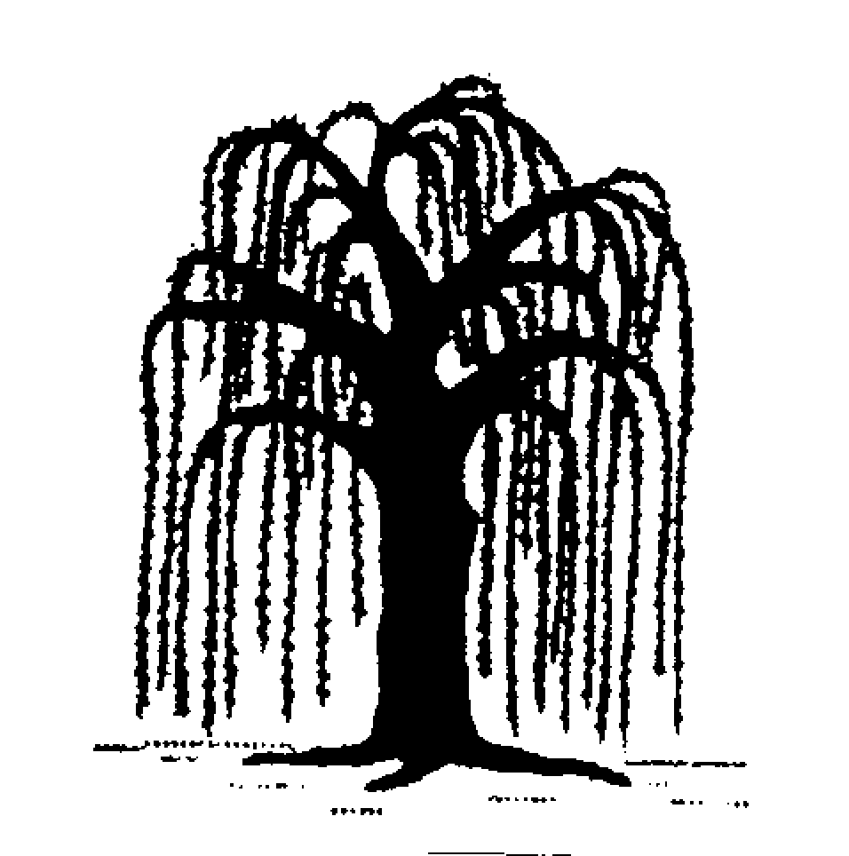



**Early Years Foundation Stage Policy**

**September 2024**

**Learning with Pride**

Our vision is to encourage, motivate and challenge all our pupils to achieve their full potential within a secure learning environment. We aim to help pupils feel empathy for others and show respect for all whilst developing as honest, polite, well-rounded, creative, confident and happy citizens who have a life long love of learning. We understand the importance of providing exciting and challenging opportunities in the early years to develop secure and solid foundations for a child’s learning journey.

*“The education of even a very small child does not aim at preparing him for school but for life.”*

*Maria Montessori, 1967*

**Contents**

* Aims of the Early Years Foundation Stage (EYFS) curriculum
* The Curriculum
* Planning
* Assessment
* Learning through play
* Equal Opportunities

**Aims of the Early Years Foundation Stage Curriculum**

* To provide high-quality learning opportunities for all children, which are informed by their current level of development and their identified next steps in learning.
* To ensure that all children enjoy a broad, balanced curriculum and a mixture of adult-led activities and child initiated independent learning.
* To ensure that learning is placed in a meaningful context that is relevant to the child.
* To create an enabling environment where all children experience success in a variety of ways, to develop confidence and enthusiasm for learning.
* To ensure an inclusive environment where every child is celebrated as being a unique child, and no child is subject to bullying or discrimination.
* To develop positive relationships between staff and children and between children and their peers, and with the wider school community.
* To develop and maintain an effective working partnership with parents and carers.

**The Curriculum**

The Foundation Stage Curriculum is based around the new EYFS framework 2021.

Within this framework, there are four guiding principles which shape our practice.

These are;

1. ***A Unique Child****.* Every child is a unique child who is constantly learning and can be resilient, capable, confident and self-assured.
2. ***Positive Relationships****.* Children learn to be strong and independent through positive relationships.
3. ***Enabling Environments****.* Children learn and develop well in enabling environments, in which their experiences respond to their individual needs and there is a strong partnership between practitioners and parents and carers.
4. ***Learning and Development.*** Children develop and learn in different ways. The statutory framework covers the education and care of all children in early years provision, including children with special educational needs and disabilities.

Our curriculum encompasses **seven areas of learning and development**. All areas of learning and development are important and interconnected.

Three of these areas are particularly important for building a foundation for igniting children’s curiosity and enthusiasm for learning, forming relationships and thriving.

These are called the prime areas:

• Communication and Language. (CL).

• Physical development (PD).

• Personal, Emotional and Social Development. (PSED).

The prime areas skills are further developed and strengthened through the following four specific areas:

• Literacy.

• Mathematics.

• Understanding the World (UW).

• Expressive Art and Design (EAD).

Throughout their time in reception at Willow Farm, our children are taught through an ambitious curriculum which is designed in a sequential way to ensure progress towards the end reception goals. These goals are called the Early Leaning Goals (ELGS) and can be found on page 26 in the Early years foundation stage profile handbook 2024.

[Early years foundation stage profile handbook](https://assets.publishing.service.gov.uk/media/6747436ba72d7eb7f348c08b/Early_years_foundation_stage_profile_handbook.pdf)

All of these areas of learning are developed by a range of learning opportunities. These take place indoors and outdoors, are provided through a mixture of adult-led and independent learning experiences, and may be worked on individually, in groups or as a class team. Our plans remain flexible to allow us to respond to children’s new interests and/or needs.

Weaving through our EYFS curriculum are the three **Characteristics of Effective Learning**.

* ***Playing and exploring*** *– children investigate and experience things, and ‘have a go’.*
* ***Active learning –*** *children concentrate and keep on trying if they encounter difficulties and enjoy achievements.*
* ***Creating and thinking critically*** *– children have and develop their own ideas, make links between ideas and develop strategies for doing things.*

These elements underpin how we reflect on each child’s development and adjust our practice accordingly. Supporting children in their individual learning behaviour and observing the context of children’s play is essential.

*“What children learn is important, but how children learn is even more important if they are to become learners in today’s society.”*

*How children learn, Nancy Stewart, Helen Moylett (2011)*

We aim for all children to achieve the Early Learning Goal in all curriculum areas by the end of the Foundation Stage.

**Planning**

Our curriculum and planning is based on the learning and development needs of our children, as identified through observations and assessment. Before they join our school, Willow Farm staff spend time with the children, their families and key workers at their nurseries and in school, and preliminary observations of the children’s abilities and interests form the basis of our planning for the first few weeks of term.

Topics are identified based on the interests of the children, and may change every week, every few weeks or every half term, depending on the children’s needs.

Medium term planning shows which aspects of the prime and specific areas of learning will be the focus each week throughout the half term. This is tracked over the year to ensure that children cover all aspects of the curriculum, with opportunities to revisit and consolidate their learning.

Weekly planning shows the whole class, group and independent activities that are planned for that week, and the enhancements made to our indoor and outdoor continuous provision to enhance child-led learning.

All members of Foundation Stage staff contribute to planning through weekly meetings and daily informal discussion of the children.

**Assessment**

The purpose of assessment is to provide detailed information on a child’s current level of development which informs planning for their next steps of learning, both within the Foundation Stage and moving on to year 1. All members of staff contribute to all aspects of assessment, to ensure that we have as accurate a picture as possible of each child.

We assess the children in a variety of ways. Informal observations are made of the children engaged in independent learning, group or class activities and through interacting with the children. A termly ‘book look’ carried out with all of the children allows us to assess understanding and revisit and deepen concepts learnt in previous weeks.

Formative assessments take place during all phonics and maths lessons, quickly identifying who has and has not understood a new concept and informing future planning.

Summative phonics assessments are carried out half termly and reading groups and small intervention ‘keep up’ groups are informed by the most current assessments. These assessments are entered on the Little Wandle portal which then informs us of areas of focus to work on next with particular children.

Each child has a Wonderful Writing, Marvellous Maths, Topic and Weekend News book, where evidence of writing, maths and writing is kept.

In Literacy, we use Talk 4 Writing where children are encouraged to develop story telling and early writing skills through oracy.

The children and their parents are encouraged to access and contribute to their learning journey via our online seesaw app.

The children are assessed on their progress towards the ELGs three times a year. In June, EYFS profiles are completed and the results reported to the Local Authority, to the year 1 teacher and to parents and carers, as required by law.

In addition to contributing to their children’s learning journey, parents are welcome to make an appointment to discuss their child’s progress with the class teacher at any time. We offer information evenings in June, prior to entry and in September, a parents’ evening in February, a report and EYFS profile in July and a chance to discuss the report with the teacher in July.

**Learning through play**

We believe that the most crucial aspect of early learning is through play. Through play, children access a wide variety of learning opportunities across all seven curriculum areas, in which they are working towards the Early Learning Goals. They focus and become actively involved in their learning, which is placed in a familiar, relevant and meaningful context.

The indoor and outdoor learning environment should give children time and space to develop and consolidate their learning through play. Resources should be freely available and accessible to the children, they know where things are and do not need to ask for what they need. They have been taught appropriate safety measures (e.g. for using scissors, using the climbing frame) which they put into practice independently.

Play enables children to develop their skills of co-operation, working together, communication, thinking creatively and critically, exploring, investigating, taking risks, making mistakes and solving problems, within a safe and secure environment.

Adults support play by providing and maintaining an inviting, well-resourced environment. They may plan and lead play, or they may join in children’s spontaneous play, extending and supporting as appropriate, for example, encouraging and facilitating effective team work or developing communication skills. They should use effective and appropriate questioning to further the children’s understanding. Adults recognise the value of play-based learning and communicate this to the children by their own enjoyment and enthusiasm when they are playing with the children.

**Equal Opportunities**

Every child is a unique and special child, and each child’s needs are equally important. All children should be treated equally and fairly regardless of ethnicity, religion, culture, family background, disability, special needs, gender, home language.

Children learn about the things that make us the same, things that make us different, and are encouraged to be interested in and celebrate this. We aim to develop in each child a positive sense of self and self-esteem, to feel that they are a valued member of our class, our school and the wider community. The children understand and follow our three school rules – **safe, ready, respectful**.

During the year, every child receives our “Pride of the Week” award in our Friday whole school assembly. The message of this is clear, however young they are and whatever their individual needs, every child has unique abilities, talents and efforts, and this is appreciated, celebrated and rewarded. The awards are linked to our five school values – the children are told which value they have demonstrated to gain the award; **Positive, responsible, inqusitive, determined and empathetic.**