 | Autumn 1 | Autumn 2 | Spring 1 | Spring 2 | Summer 1 | Summer 2
EYFS | Curriculum link: What makes me special?  Stimulus: Faces in Clay  Product: Drawing and Painting self portraits  Sculpture: Salt dough/Clay Face | Curriculum link:Maths  Paradigm: Modern  Artist: Kandinsksy  Product: Printing  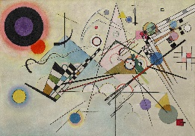 | Curriculum link: Text: Not a Box  Paradigm:  Artist:  Product: Sculpture - Box modelling | Curriculum link:Where does bread come from?  Paradigm:  Artist:  Product: Printing, textile, painting drawing | Curriculum link: Why do ladybirds have spots?  Paradigm:  Contemporary  Artist: Henri Matisse  Product: Snail Collage 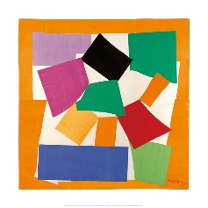 | Curriculum link: What can we do on a sunny day?  Paradigm: Modern  Artist: Alma Thomas  Product:  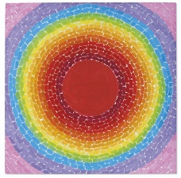
Yr1 | Curriculum link:  Paradigm: Contemporary  Artist: Yagoi Kusama  Product: Dot Painting  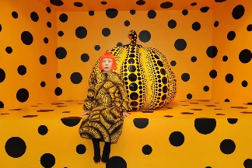 | Paradigm: Traditional  Produce clay pot (Diwali Divas)  Paradigm: Contemporary  Artist: Andy Goldsworthy  Product: Pattern making land art sculpture  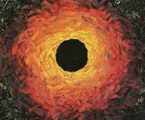 | Paradigm: Modern  Artist: Van Gogh Starry Night  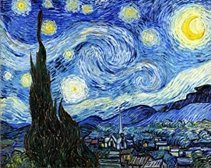  Product:Painting | Paradigm: Contemporary  Artist: Orla Kiely  Product: Printing | Artist: David Hockney  Paradigm: Modern  Product: Mixed Media Collage/Applique  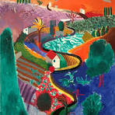
Yr2 | Curriculum Link: Great Fire of London  Product: Colour Mixing |  |  | Curriculum link: Kings and Queens  Paradigm: Modern  Artist: Picasso  Product: Sketching drawing portraits |  | Curriculum link: Animals  Paradigm: Contemporary  Artist: Andy Warhol  Product: Printing
Yr3 |  | Curriculum link: Stone Age  Paradigm: Traditional  Artist:  Product: Clay pots/chalk drawings cave art  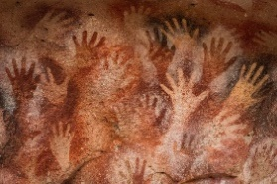 |  | Paradigm: Contemporary  Artist: Andy Goldsworthy  Product: Sculpture |  | Paradigm: Modern  Artist: John Constable  Product: Landscapes painting and weaving  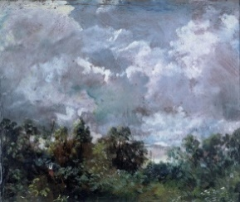
Yr4 | Curriculum Link:  The Romans  Paradigm: Traditional  Product: Mosaics  Clay bust sculpture  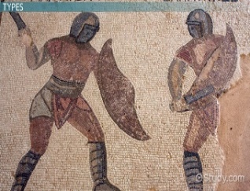 |  | Curriculum link: Colour and Sound  Paradigm: Modern  Artist: Kandinsky and Picasso  Product: Painting |  | Curriculum link:  Paradigm: Contemporary  Artist: Julian Opie  Product: portraits and moving figures  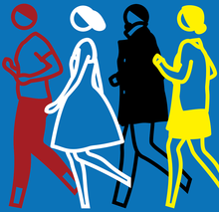
Yr5 | Paradigm: Modern  Artist: William Morris/Voysey  Product: Print making |  | Curriculum link: Anglo-Saxons  Paradigm: traditional  Product: Clay Sculpture |  | Paradigm: Modern  Artist: Frida Kahlo  Product: Drawing and Acrylics  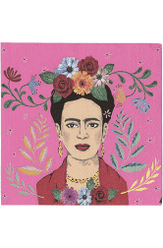
Yr6 | Curriculum link: Impact of War -Battle of Britain  Paradigm: Modern  Artist: Paul Nash  Product: Drawing/painting sky Landscape |  | Curriculum link: Pop Art Computing  Paradigm: Contemporary  Artist: Andy Warhol  Product: Printing |  | Curriculum link: The Mayans  Paradigm: Contemporary  Artist: Paul Klee  Product: Rod Puppets

