Year 1 Mechanisms - Sliders and levers
Design and make a moving picture for a teacher to use when telling a story.
Unit outline:
Most children will:
have used tools safely to make a moving picture that incorporates a simple lever or slider; have used given techniques to practise their making skills and as a starting point for developing their own ideas; have been able to talk about how simple moving products work
Some children will not have made so much progress and will:
have made a moving picture with help – either in developing their ideas or in using tools to make it; have a limited understanding of how simple moving products work
Some children will have progressed further and will:
have developed their own ideas from the initial starting points and will have used tools relatively accurately to make their moving picture(s); have made simple judgements about their work eg ‘The lever is a bit floppy but I could stiffen it with a lolly stick’, ‘I am pleased with the way the boat moves but sometimes it gets stuck’; have been able to explain how the lever or slider works and will have recorded through drawing and labelling

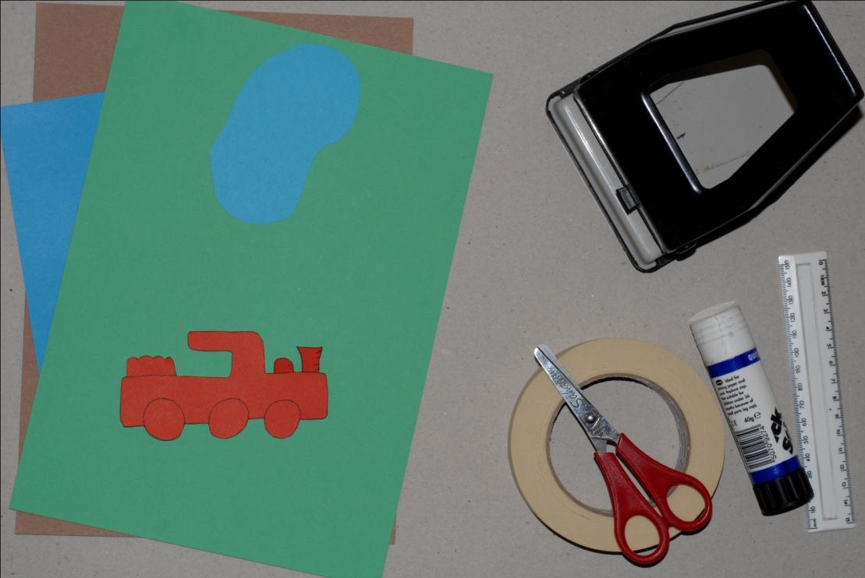

Session 1 - Researching sliders | WALT: | WILF: | Resources
 | Investigate how simple levers and sliding mechanisms can be used to create movement | All will: identify simple levers and sliders in moving books/products and explain how they work  Most will : make drawings of simple products to show how they work  Some will: use appropriate vocabulary to describe mechanisms | - PowerPoint  - Worksheet  - Teaching board | - Example books with sliders  - Example mechanisms  - Balance scales
 | Teaching Points |  | Independent Learning Tasks
 | Starter  Slide 3. Discuss with the children if they know what sliders and levers are.  Main sequence  Slide 4. Have a book and ask where the sliders are. Use an example book to show  - What does the moving part do?  - How does it work?  - What effect does it have? ... Surprise?  Slide 5. Then introduce the term lever and pivot to the children and show what they are on the teaching board. Again model the movement and how the mechanism works. Explain to the children that a lever has a pivot point. This can be shown with card strips and a paper fastener. Compare the movement of a lever to a slider. A slider moves backwards and forwards in a straight line. This can be shown by a strip of card that can move backwards and forwards through slots in another piece of card. Children could cut out their own pictures to attach to the card strips to create simple moving pictures.  Use a simple moving picture book to talk about how levers and sliders can be used to make movement and bring stories to life. Read through the story using the levers and the slider. Asking questions about the movement and the effect as in the starter.  Using the teacher board model how the moment is created and how the different slider mechanisms work (many different ways)  After children have had time to explore the different mechanisms get children back together and model the final activity. Children must draw a picture of a mechanism labeling the parts and what each part is. They should also add arrows to show which way the mechanism moves.  Plenary  Children explain to each other how the mechanism that they investigated worked. |  | Give children opportunity to use the different levers and slider mechanisms and explore how they work  Children to use the investigating sheet to make a simple drawing of a mechanism that they have investigated. Make sure that they are carefully labeling the different parts and where the movement is.  Children talk to partners about how their system worked and what they thought about it

Session 2 - Focused practical tasks | WALT: | WILF: | Resources
 | to make simple sliding and lever mechanisms | All will: be able to make a simple slider and lever mechanism with adult support  Most will: be able to make a simple slider mechanism independently  Some will: be able to make a simple lever mechanism independently | - Powerpoint  - Teaching board | - Templates (flower, plant pot, dolphin, lever/slider card cut in strips, slider background, car)  - Masking tape  - Dowels  - Straws  - Scissors
 | Teaching Points |  | Independent Learning Tasks
 | Starter  Recap the term pivot and lever from last lesson what are they? Can they name any examples e.g. seesaw  Main sequence  In groups of 3 children are going to make an example of each system. First demonstrate making the first mechanism using the Powerpoint as a guide. Then as a class make it together following the points on the powerpoint. Try to keep everyone at the same point.  Repeat this for all three mechanisms. So that each group has one of each of the 3 systems.  If doing parts of a class at once rotate round so that all groups get a chance to make the 3 systems. |  | Children discuss in partners what a pivot and a lever is.  Points to note  - A lot of set up is required for this lesson. Templates will need cutting out ready for the children to use.  - To make this more manageable you might want to only do this lesson to groups at a time as children may struggle with the cutting etc rather than to the whole class  - Children may struggle using a hole punch so this may need to be taught to them.  - You may or may not want to teach the children all 3 mechanisms depending on time constraints  Encourage the children to support each other as much as possible cutting and sticking so that you are free to help the children that are in greater need.

Session 3- Designing | WALT: | WILF: | Resources
 | To design a moving picture using sliders or levers | All will: Verbally discuss their design ideas  Most will: be able to draw a simple drawing of their design  Some will: be able to label their design with materials used | - Powerpoint  - Teaching board  - worksheet
 | Teaching Points |  | Independent Learning Tasks
 | Starter  Slide 20. Show the children the different systems that are on the teaching board  Go through how they work. Get the children to explain how they think it works. Bring in knowledge from the FPT  Main sequence  Children are going to make one each.  Slide 21. Share the title Design and make a moving picture that can be used when telling a story.  Discuss with the children the requirements for the moving picture  - What story are going to choose what character might you want to choose  - Who is the story for?  - What might it be like?  - How could you do this?  - How are you going to get it to look good? Felt tip pens, colouring pencils  Slide 22. As a class make a design criteria that the children are going to include in their design 1 will be use a slider or a lever, consider quality of finishing. Size etc.  Discuss with the children which is the best place to start (making the lever or the slider) what tools might they need?  Model designing using the design template. Including labelling and showing the direction of movement  Plenary  Children share their design ideas with others |  | Children discuss and share how the different slider and mechanisms work  Points to note  - You can give the children a wide range of books and or characters. Or let them choose their favorite character from their favorite story.  Children talk to their partners about what character they want to make.  Children complete the design grid labeling where possible. And following the structure of the modelled example.

Session 5 - Making | WALT: | WILF: | Resources
 | To make a moving picture using sliders or leavers | Design criteria that was set last lesson. | - Teaching board  - Children’s completed design sheets | - Card for character  - slider background  - Strips of card, lever templates  - Split pins  - Finishing material  - Tape  - Dowel and straws  - Scissors
 | Teaching Points |  | Independent Learning Tasks
 | Starter  Slide 24 Reacap the title of the project  Design and make a moving picture that can be used when telling a story. And the design criteria  Get children to look through their design to refresh their memory.  Main sequence  Slide 15. Today is the building lesson children should have a good idea of what they need to start building first and the materials that they need. Before all children start they need to tell you what they are starting with to make sure they are on task as quick as possible. Ensure that they use their plan to keep them close to their design. They can pair up and help each other but they need to make on each.  Model the use of the resource stations so that the children know not to grab everything in one go. Only get what they need to complete the part that they are working on e.g making the slider they need a strip of card, slider background. Once they have got the slider to fit then they can come back and get a bit of card for the character. |  | Points to note  - Set resource stations up so children can pick up the materials that they need. It is best to set this up where there is plenty of space. Include: card, split pins, lever templates and dowel and straws. Finishing materials can be spread out on tables with tape.  - Some children might need support hole punching and attaching the levers together  Support children in making their systems making sure that they are being safe with the equipment

Session 5 - Evaluating | WALT: | WILF: | Resources
 | To evaluate a product based on the design criteria | All will: be able to discuss with a teacher about how well they achieved the design criteria  Most will: be able to write a basic comment about their product met one of the design criteria  Some will: be able to write a comment about their product for each design criteria | - Evaluation sheet | - Completed moving pictures
 | Teaching Points |  | Independent Learning Tasks
 | Starter  Allow children time to share their moving pictures with the other children in the class or even allow children to walk around the class looking at other people’s moving pictures. Focus children to look at the movement and the finish quality and the other areas of the design spec  Discuss with the children who’s moving picture they like the look of and why. Aim for quality responses like the movement was interesting. Not just it looks good.  Main Sequence  Slide 26. Reap the design criteria and what were the things we needed to achieve in the building of the moving pictures (on ppt or wherever you wrote them down). Show of hands who thinks they managed to achieve them.  - Were there any that were harder to achieve than others?  - What part of the construction did you find the hardest?  - What bits worked really well?  Slide 28. Model how to use the evaluation sheet on a product going through the design criteria and writing comment for each one.  Plenary  Slide 29. Talk about what improvements might we make next time. E.g was the card to floppy, did the slider not move enough. |  | Points to note  - Sheet will need to be filled in with the design spec chosen in the design lesson.  - May need to explain what evaluating is  Children evaluate their design following the teacher example  Children to talk to their partner about what might they improve. Then share as part of a class discussion

